CMPE 273 – ENTERPRISE DISTRIBUTED SYSTEMS

Lab 2 Report

**Homeaway Prototype**

**Using Redux, MongoDB and Kafka**

**i. Introduction-**

**a) Goals and Purpose of system -**

The goal of the system is to create a full stack web application using application protocols for large scale distributed systems that include object request brokers, asynchronous messaging and web services. Homeaway is a property booking web application built using node.js as the backend and HTML5, ReactJs as the frontend.

There are two modules- Traveler and Owner. The owner can post his property for rent and manage it. The traveler can search for available properties and book it.

The purpose of the system is to –

i) Provide a portal for owner and traveler to list and book properties respectively and keep track of their properties and bookings.

ii) Let user’s signup, sign in, signout, create and update profile.

iii) Owner can post the property for rent.

iv) Users can search, and book property based on search criteria.

v) Display all previous booking history and previous trip details.

**ii. System Design-**

NodeJS architecture combined with ReactJS and Redux as the frontend has been used to design the system. The express API framework based on Rest is used to handle the http request. MySQL relational database has been used to store the data.

This server has several good ideas behind. It has **separated layers** for handling API requests and database queries. Separated files for modules of REST resources and also for database modules increases the modularity of the system.

Our domain code is reusable and independent from our API framework. The code is also easily testable, and tests can survive through frameworks and libraries changes. Default support with JSON, templating and very lightweight process. Jmeter has been used for testing for concurrent users.

**iii. Results: Screenshots of each client/server pair**

**a) Home Page on Application start**

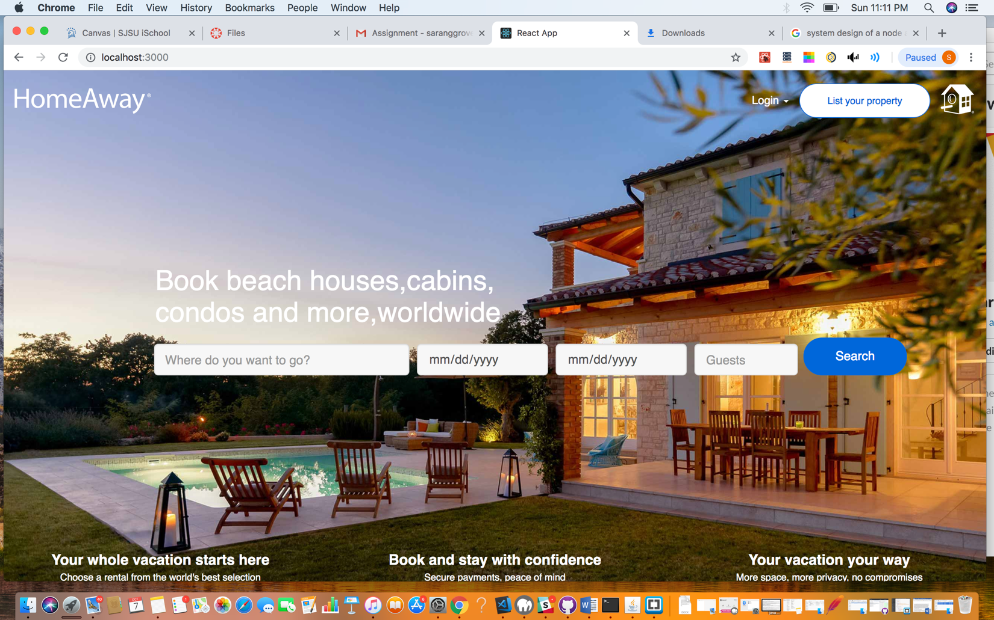

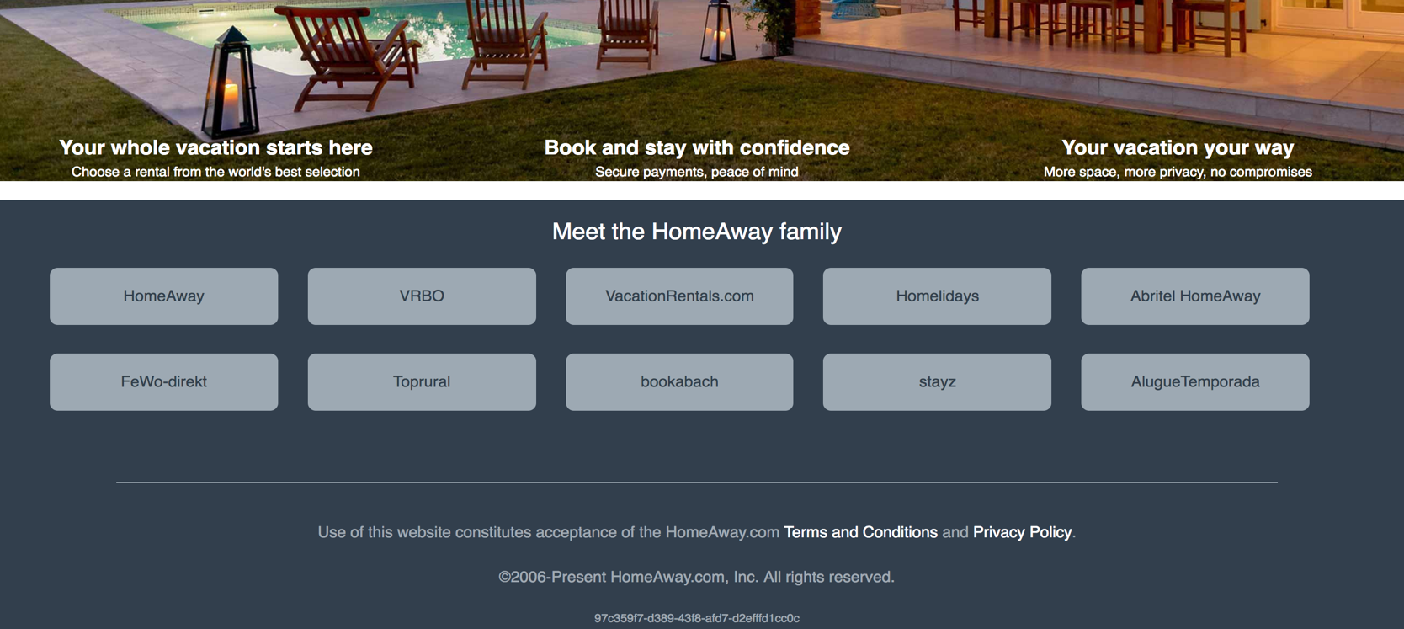

**b) Traveler Signup Page**

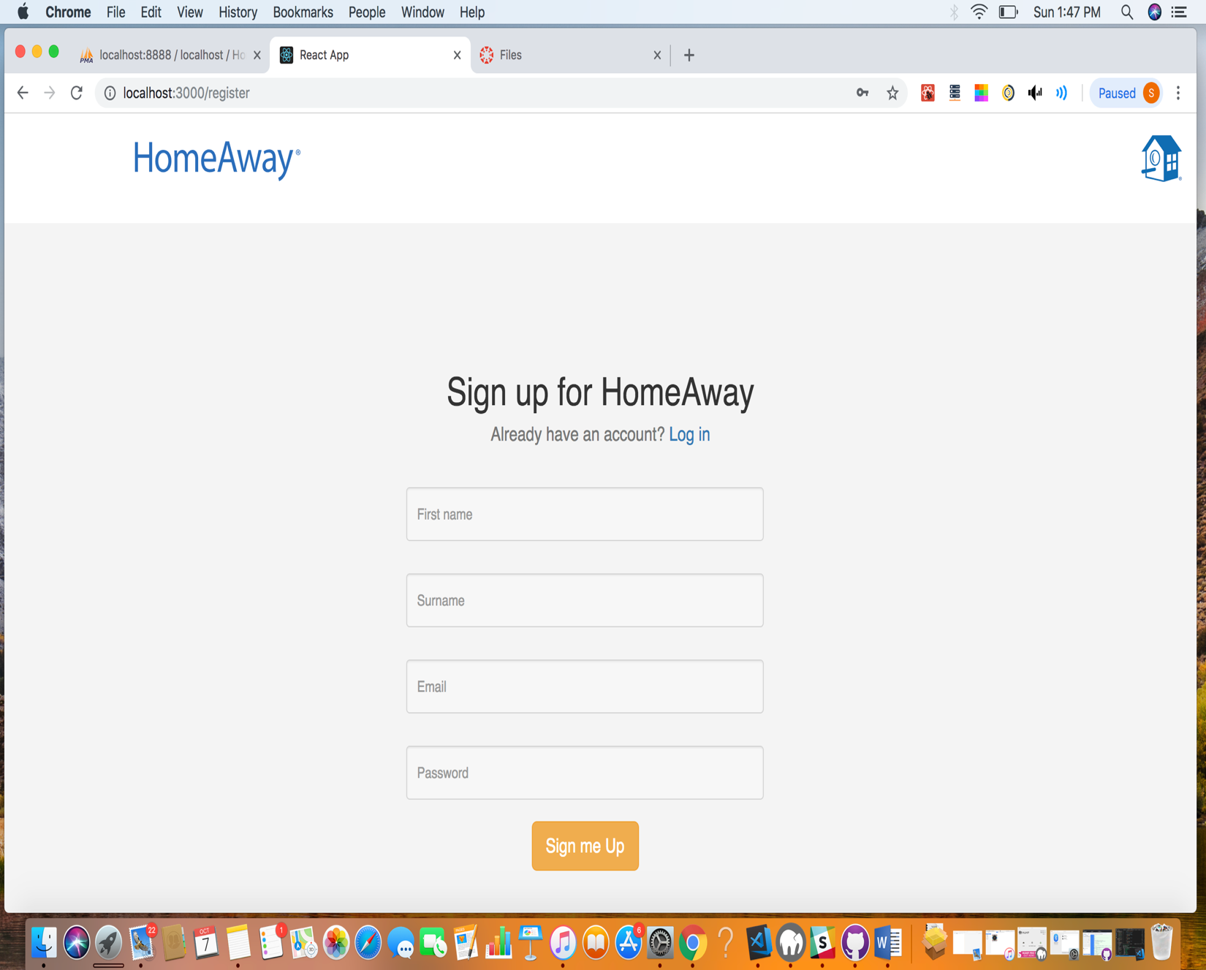

**If user already exist and tries to signup -**

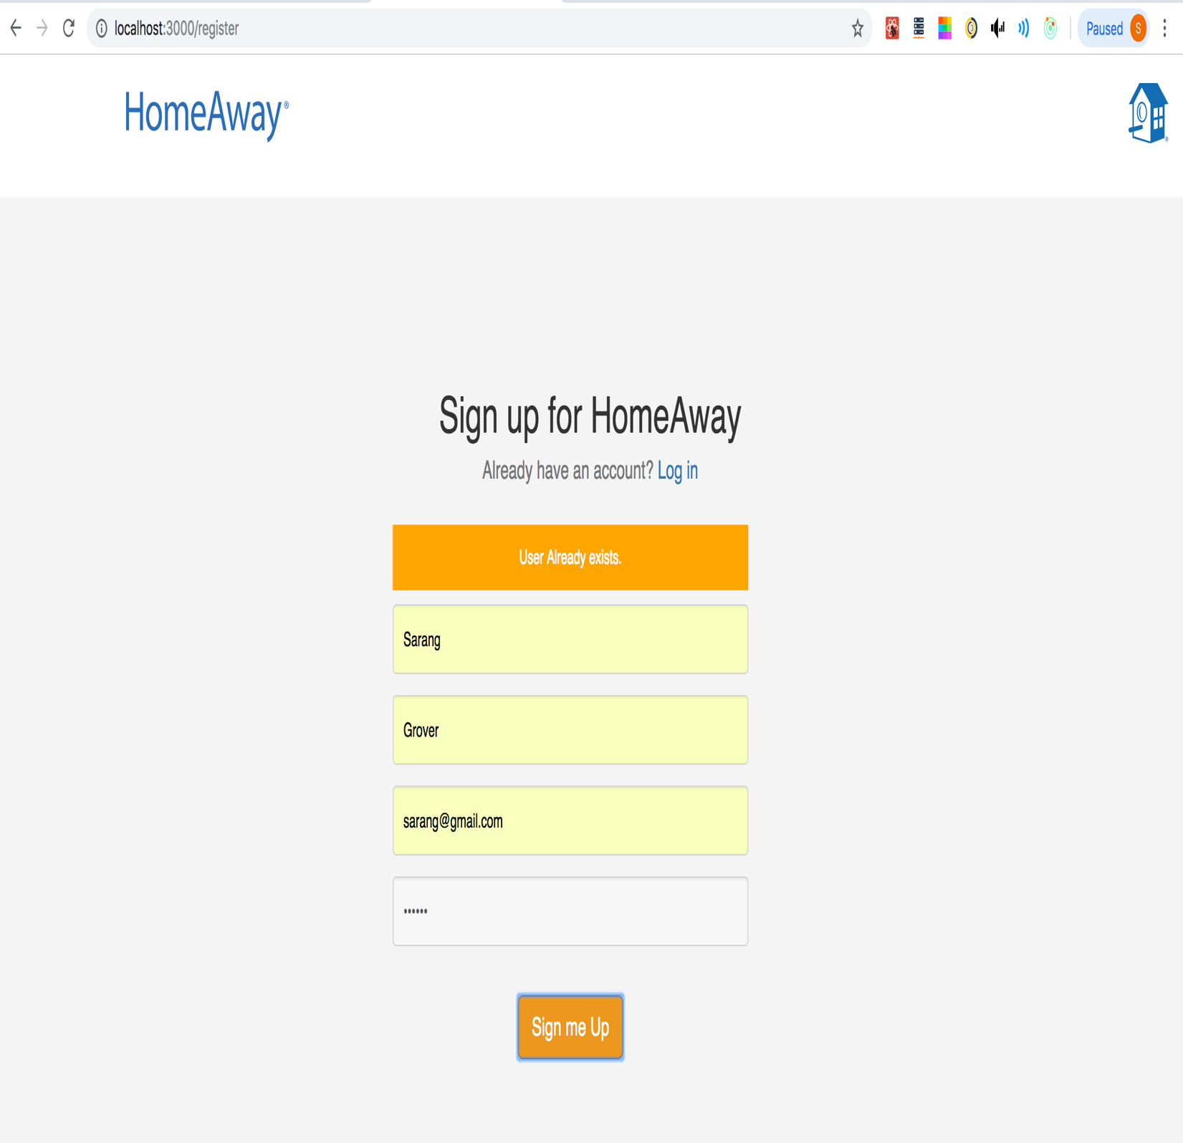

Kafka Backend Code –

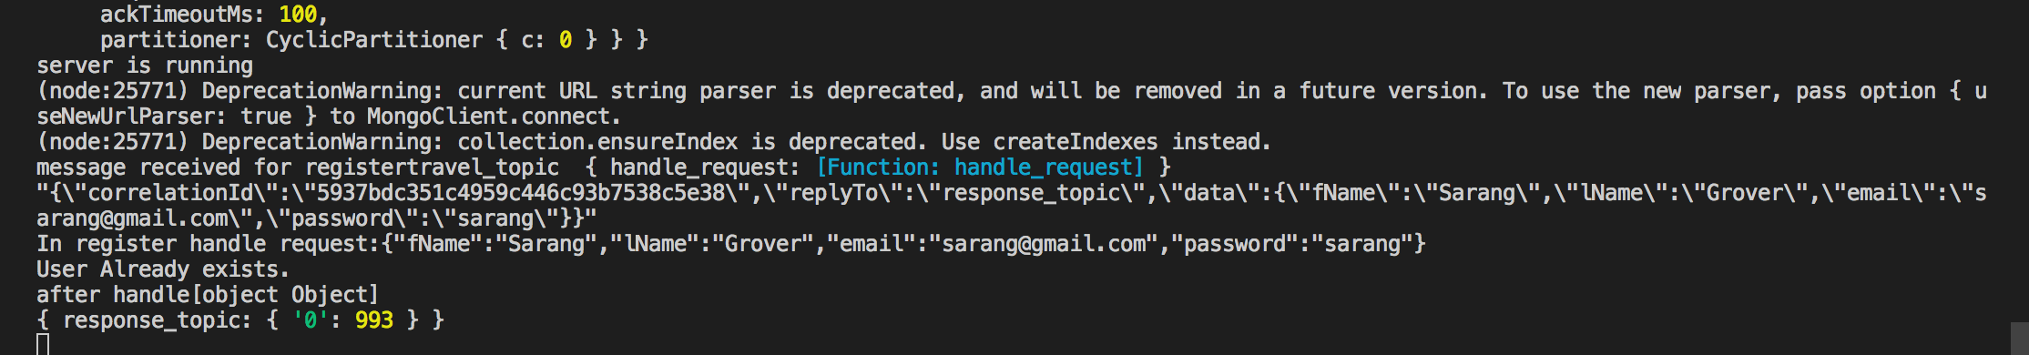

Node backend-

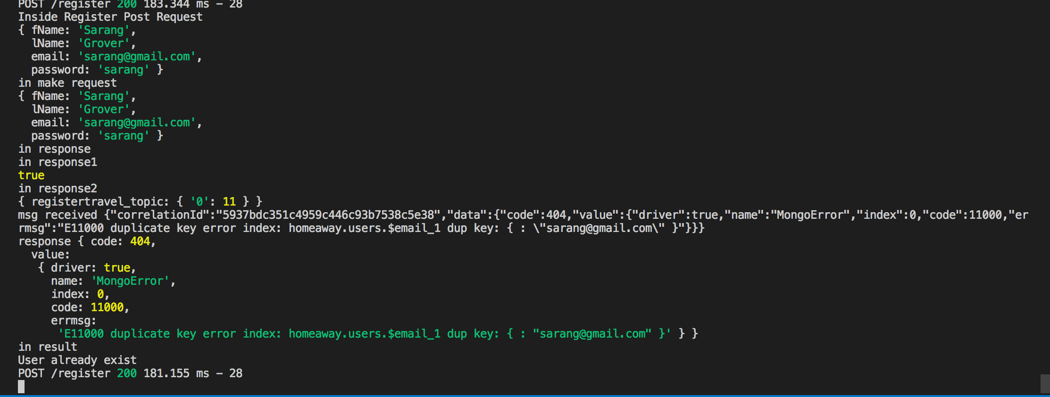

**New user signup –**

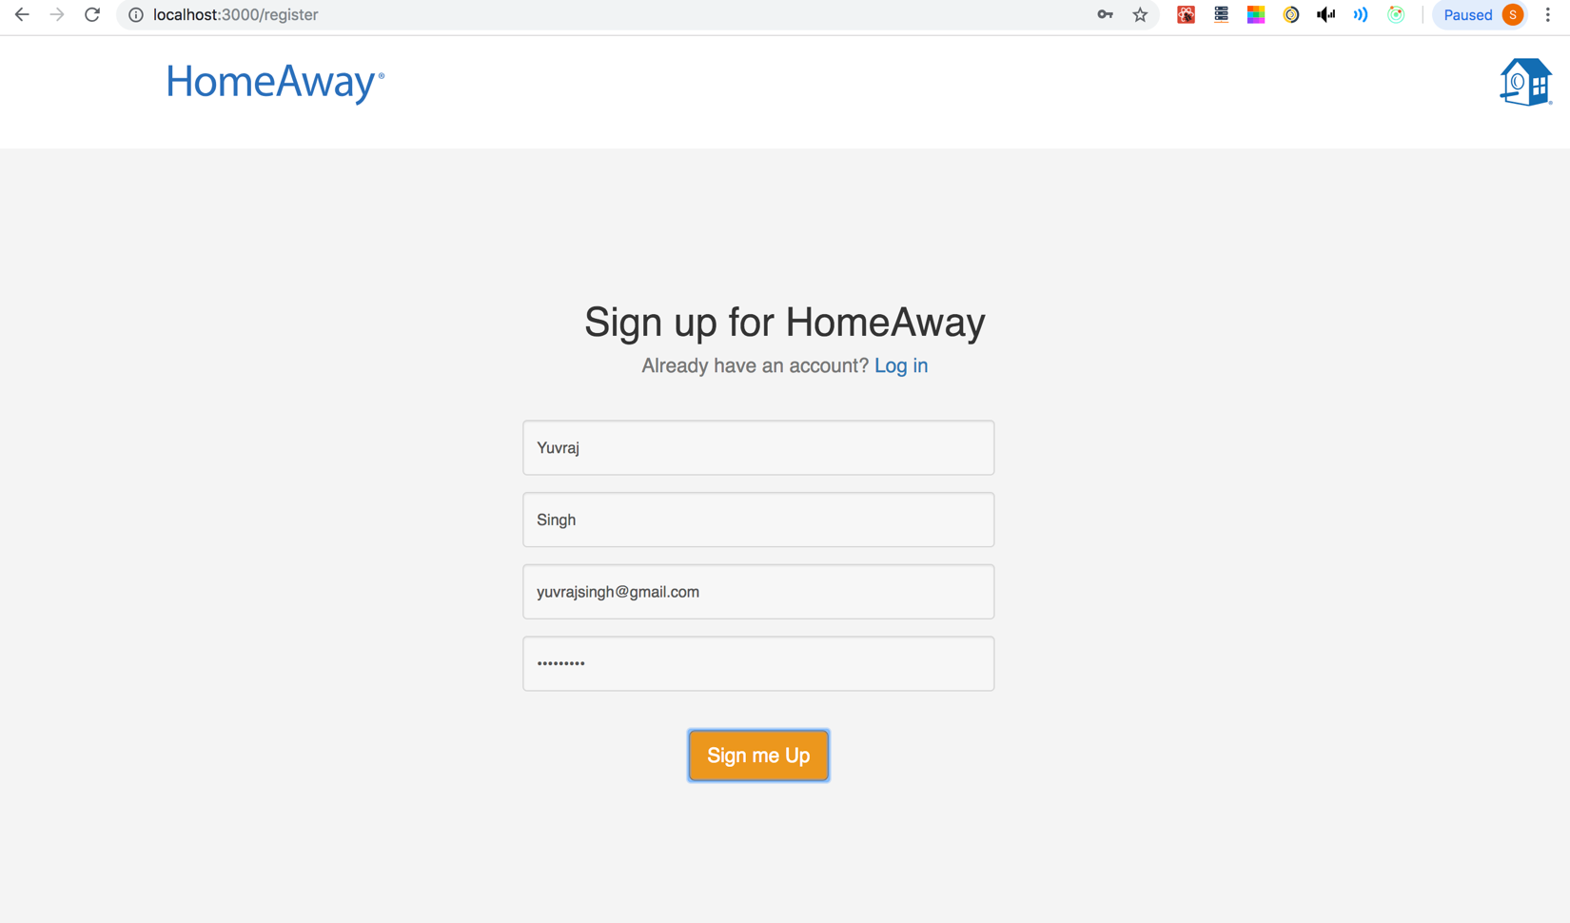

Kafka Backend –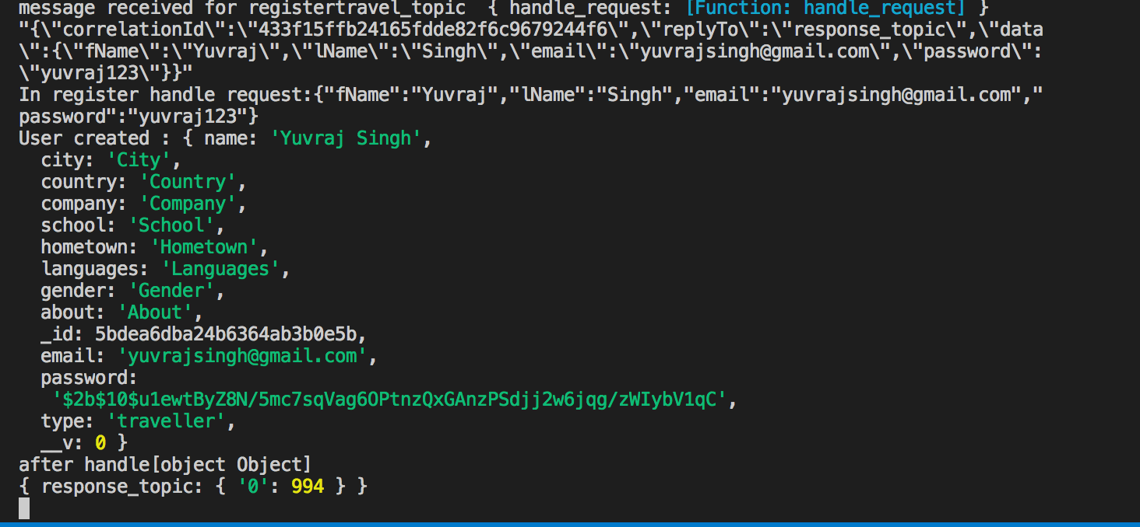

Node Backend -

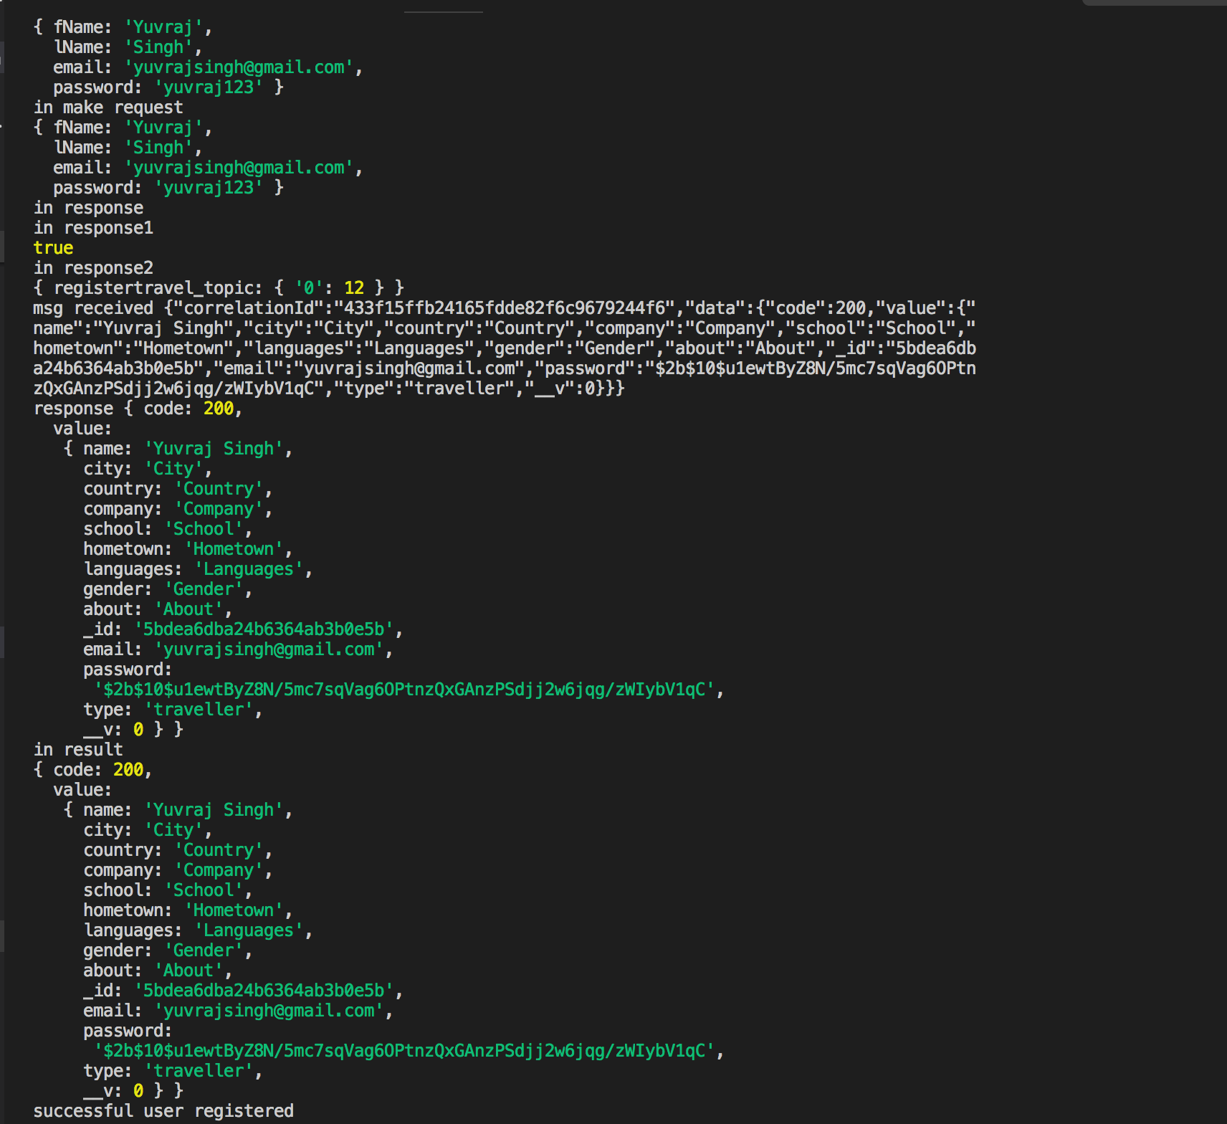

**c) Login Page on Application start**

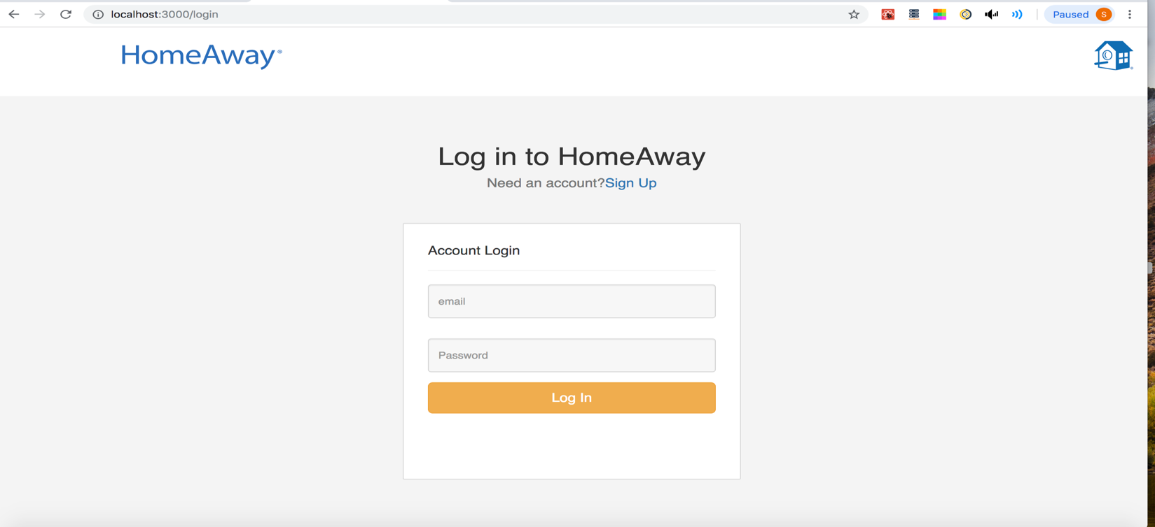

**On unsuccessful login-**

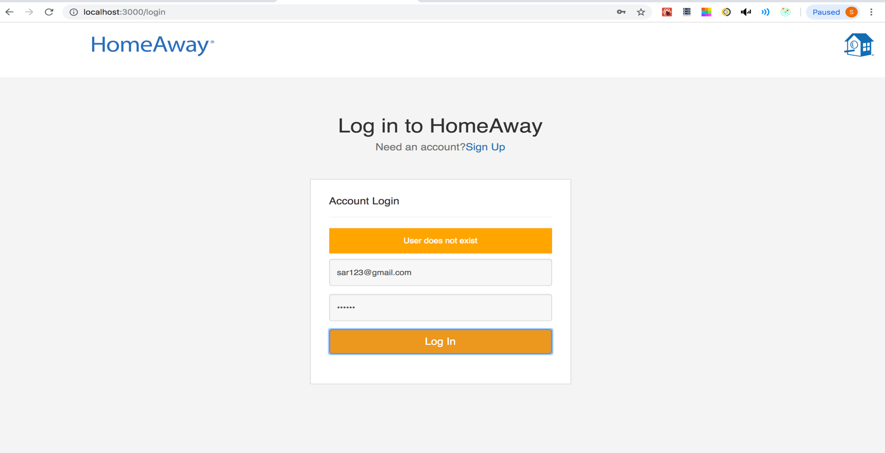

Kafka Backend-

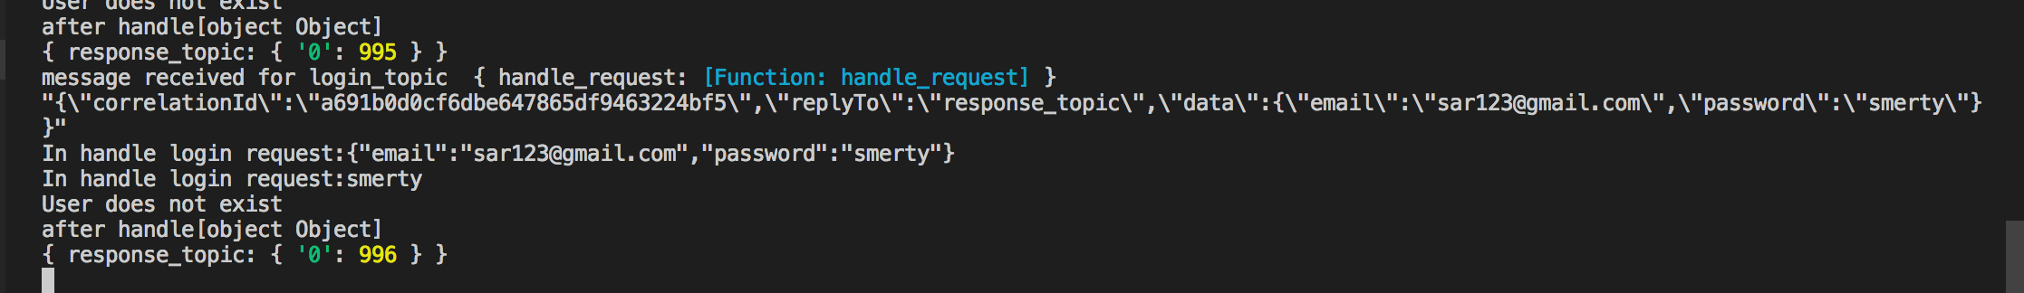

Node Backend-

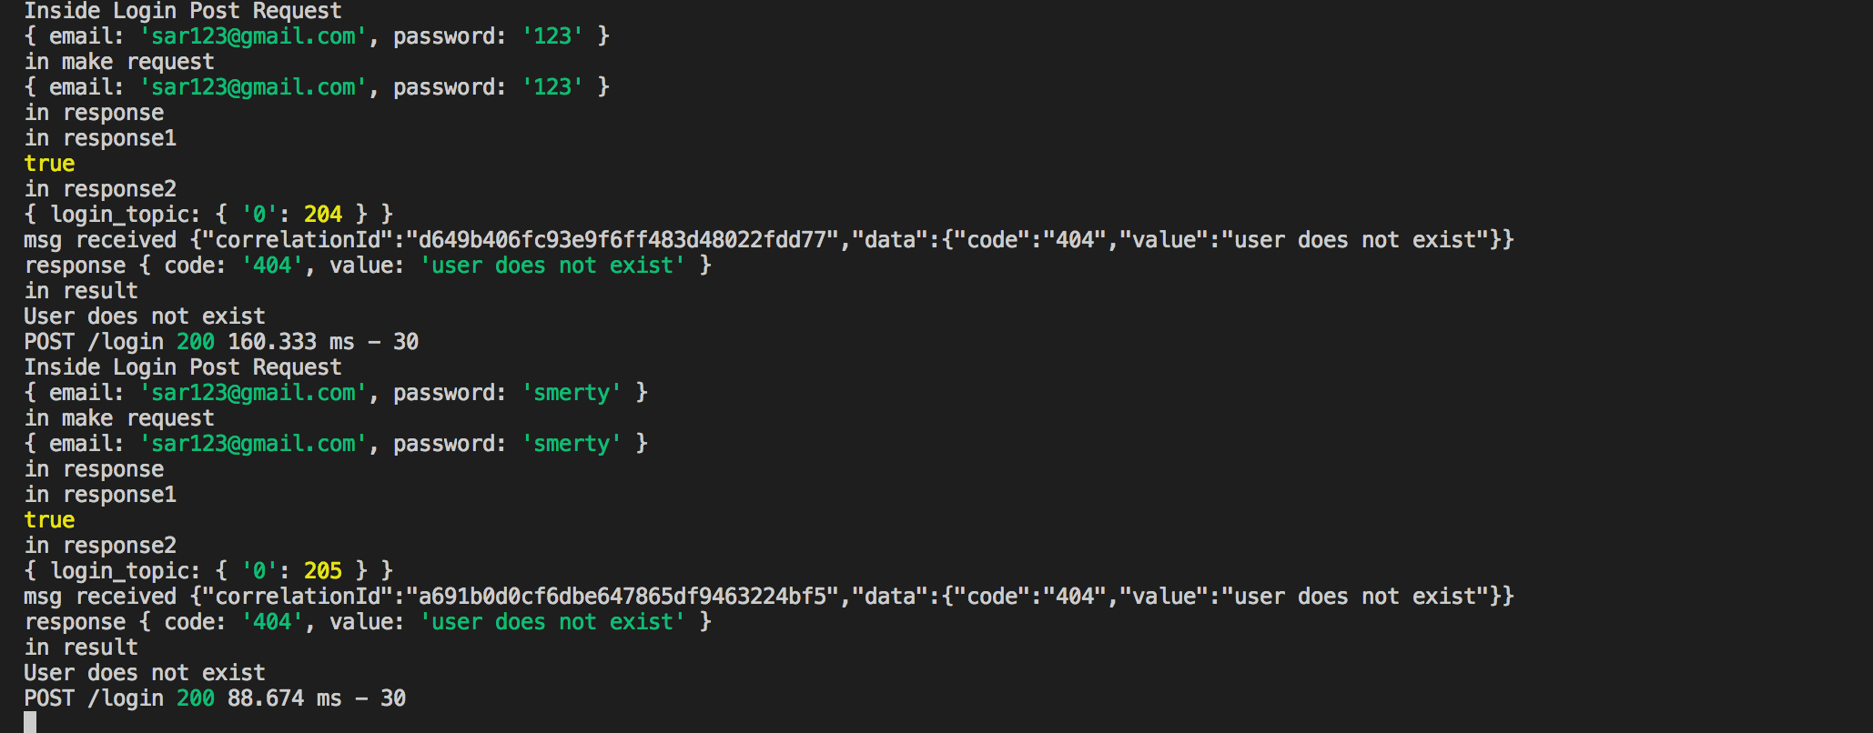

**On successful login-**

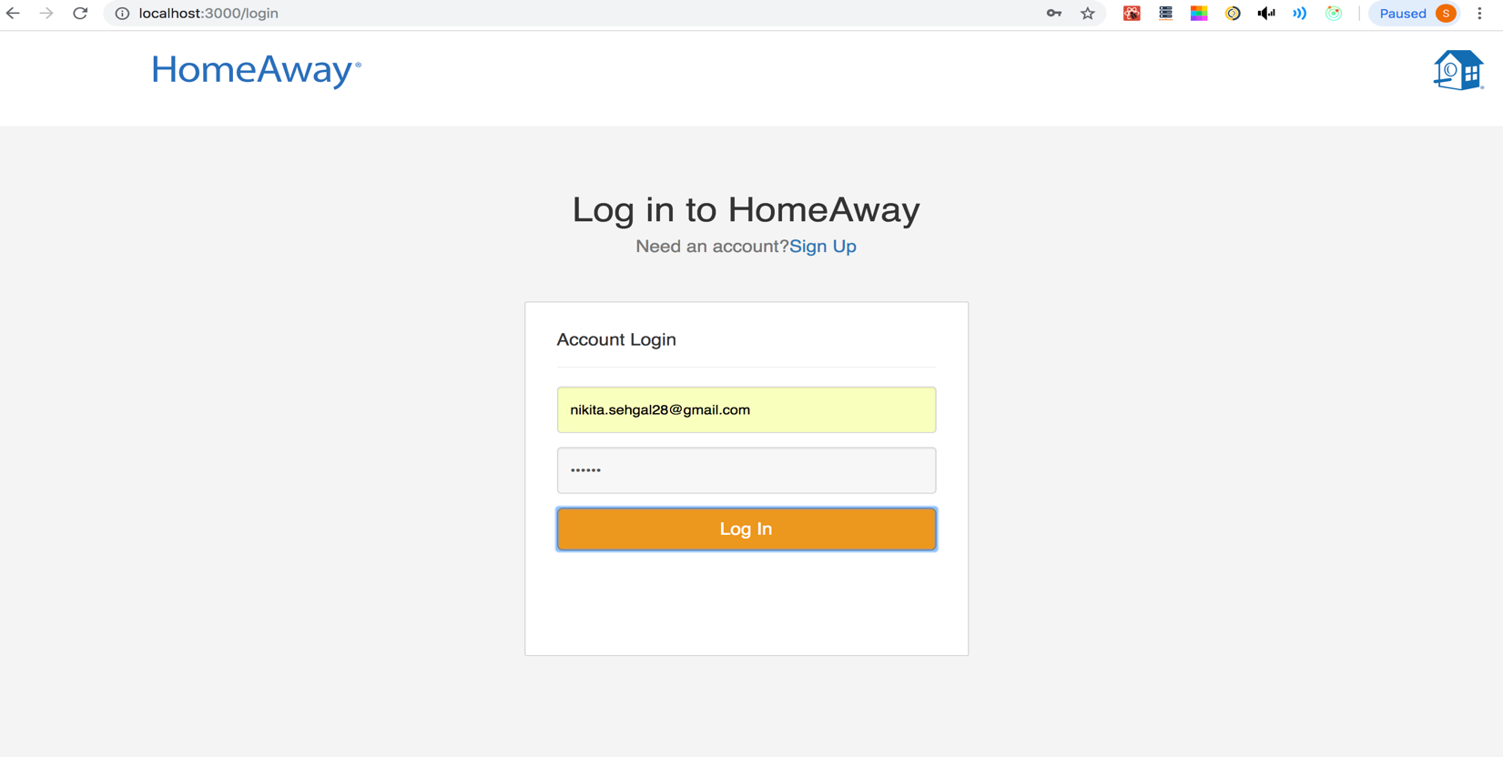

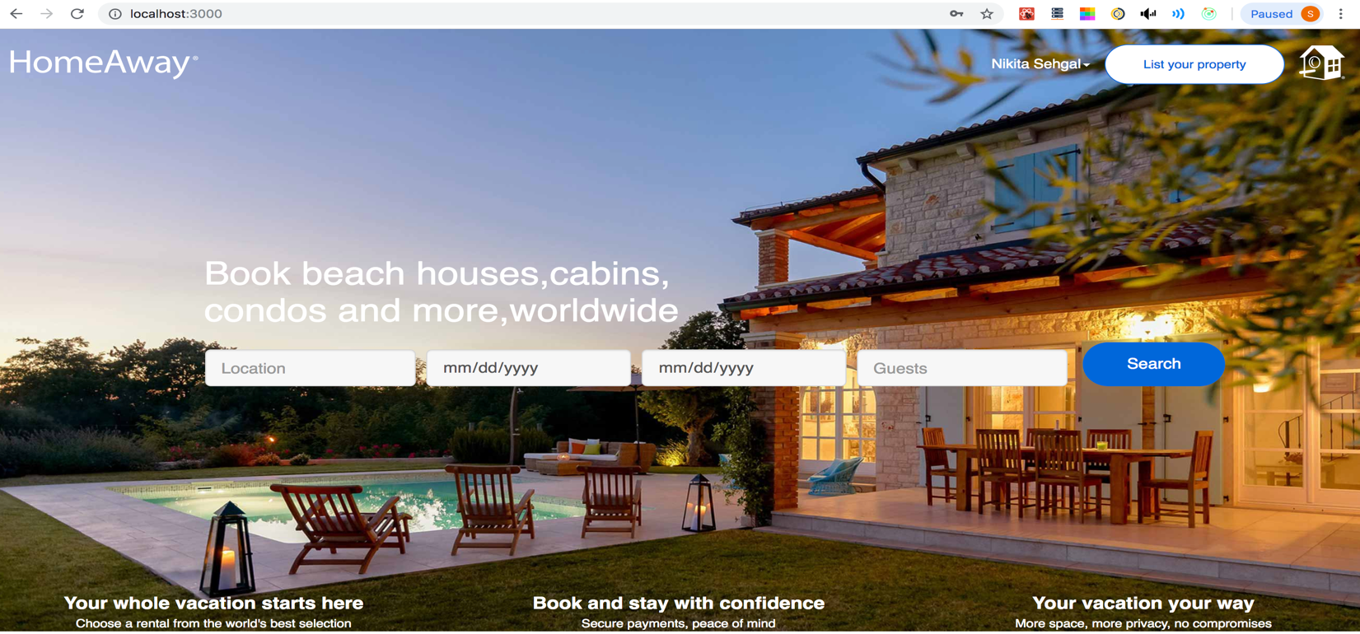

Kafka Backend-

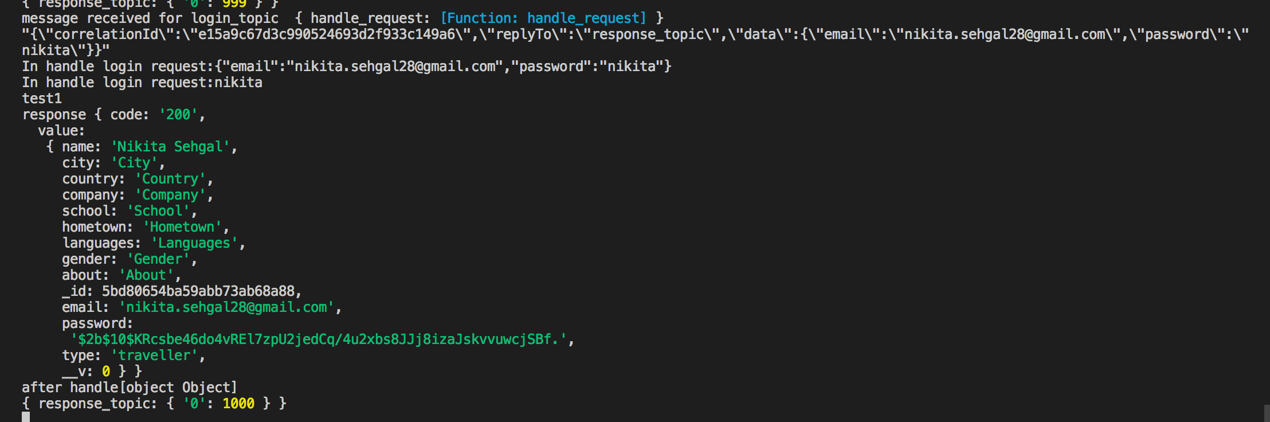

**Node Backend – ( Password is encrypted and jwt token is generated on login)**

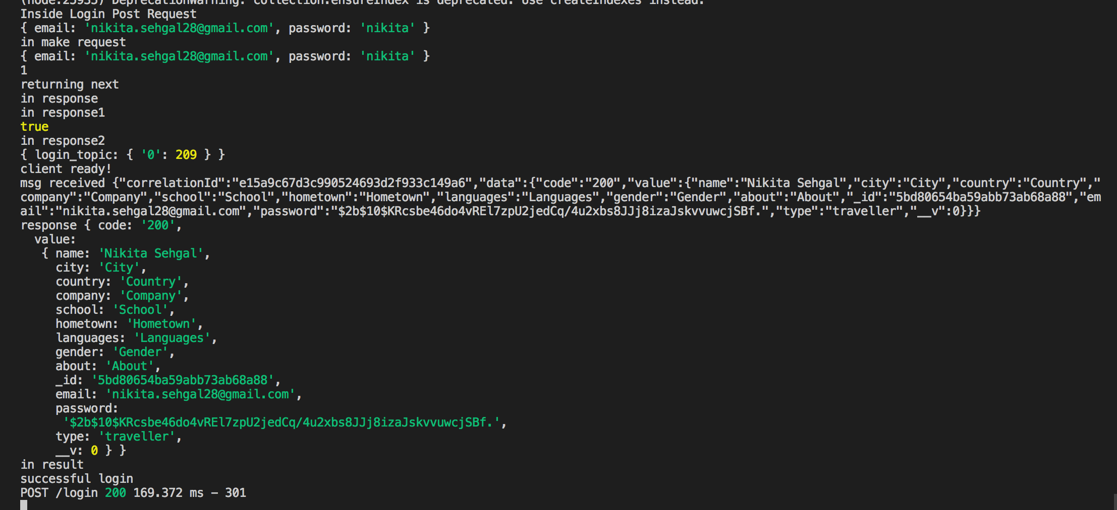

**Redux state on login ( jwt token and traveler details stored in redux)**

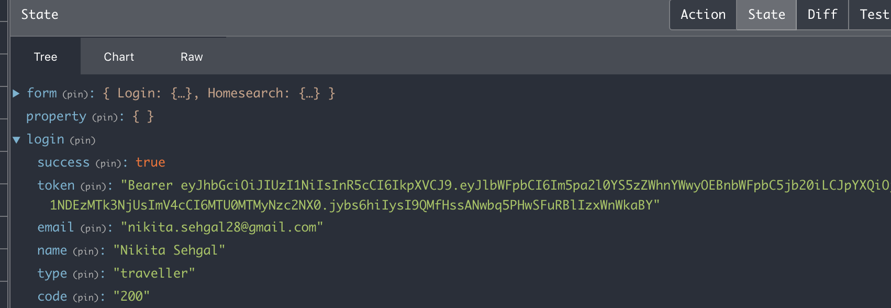

**d) Search for Property**

Validations using Redux Form –

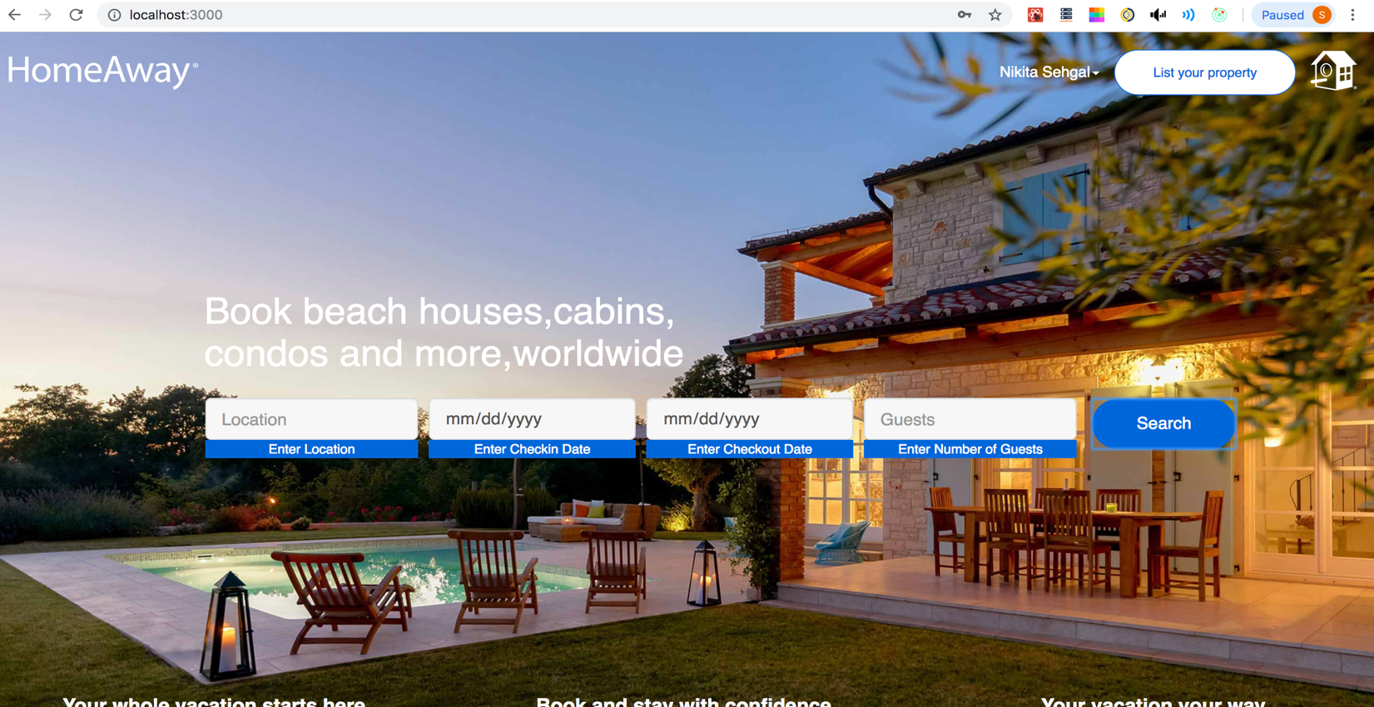

Checkout should be greater than checkin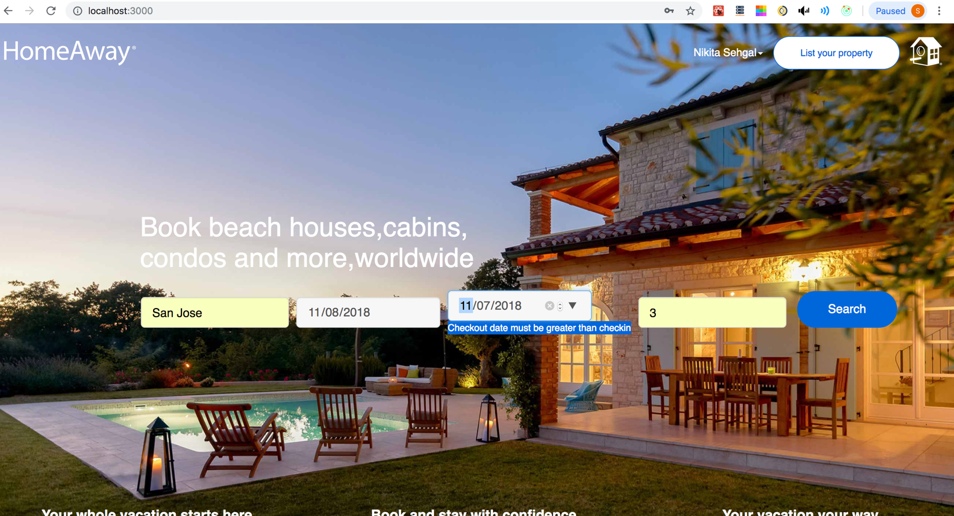

Check-in / Checkout should be greater or equal to today’s date –

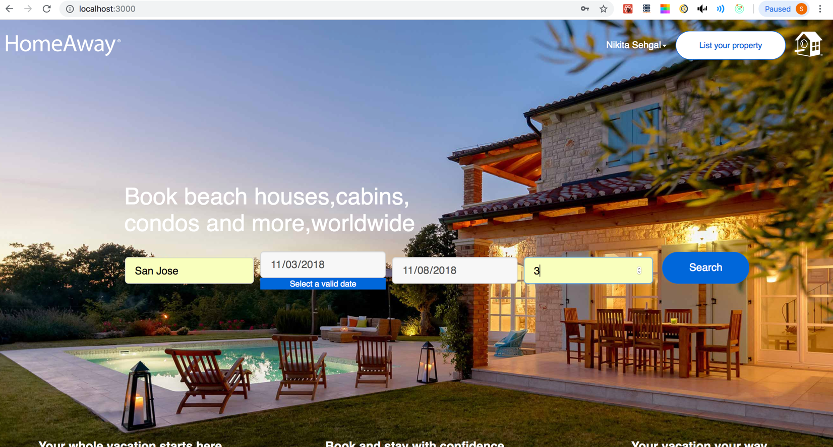

User Search –

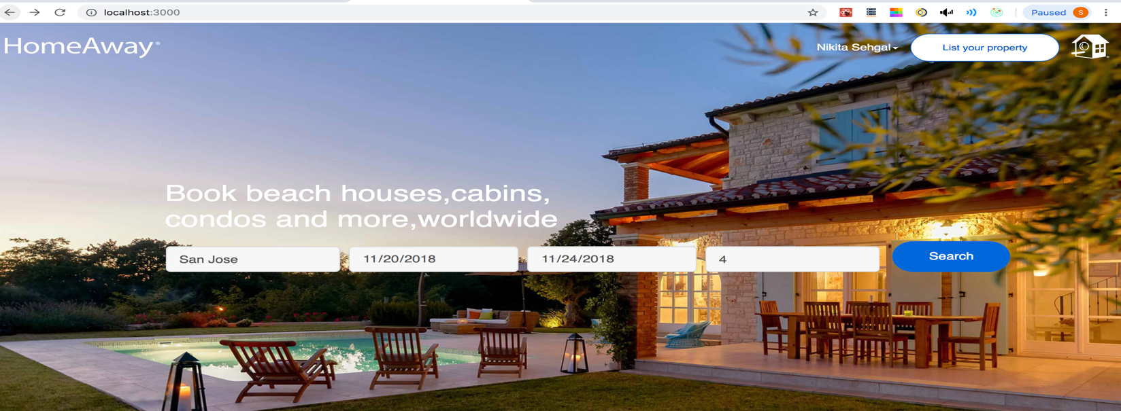

**Search Results for User—( with filters and pagination enabled)**

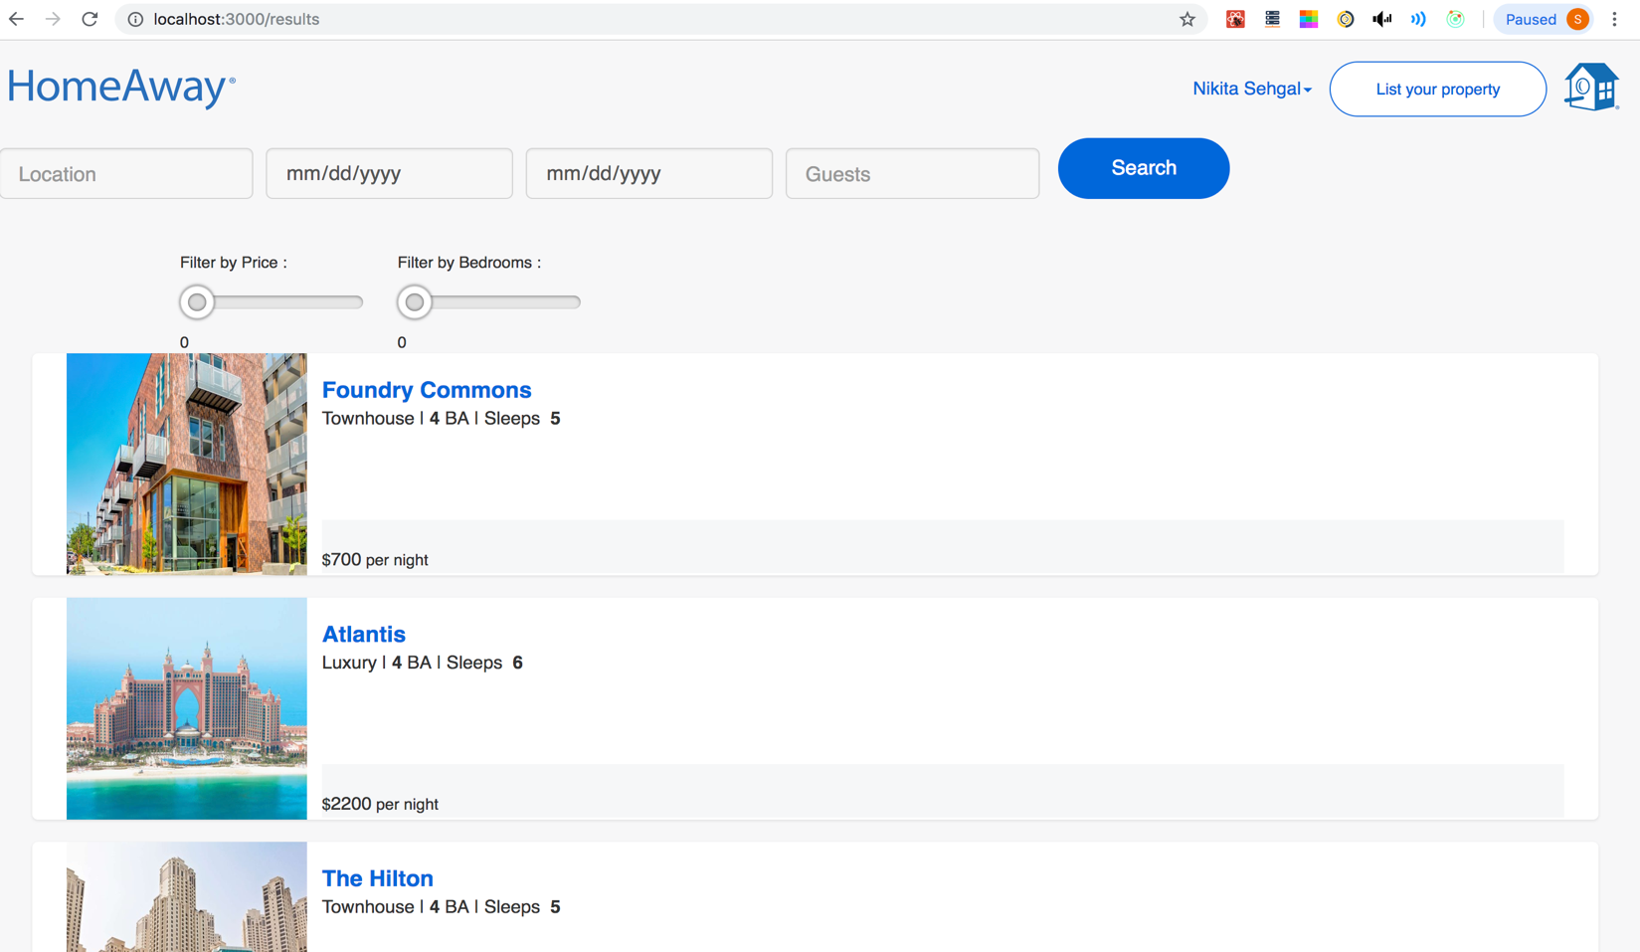

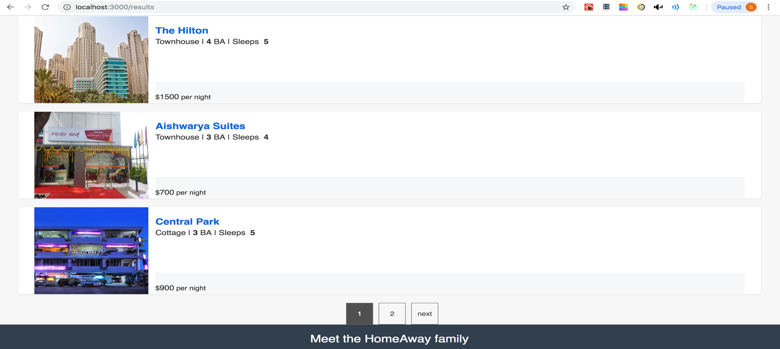

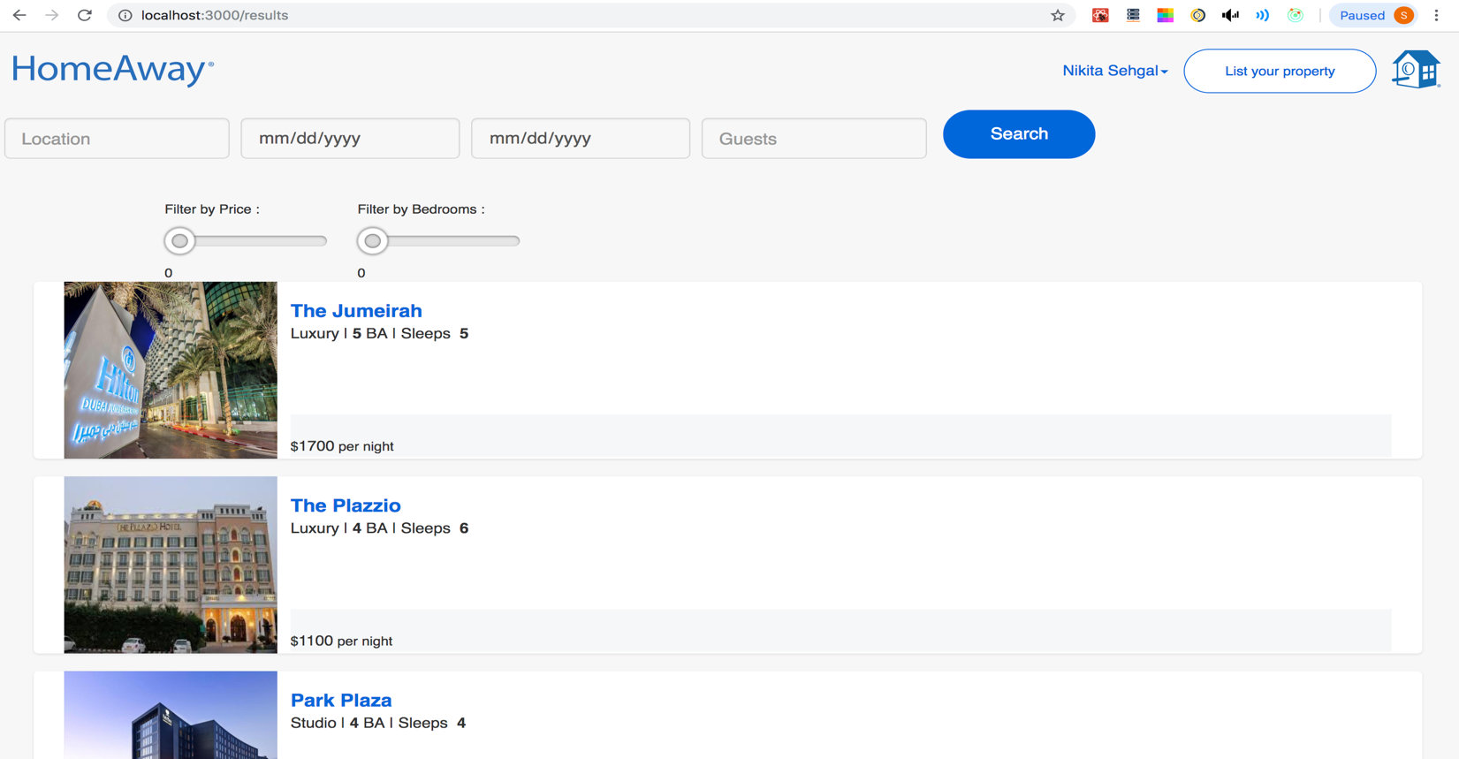

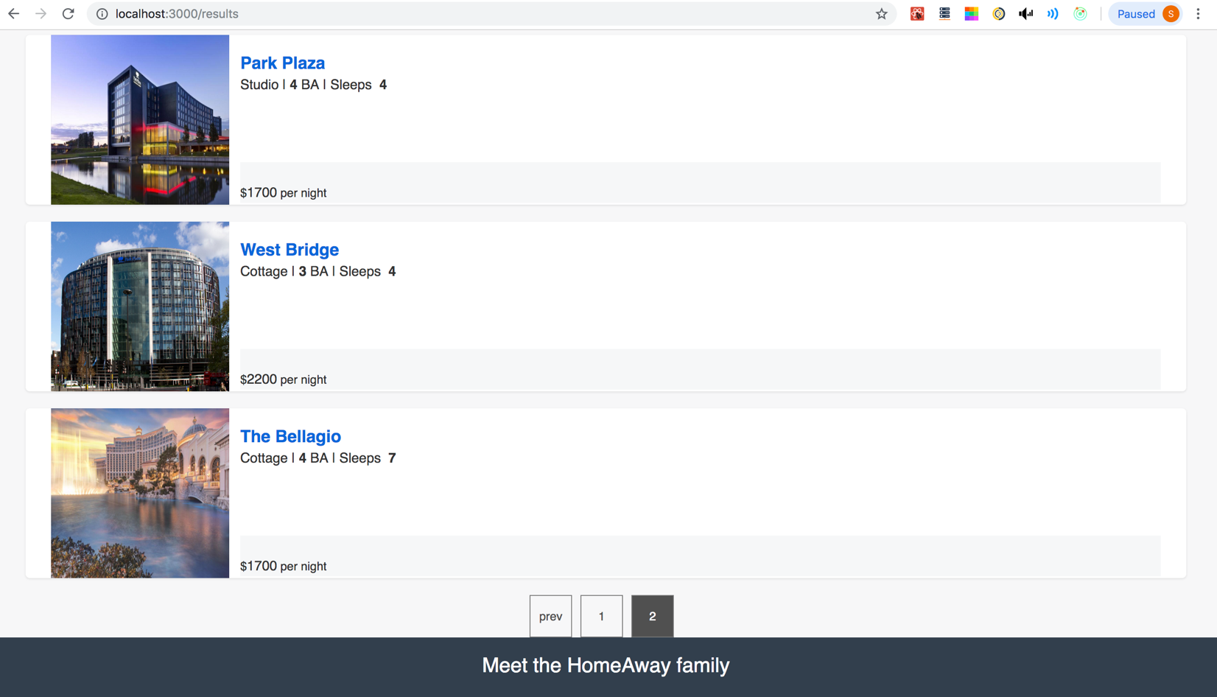

**Kafka Backend –**

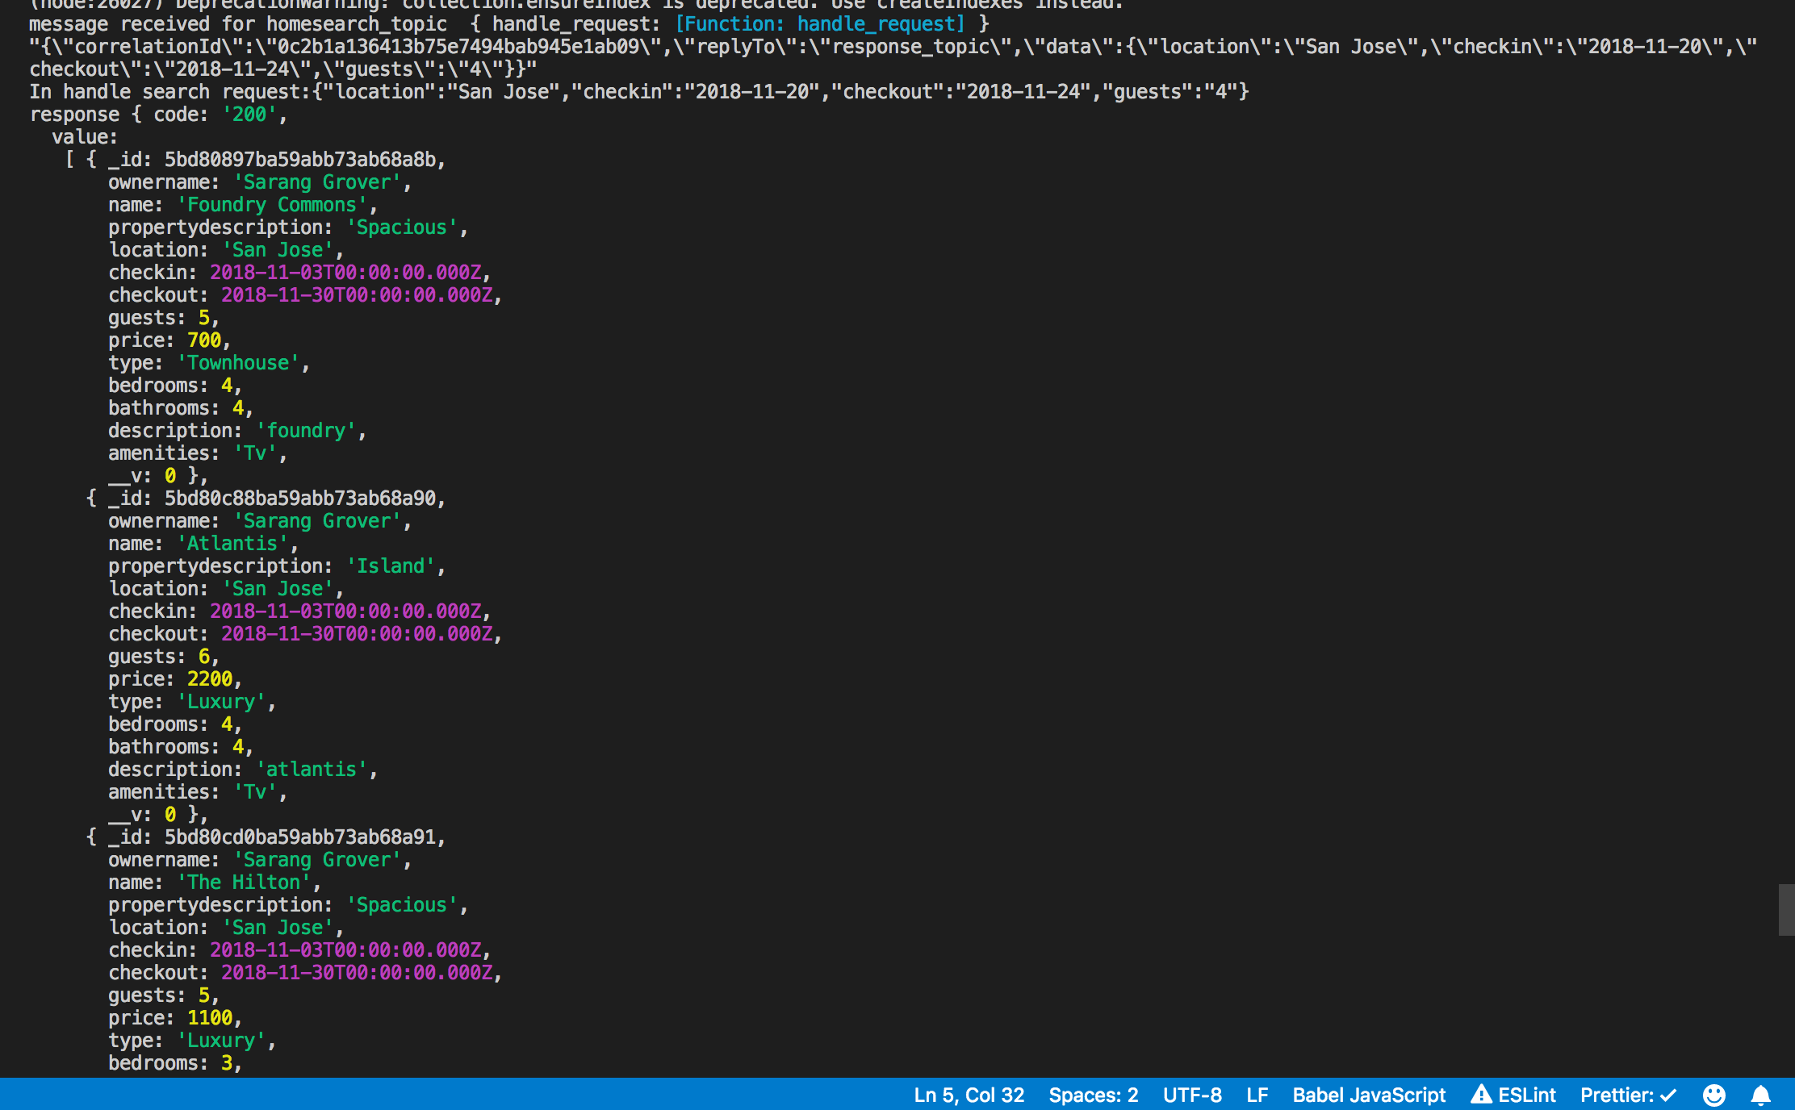

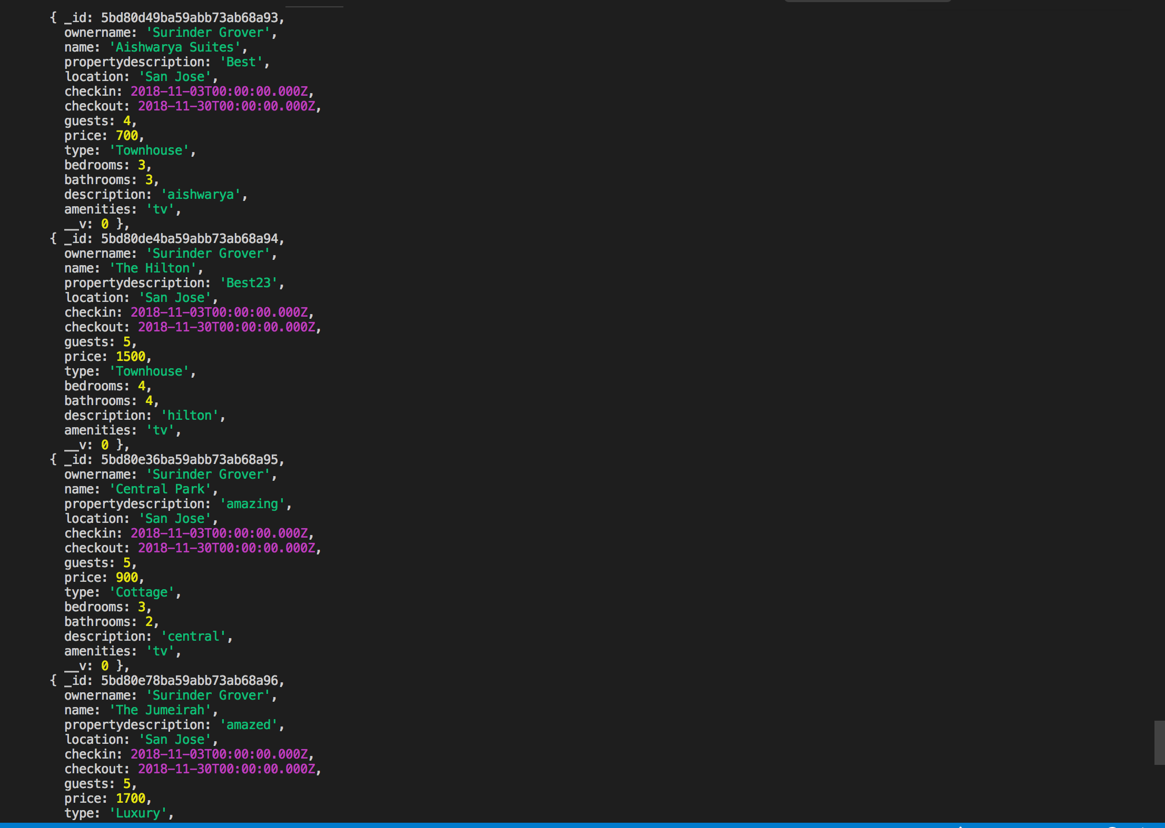

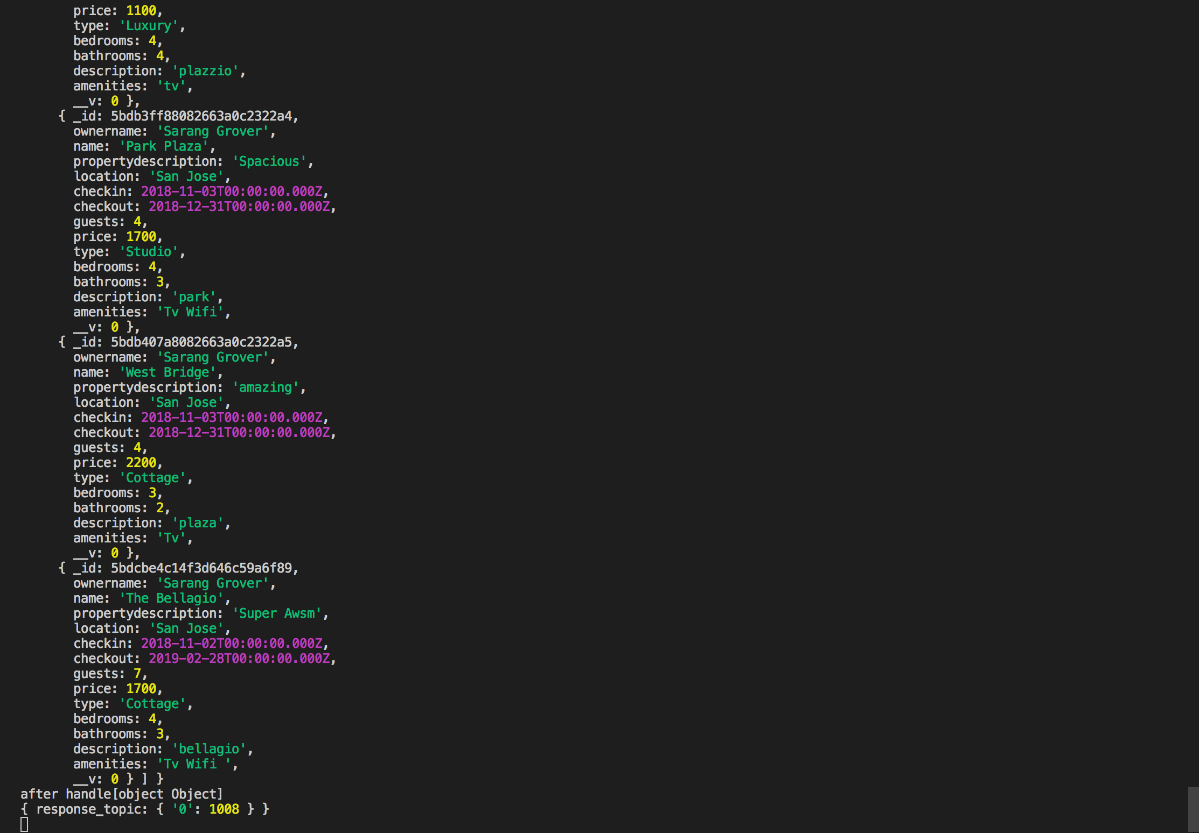

**Node Backend –**

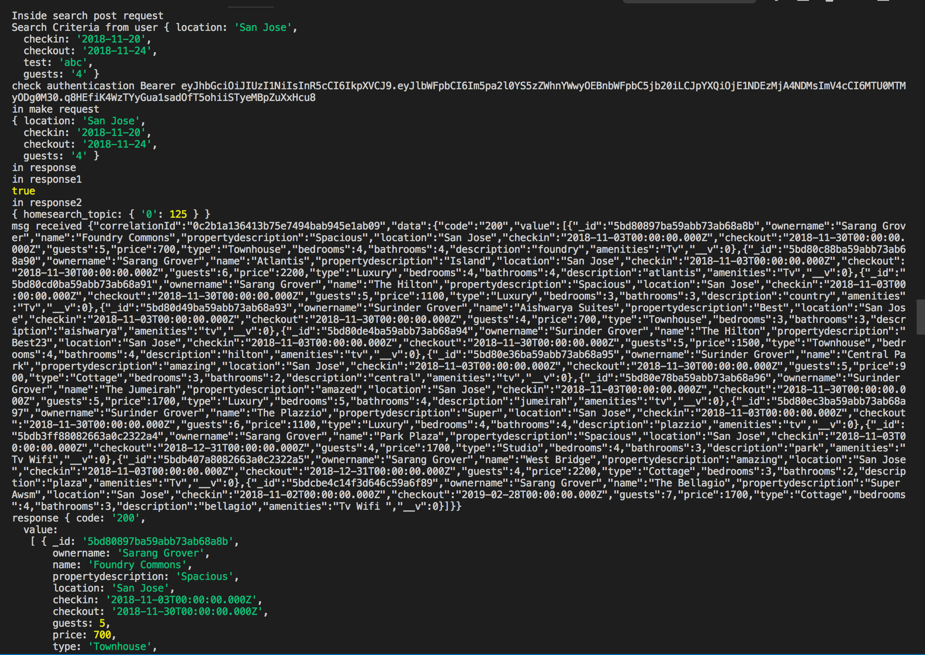

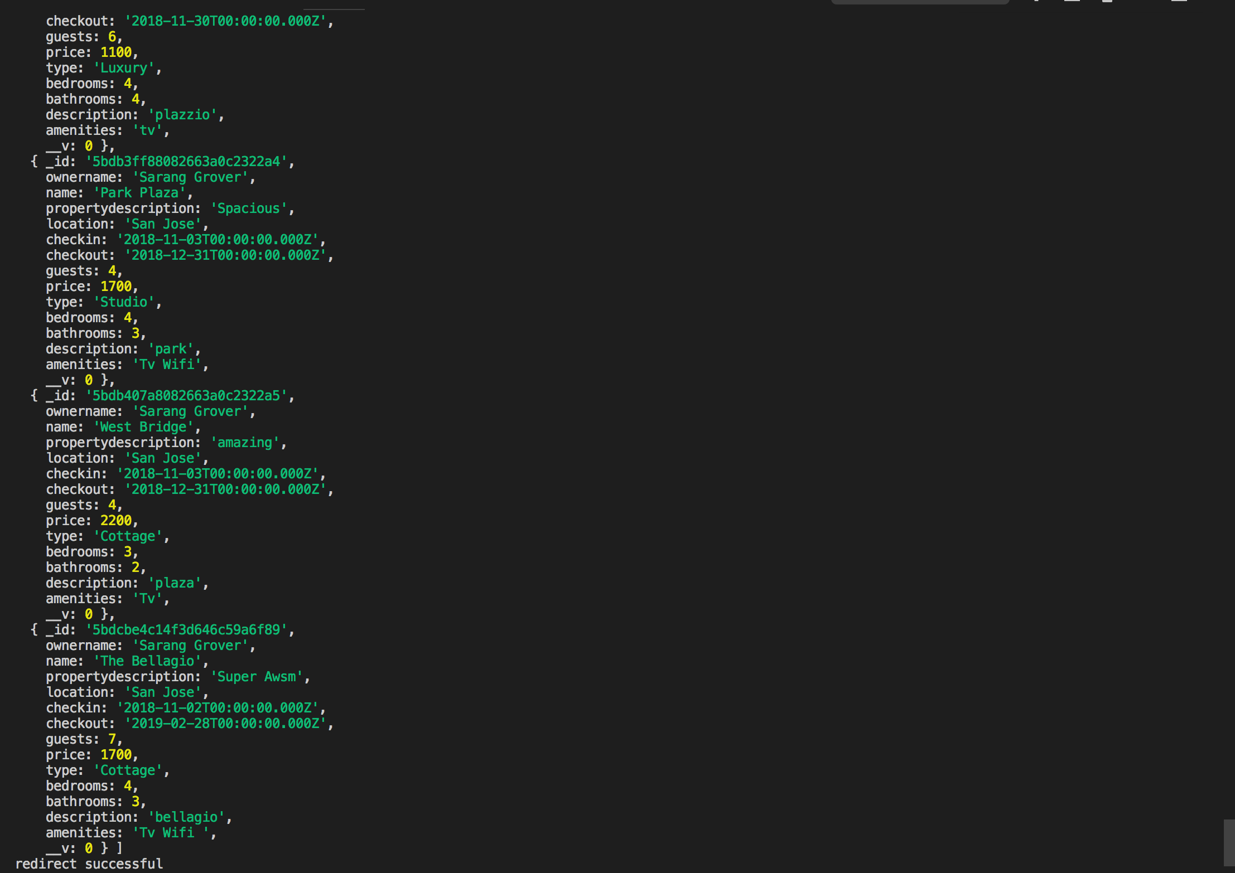

**Redux state with all the properties –**

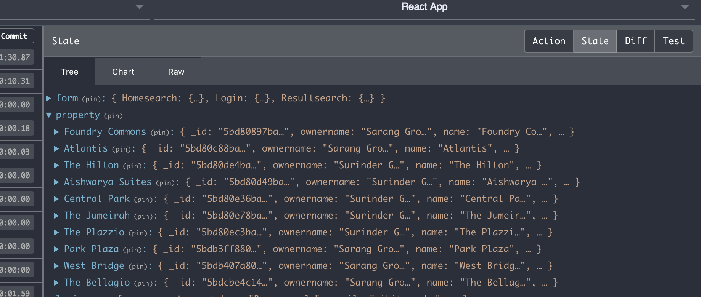

**Filtered by price : (With price less than 1685 only 5 properties came)**

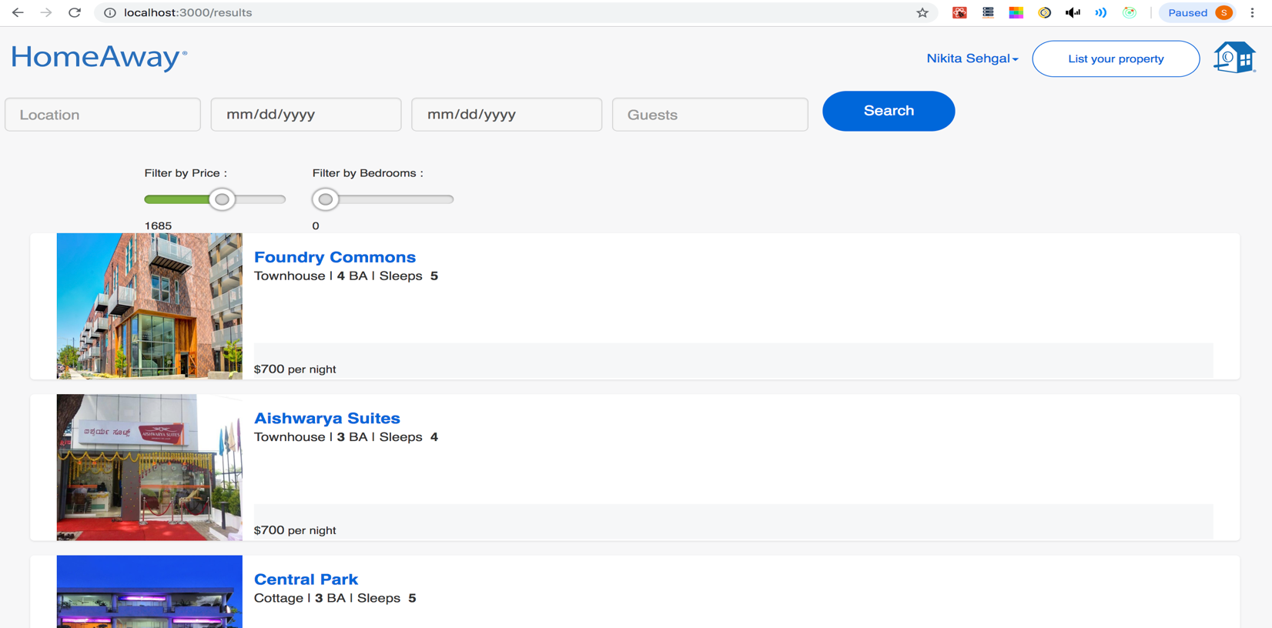

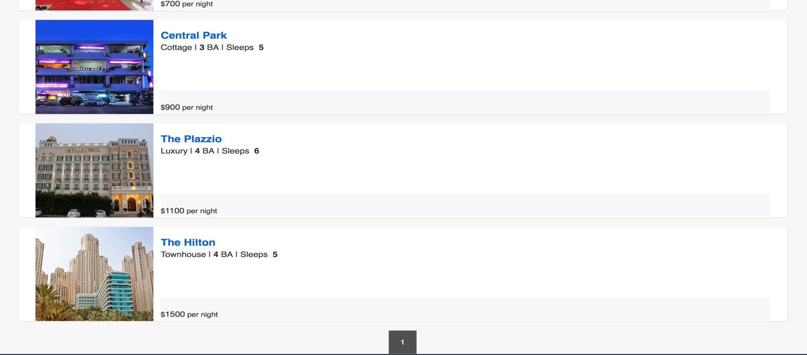

**Filtered by bedroom : (With bedroom less than equal to 3)**

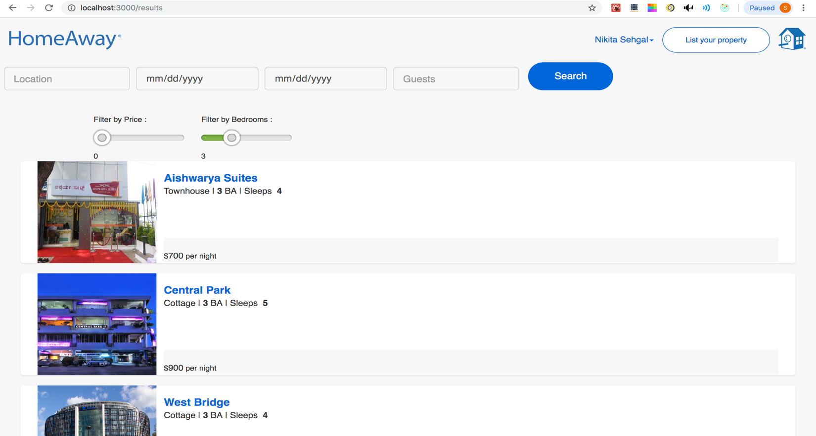

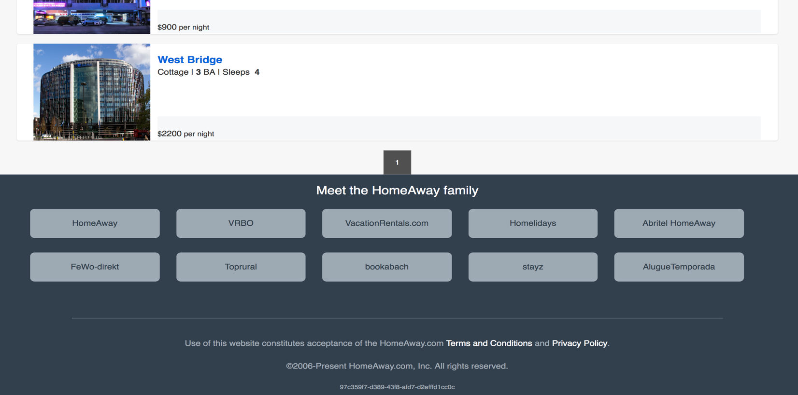

**User Clicked on a Property to book -**

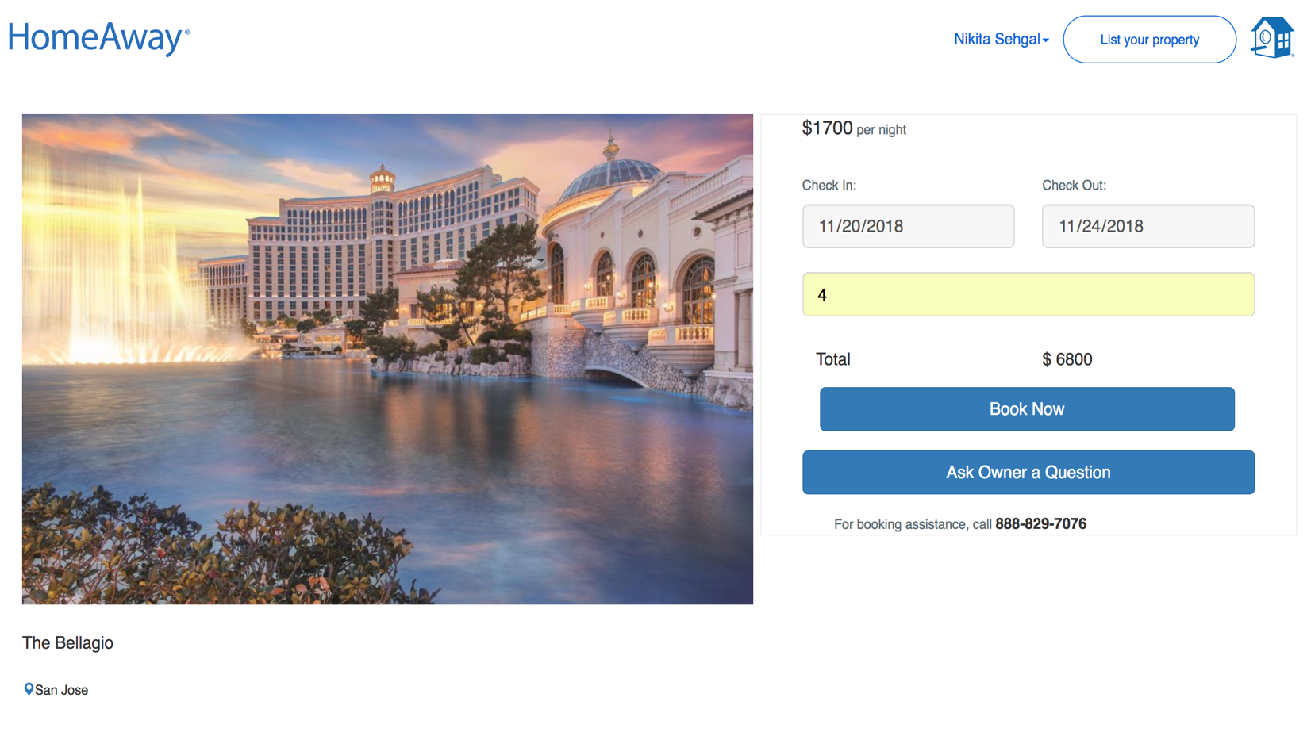

**Validations using Redux Form –**

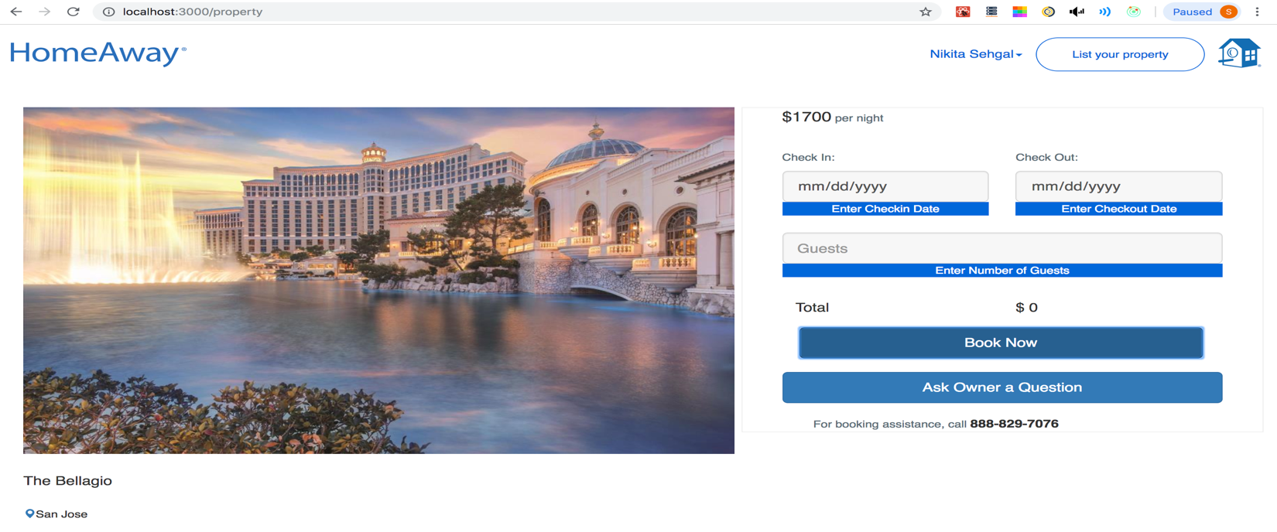

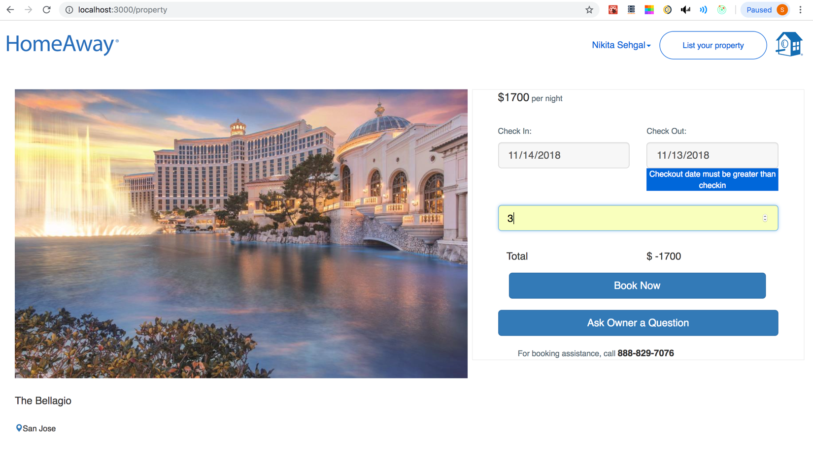

**Property Booked: User clicked on Book now with correct dates**

Kafka Backend

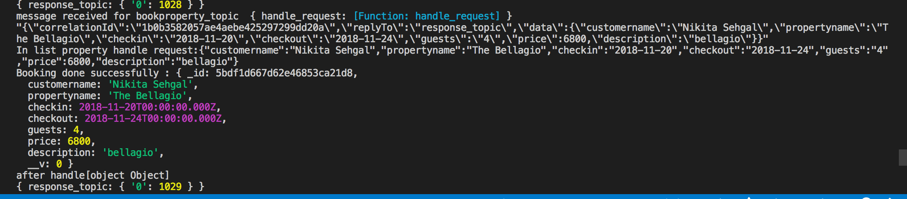

Node Backend-

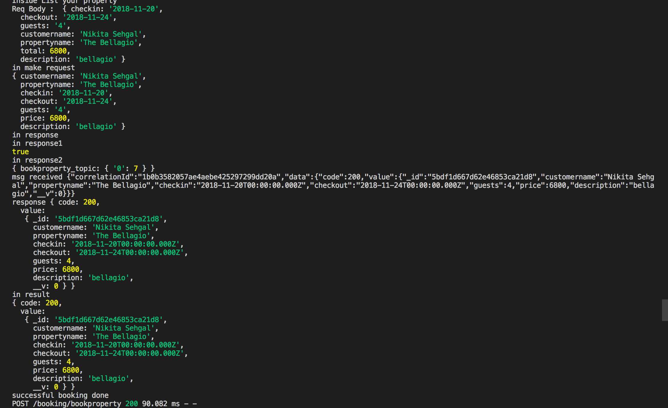

**e) Travel Dashboard**

Customer has booked the property. It will appear in the dashboard. The dashboard will display current booking along with 6 previous bookings to demonstrate the pagination property.

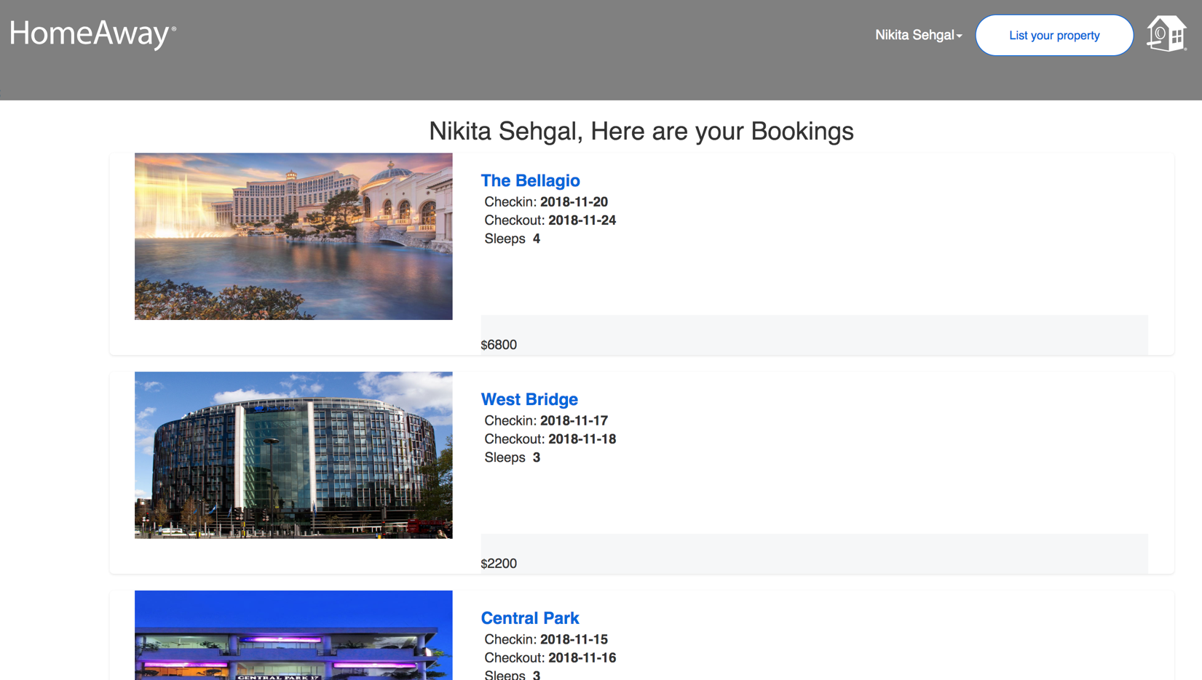

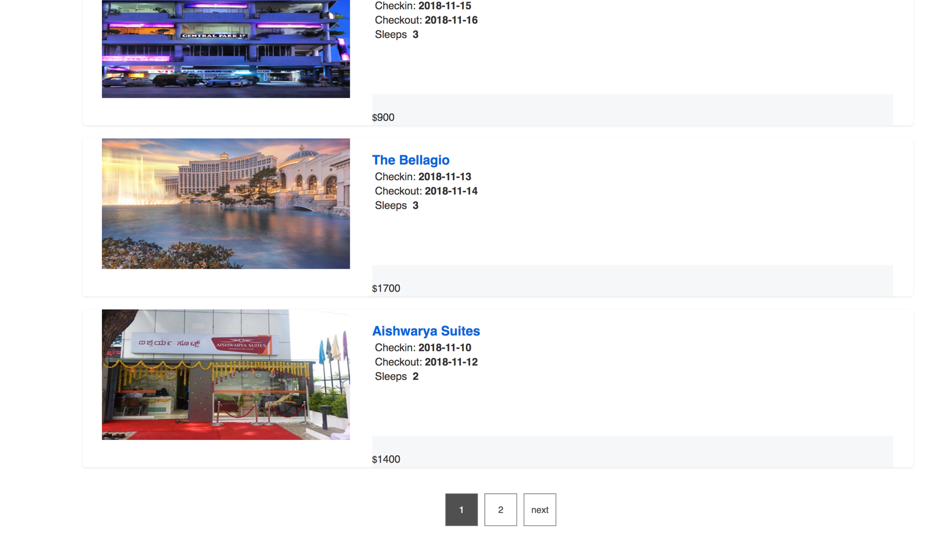

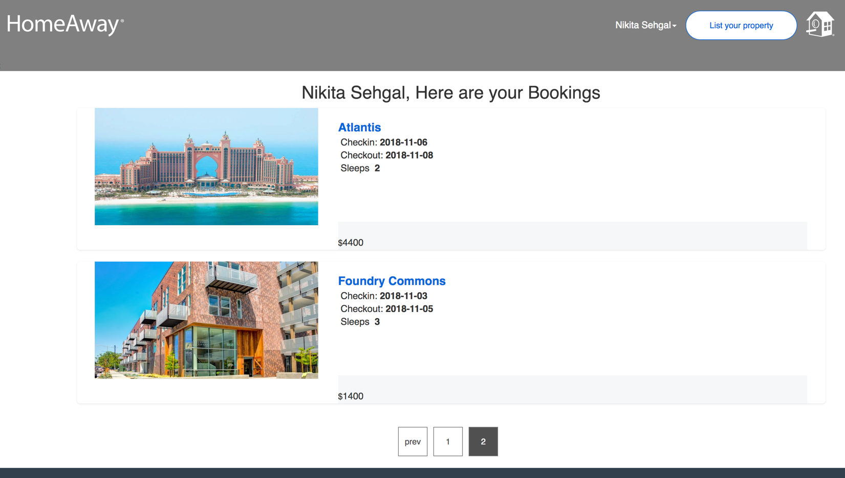

Kafka backend –

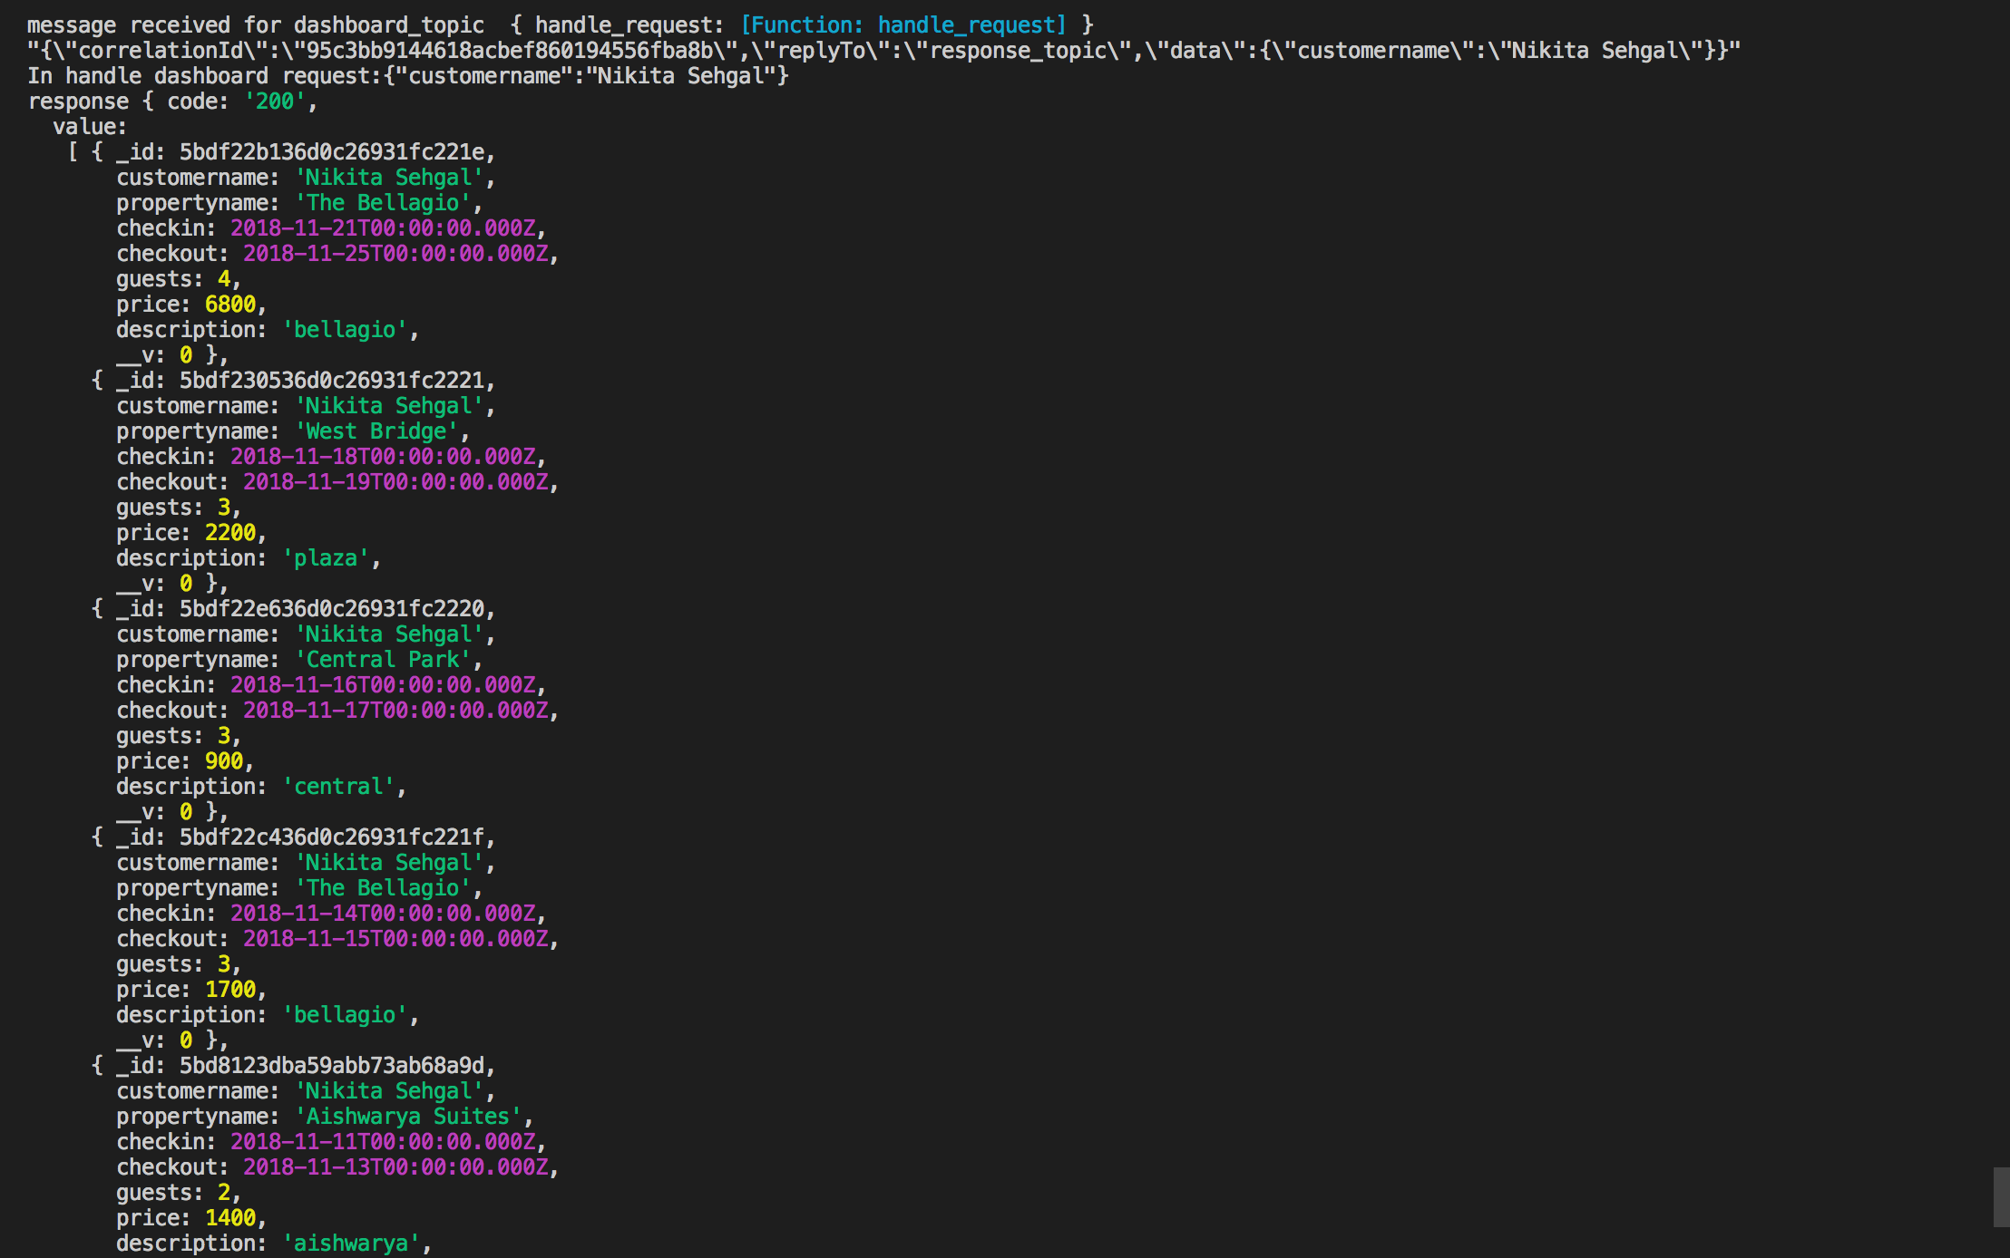

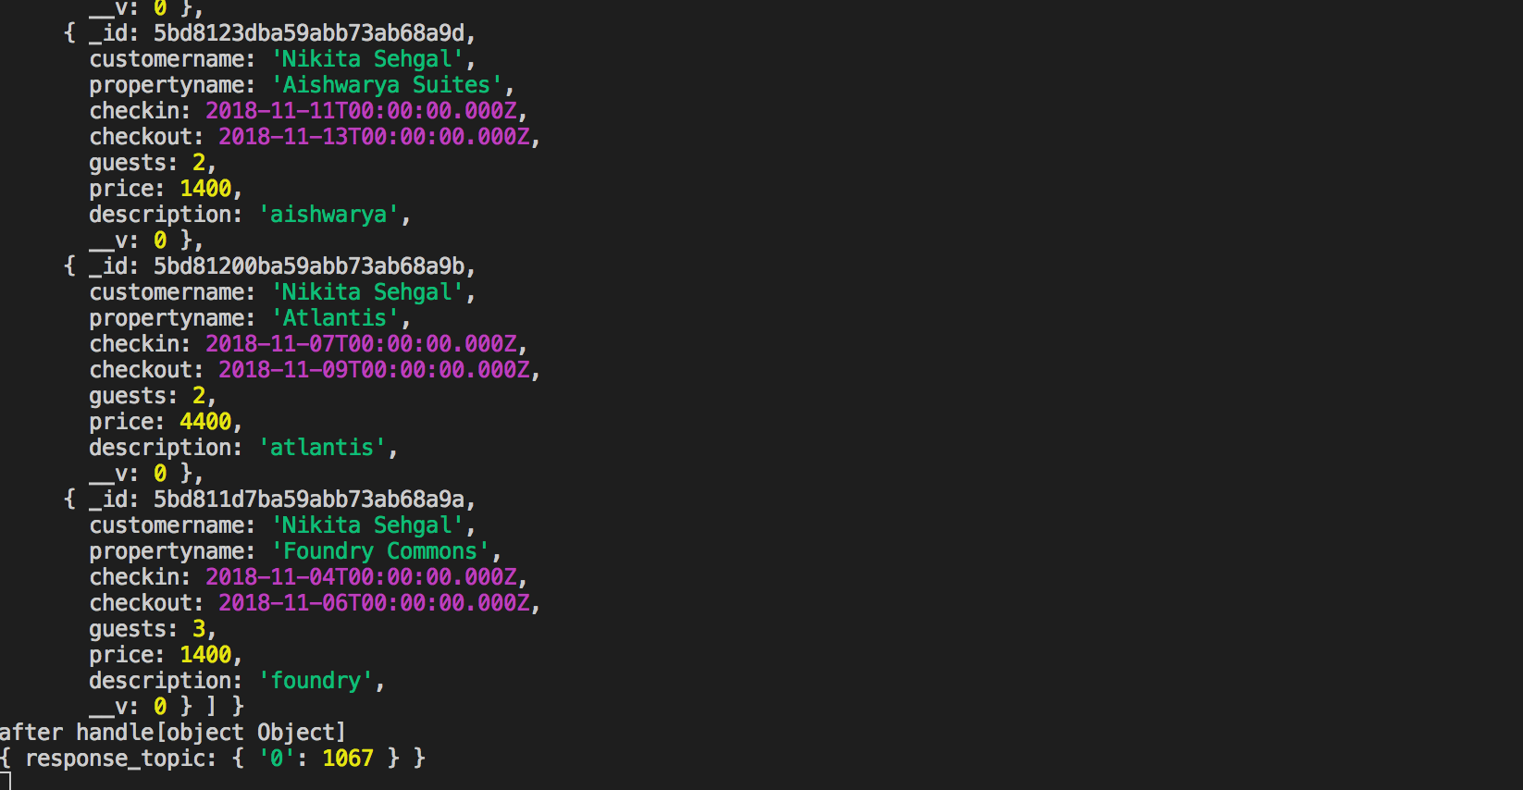

Node Backend –

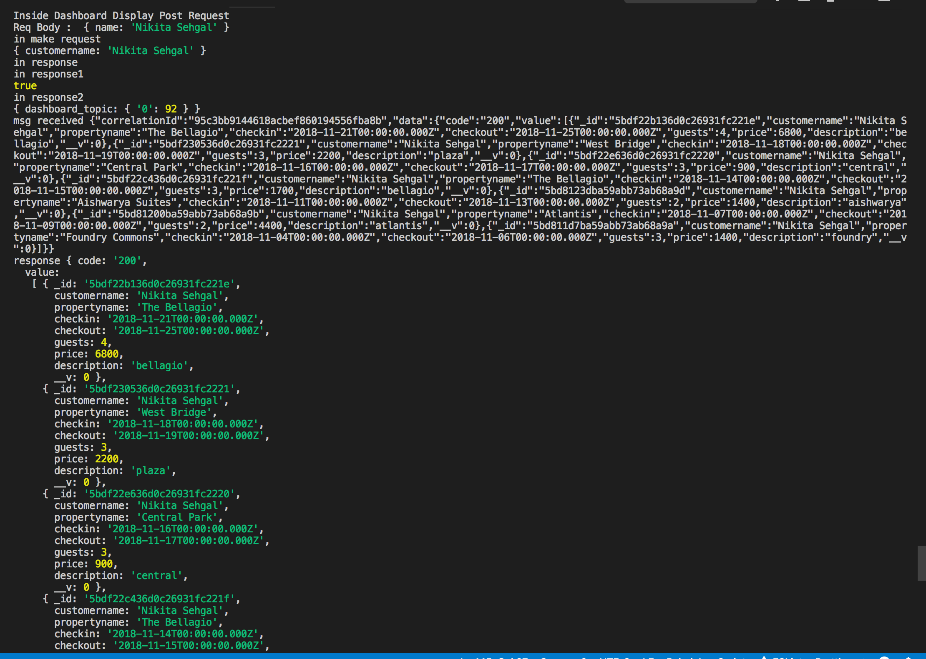

**Redux state containg all the bookings of traveler -**

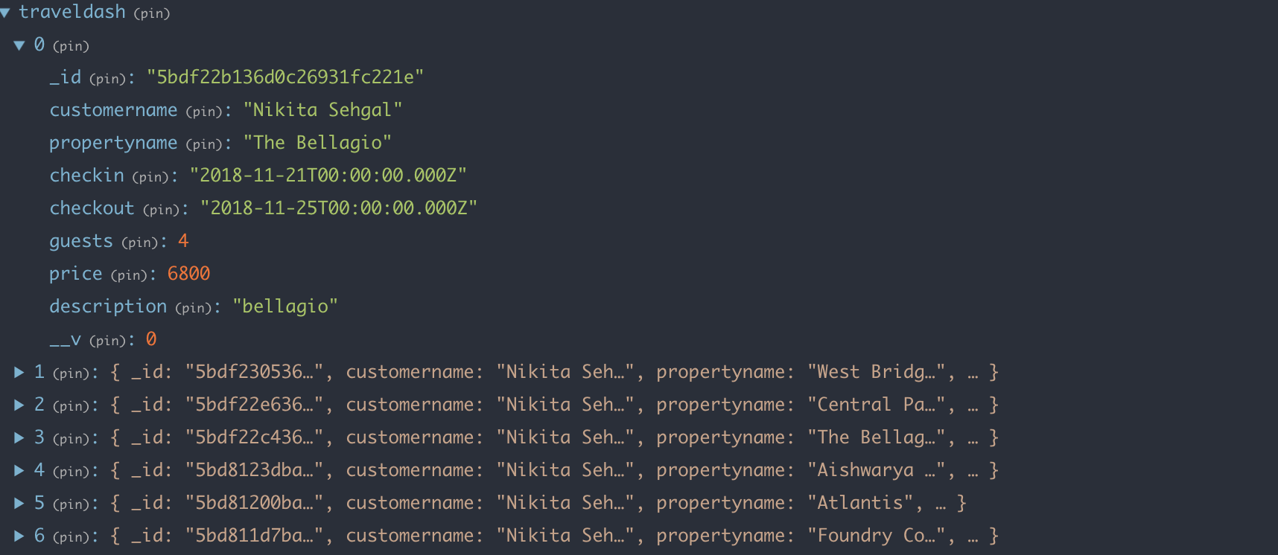

**f) Traveler can message owner regarding the property and owner can reply –**

Traveler clicks on Ask Owner a question and sends his query.

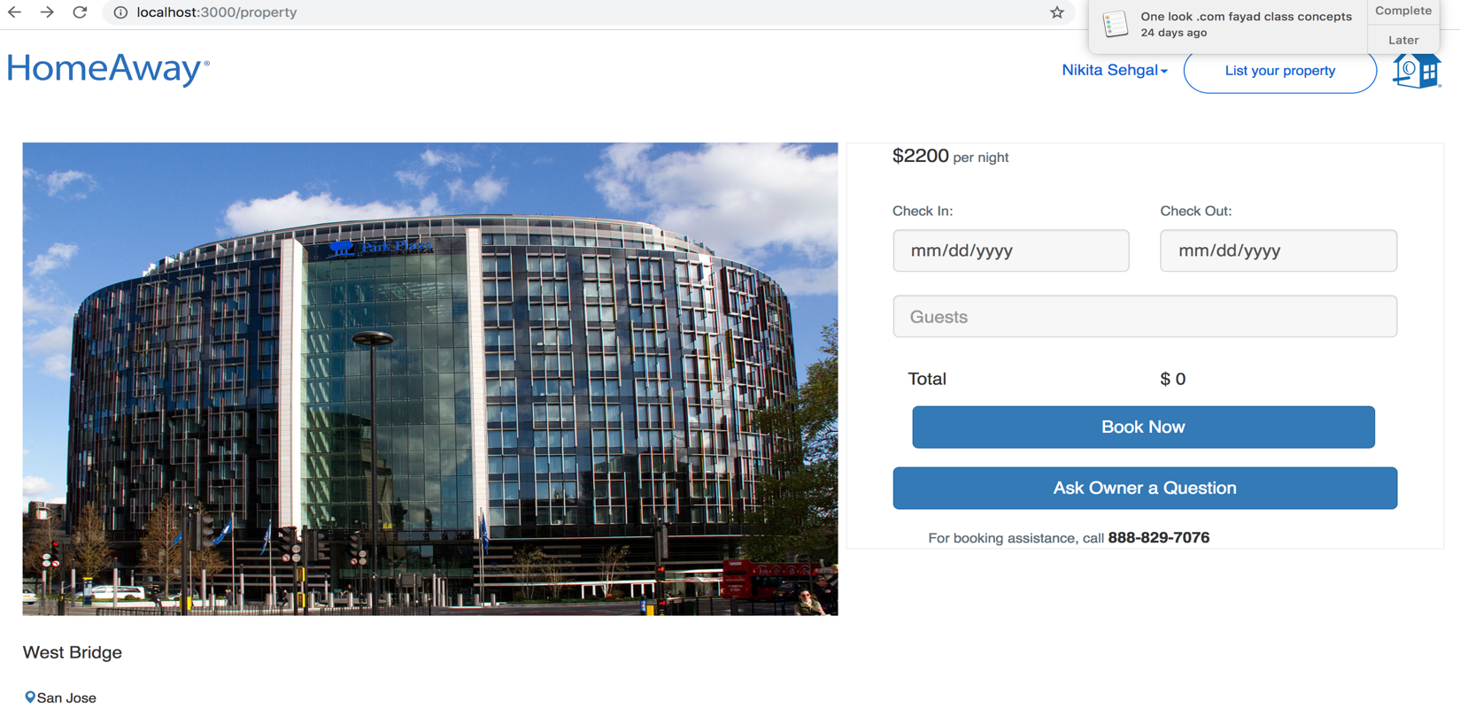

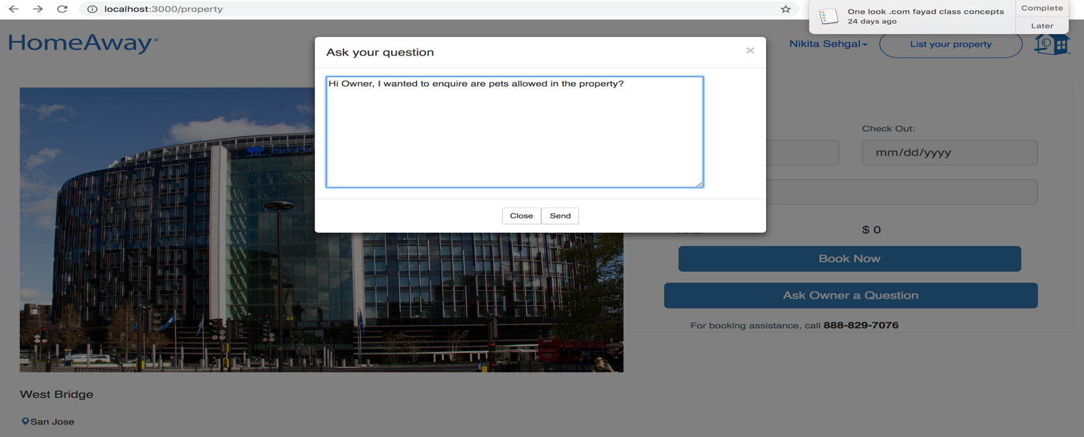

Kafka Backend –

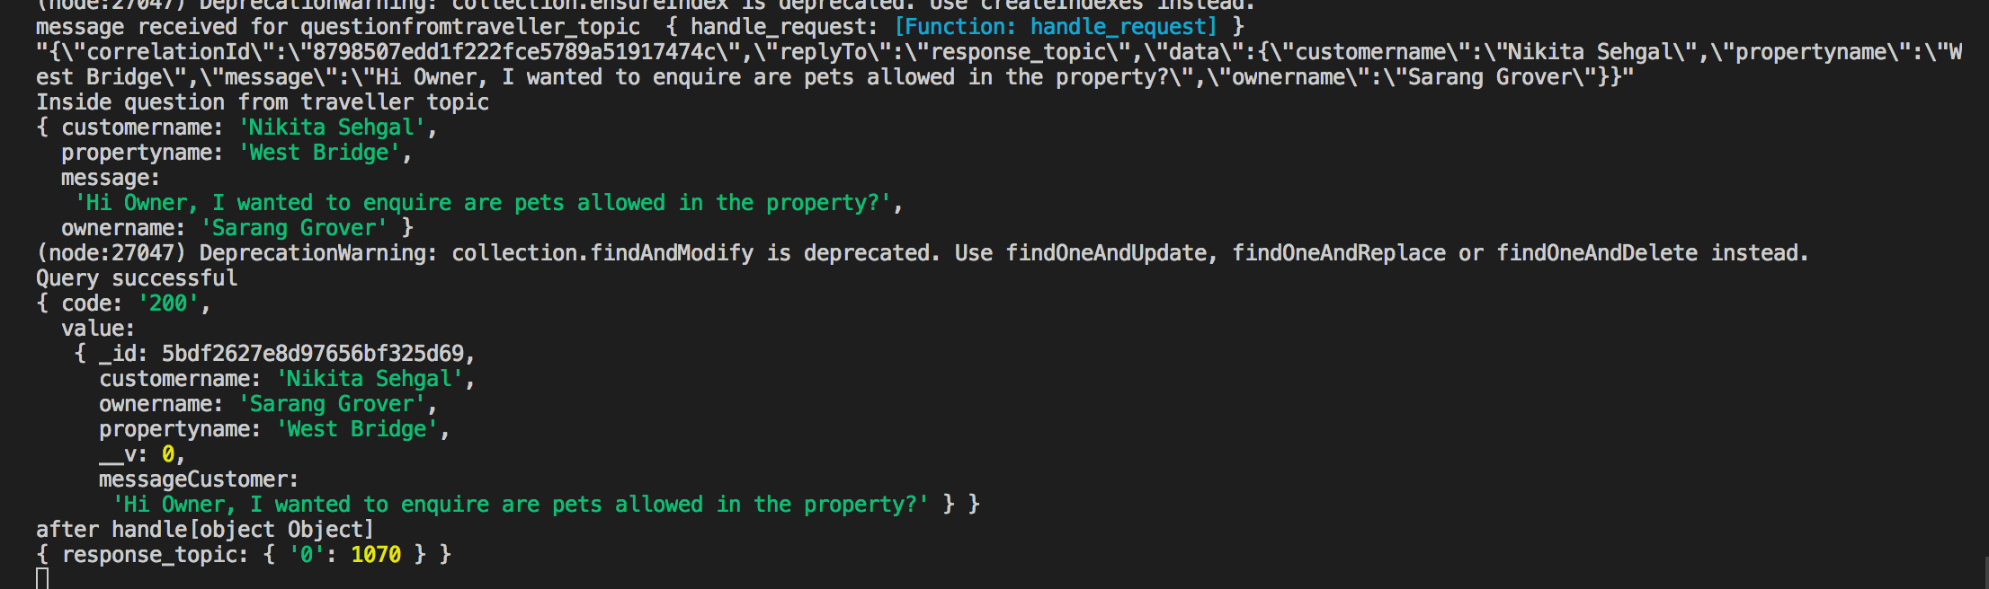

**Node Backend**

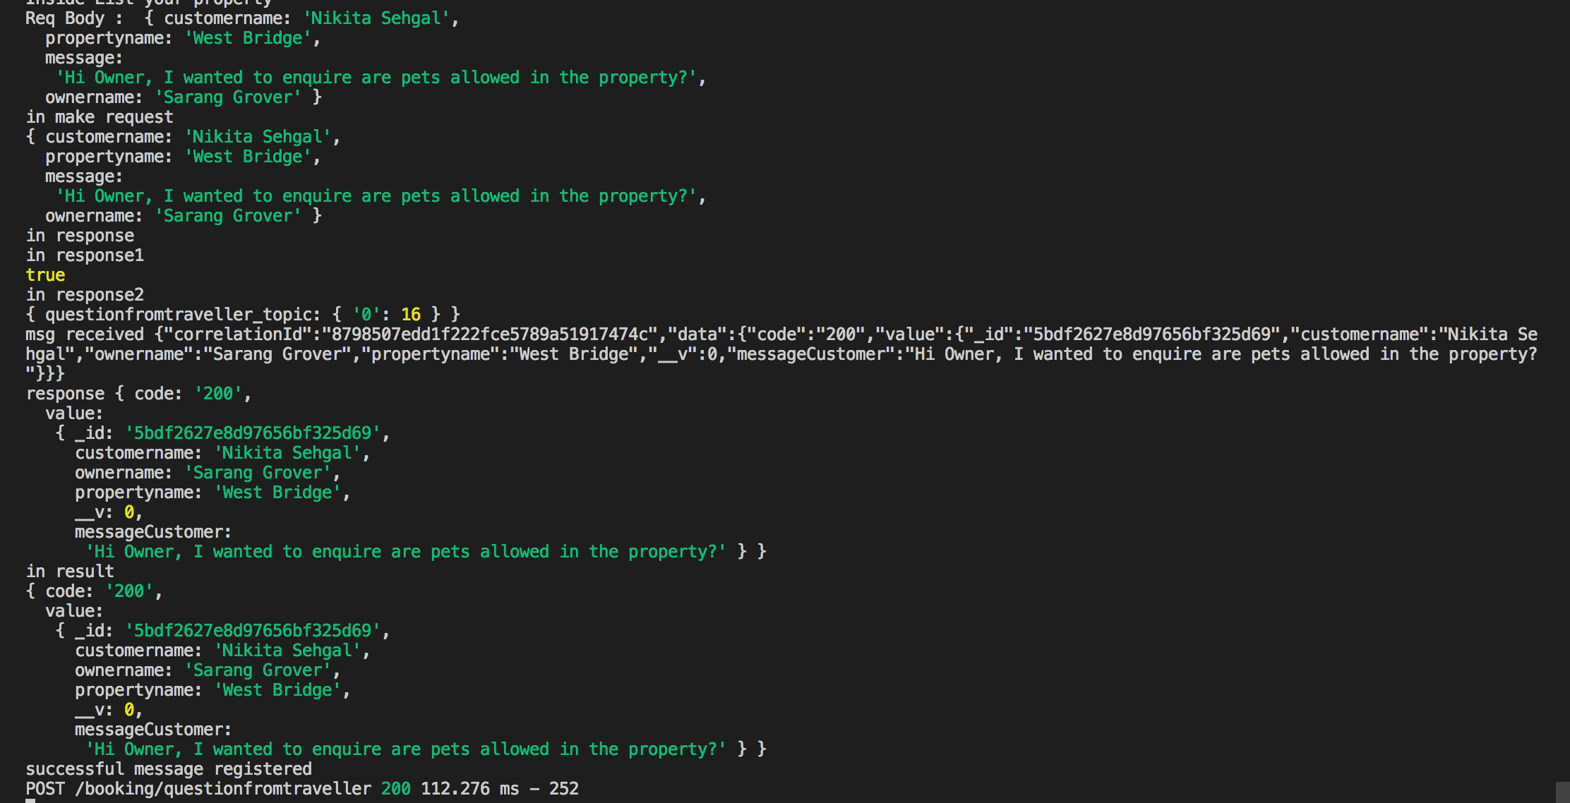

**The message comes in Owner inbox –(There is another message from another customer)**

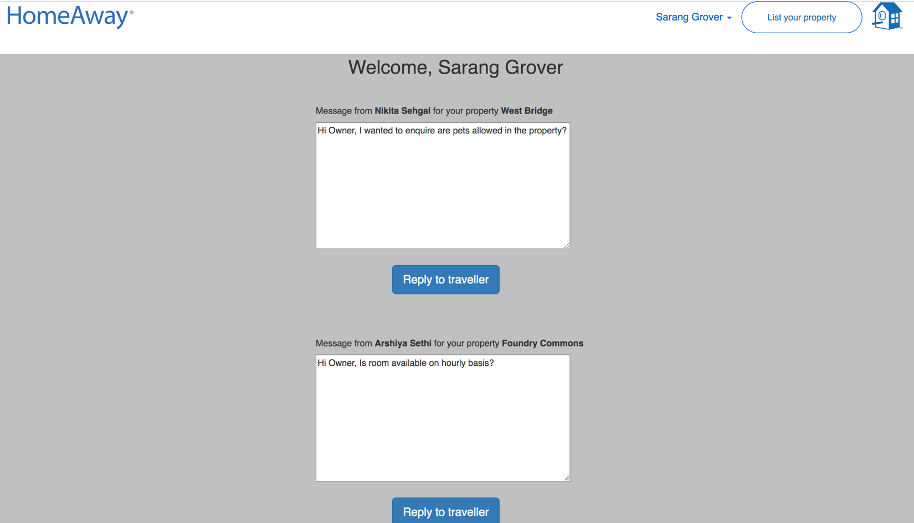

**Kafka Backend-**

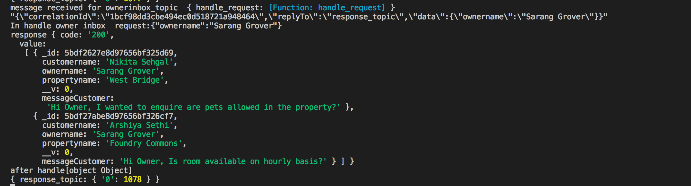

**Node Backend-**

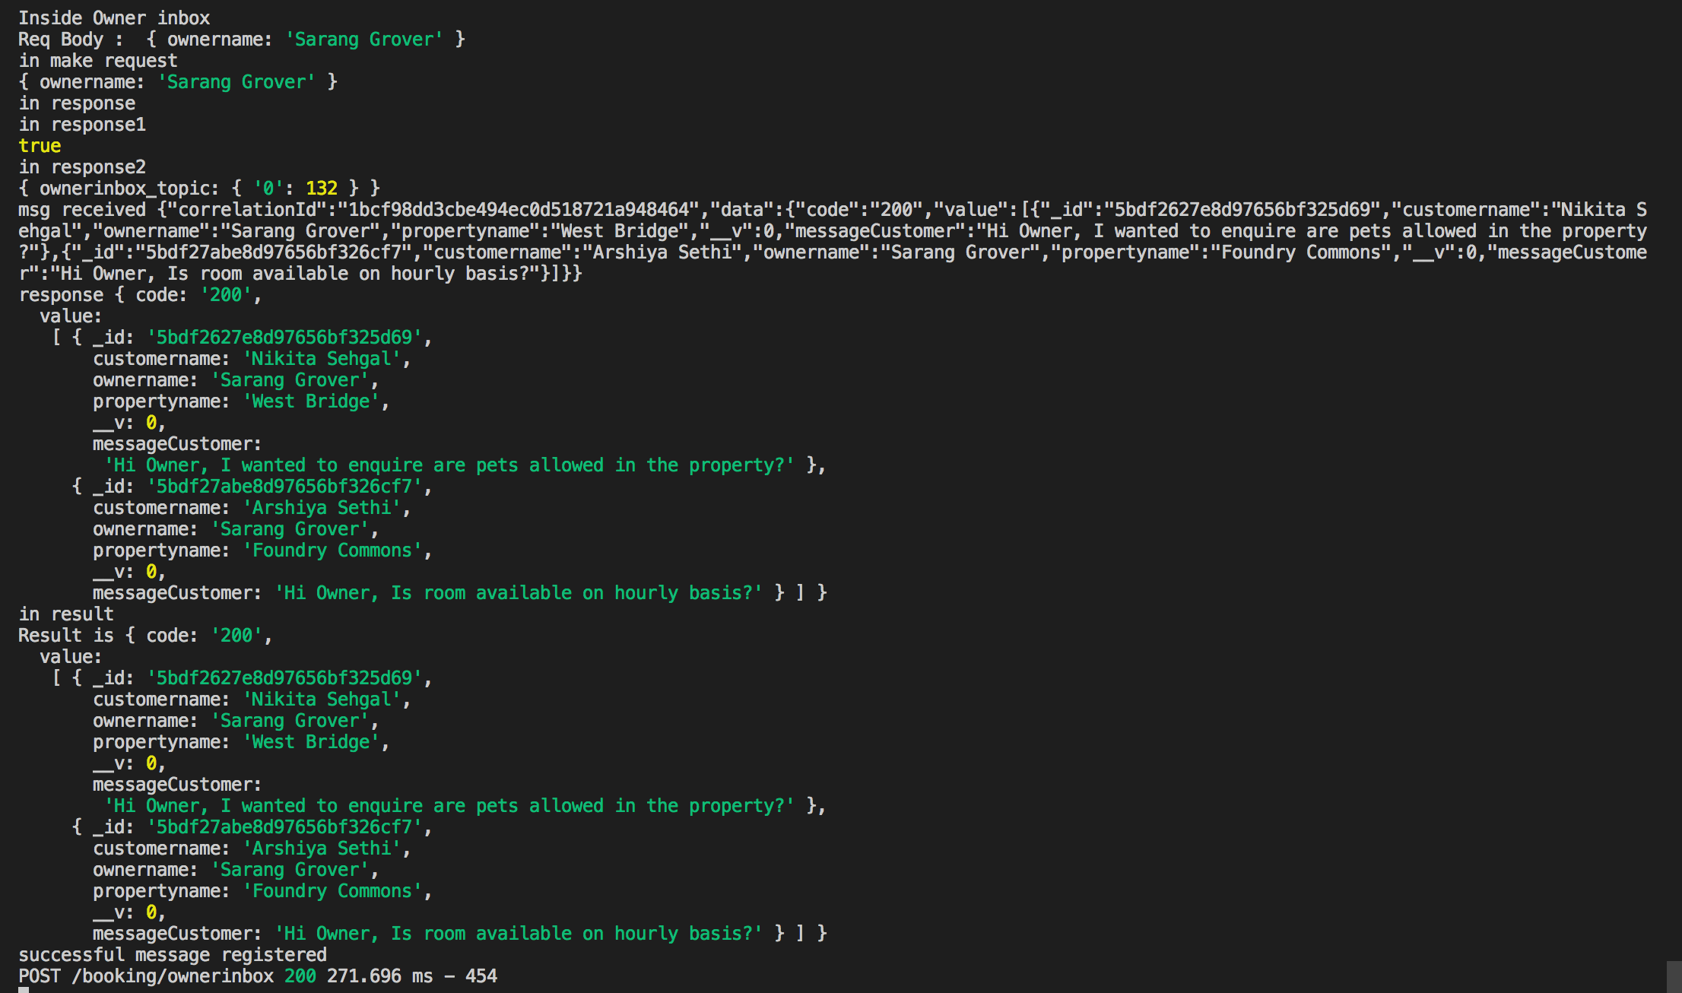

**Owner clicks on reply button and sends the reply**

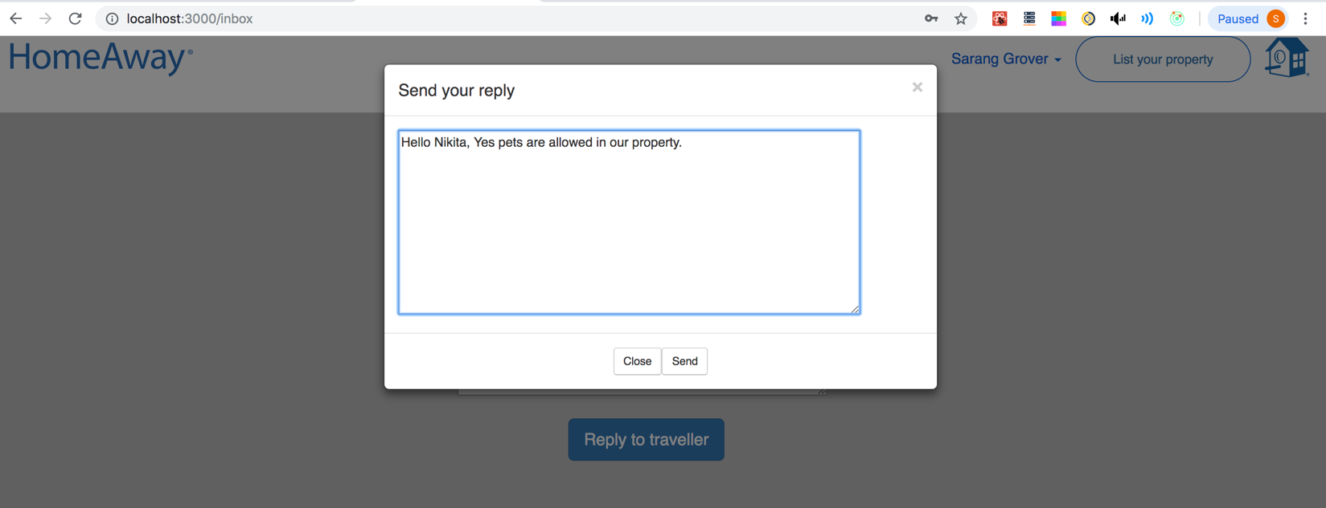

**Kafka backend**

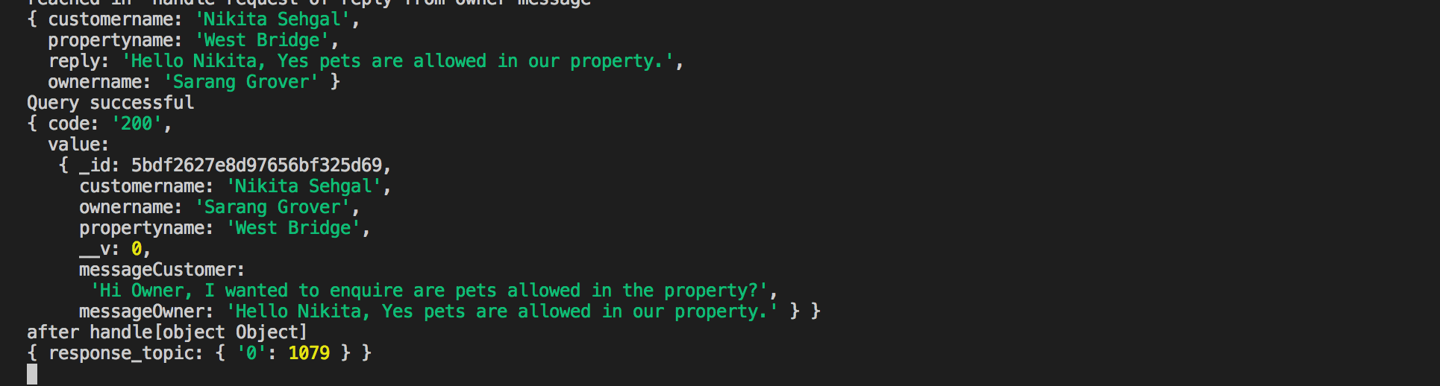

**Node Backend**

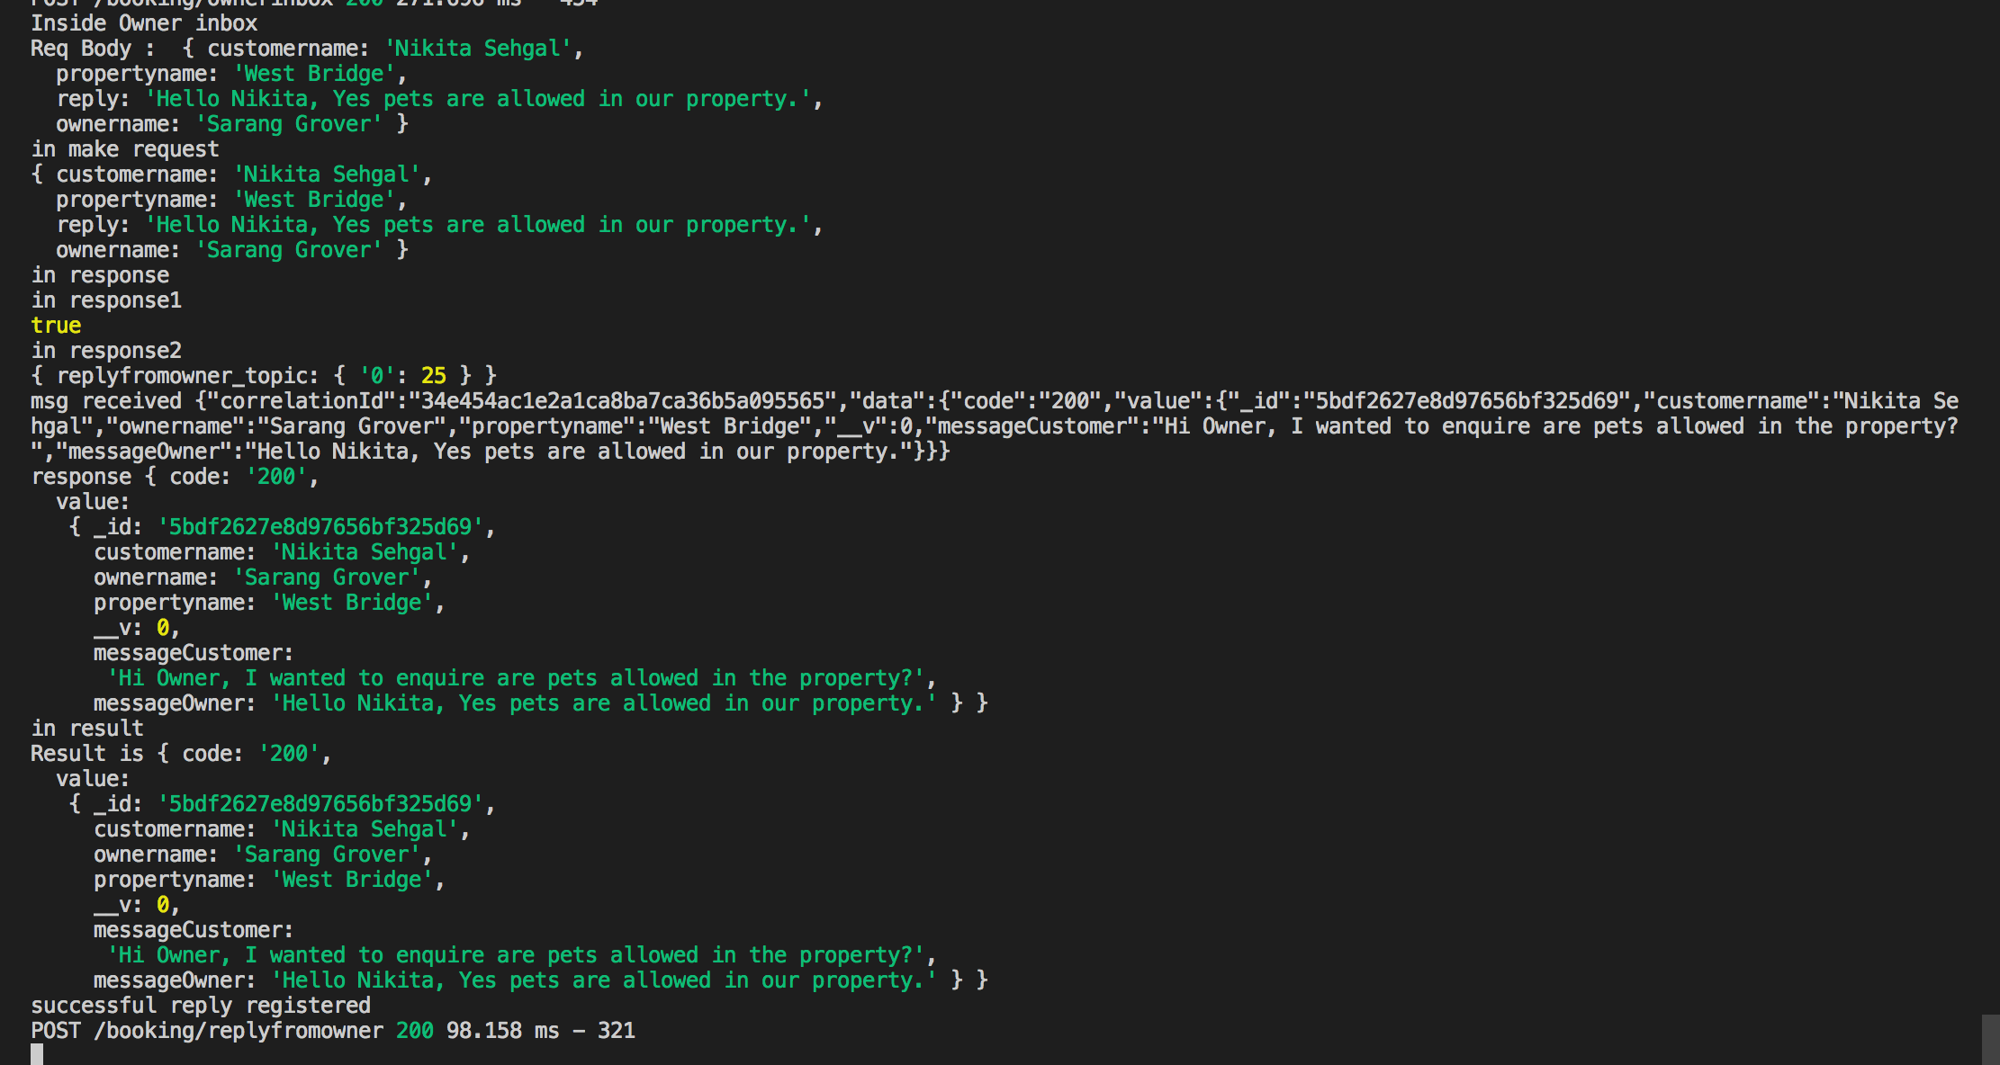

**Traveller can see the reply in the traveler inbox-**

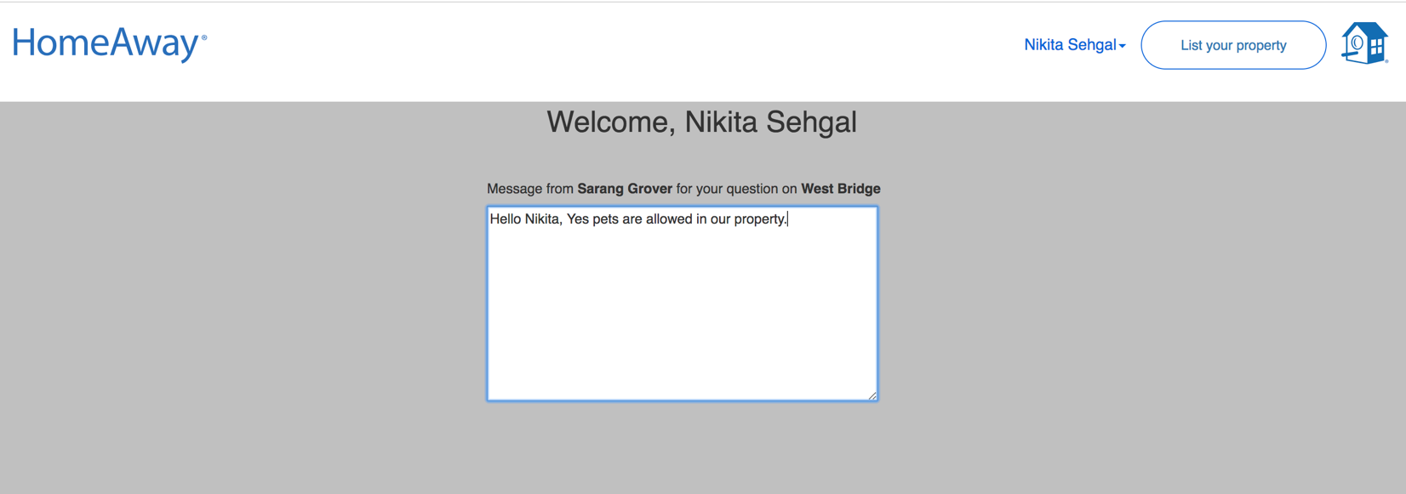

**Kafka backend-**

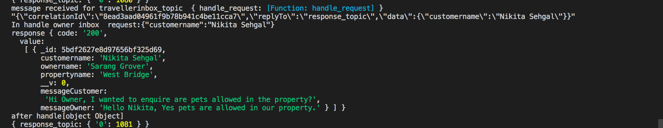

**Node Backend**

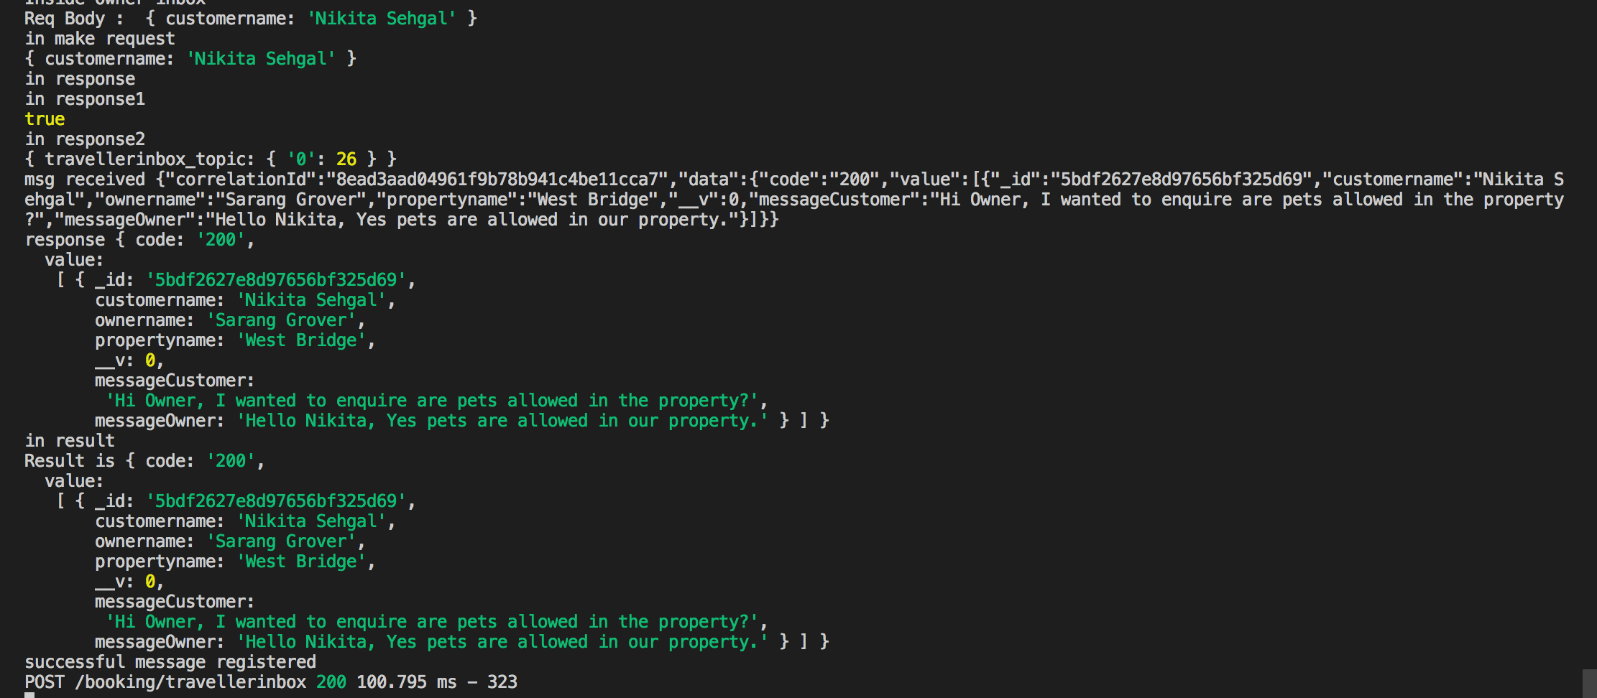

**g) User can update profile and account**

Initial Information--

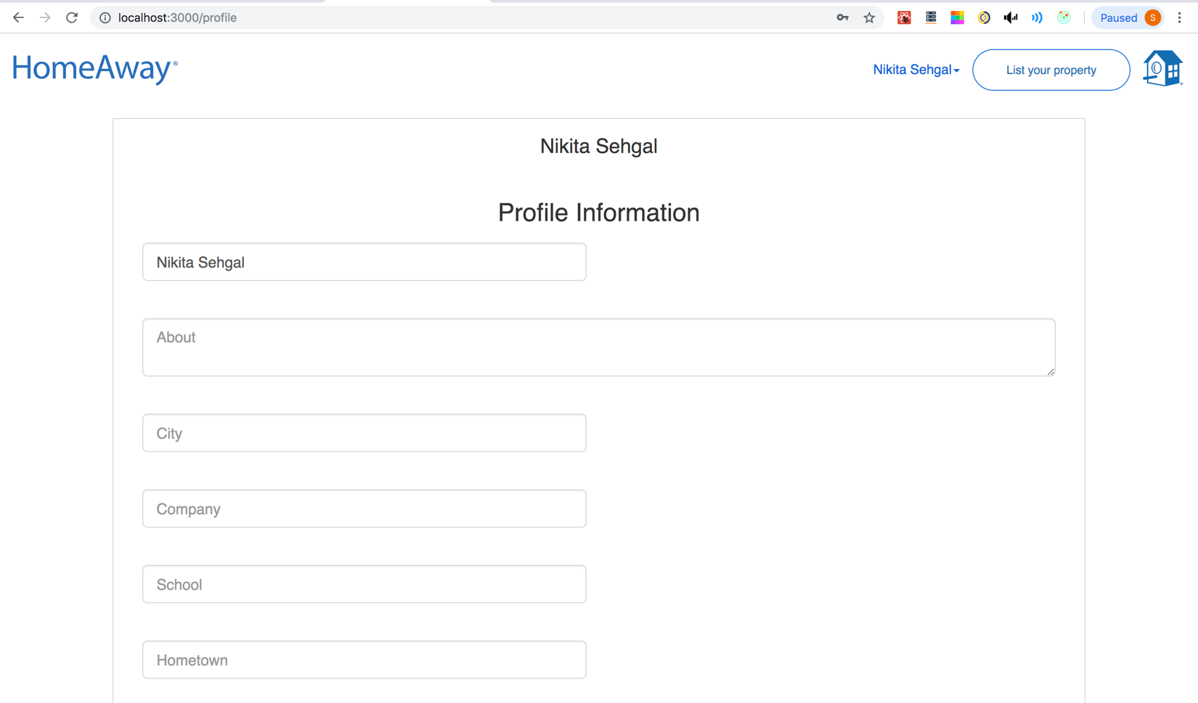

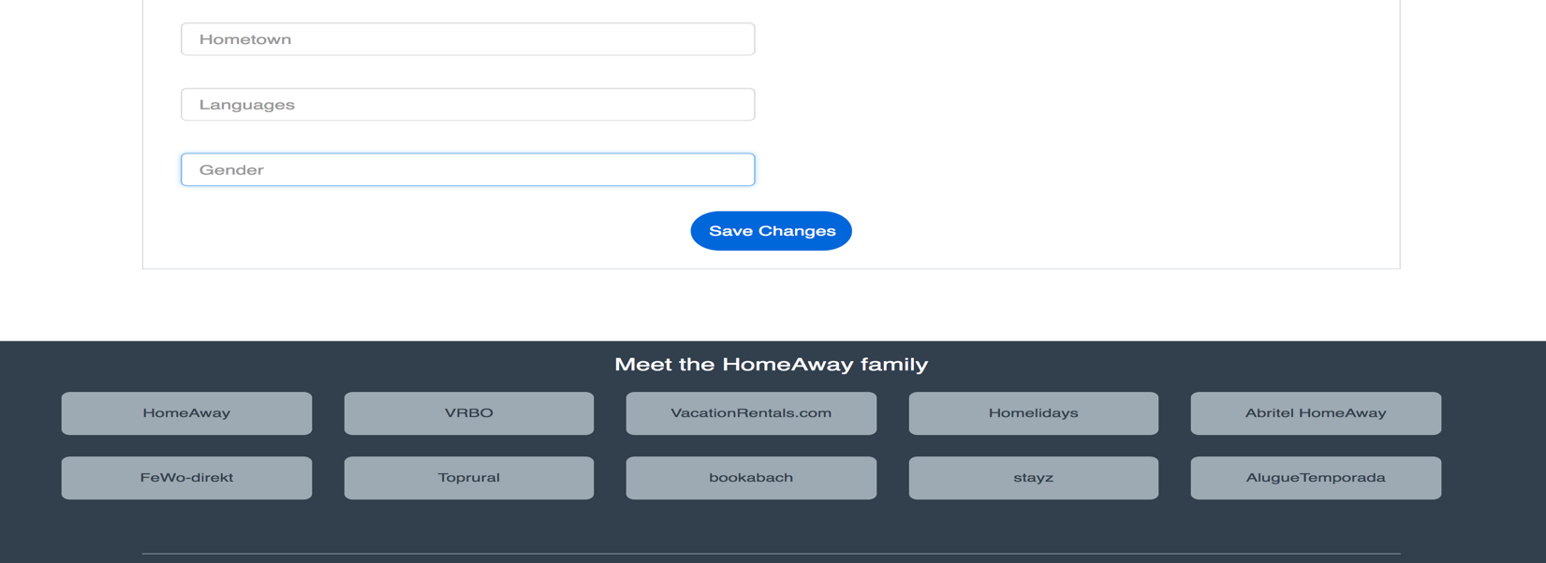

User Updating Information and and clicked on Save changes –

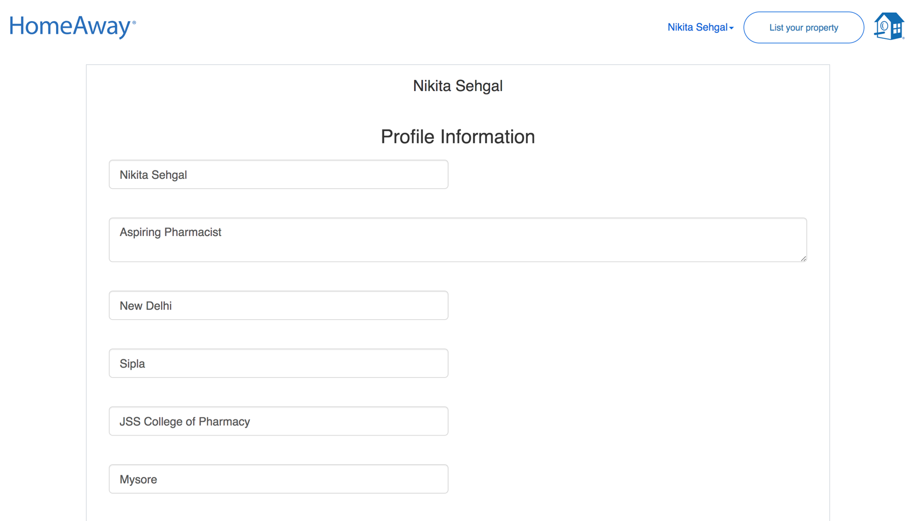

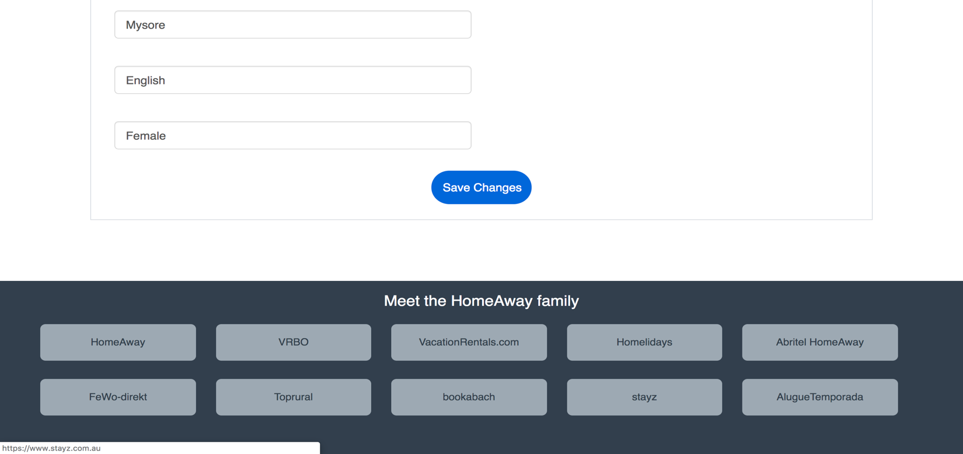

Profile Updated –

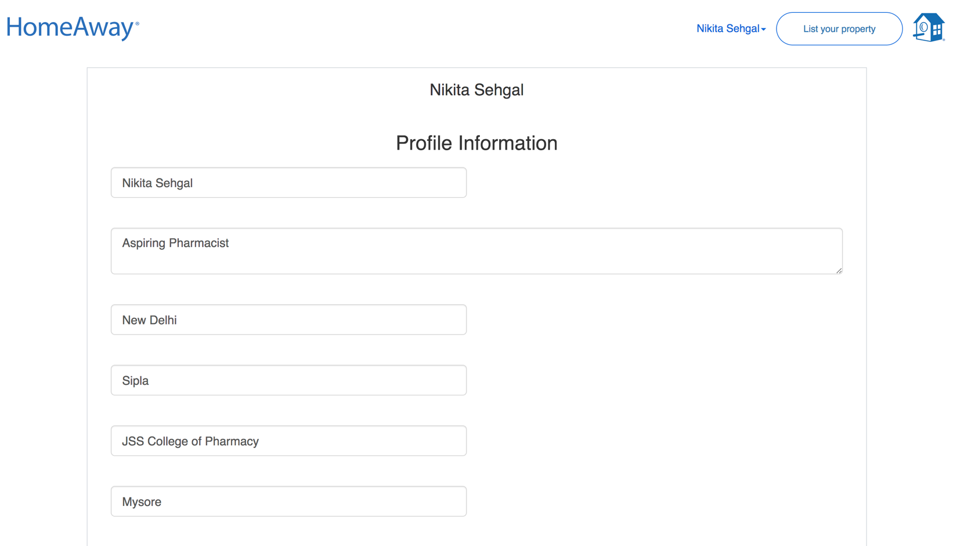

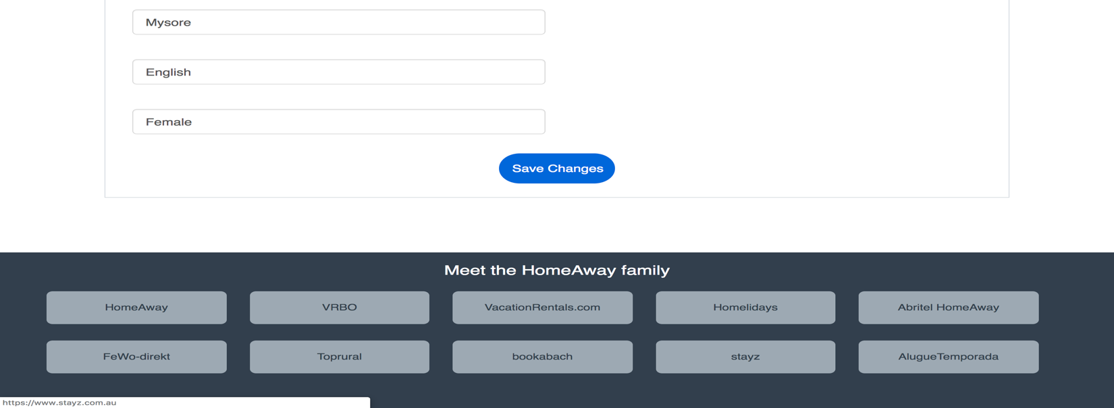

Kafka Backend-

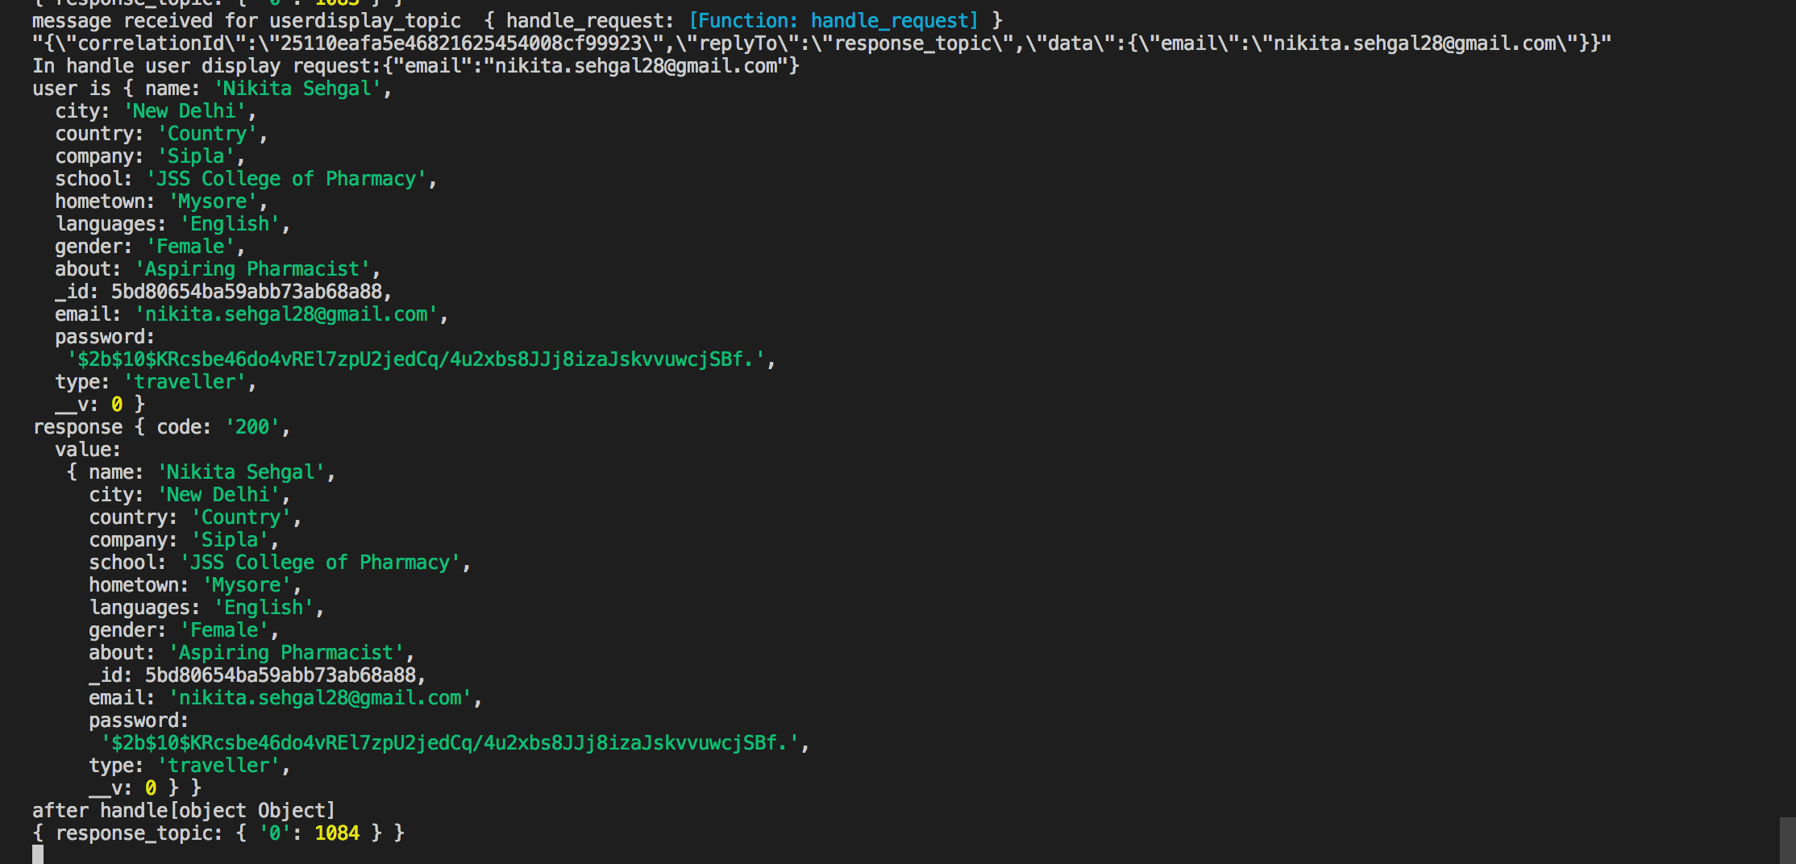

Node Backend –

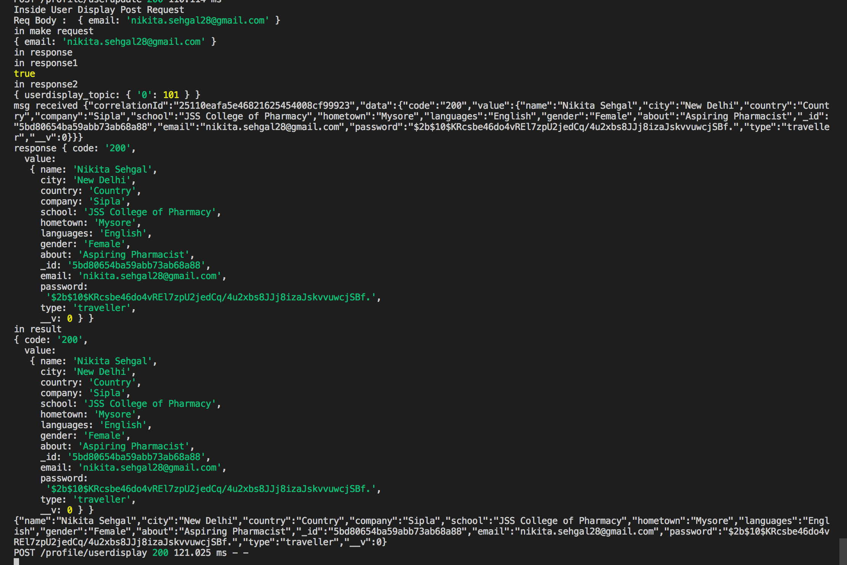

**h) Traveler wants to List a Property (Will become owner)**

Traveler clicks on List your property

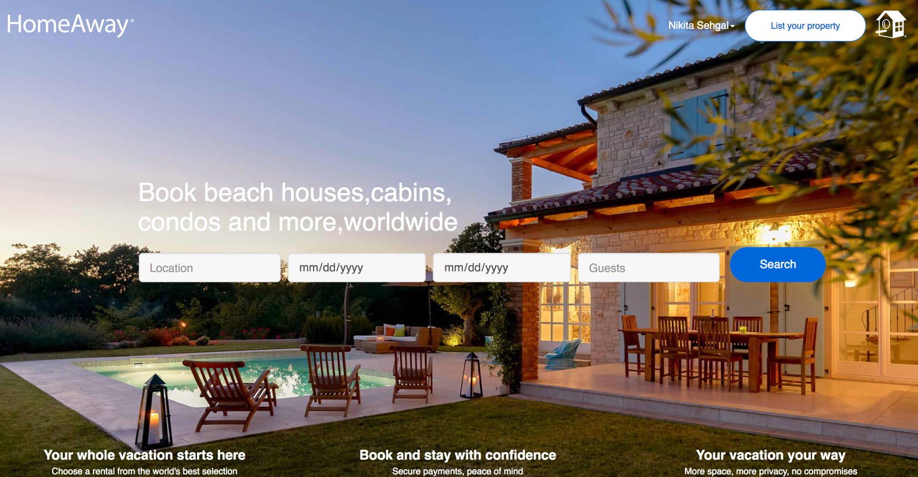

Traveler Clicks on next –

User will be asked to create an owner account. The type of user will be changed from traveler to owner. Now he can list a property and he is confirmed as an owner. An owner can both list a property and book a property whereas a traveler can only book a property.

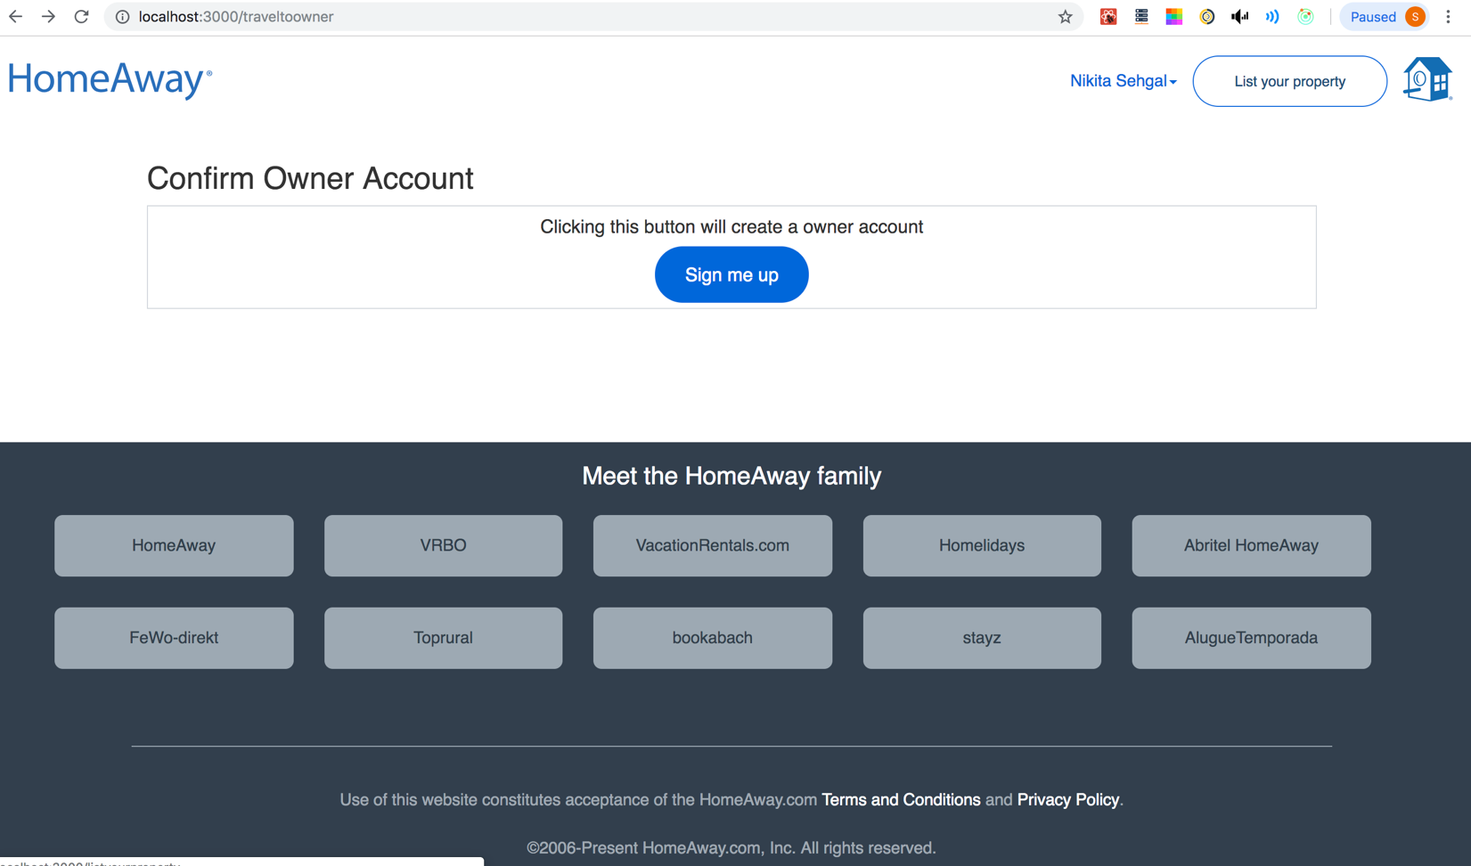

Kafka backend

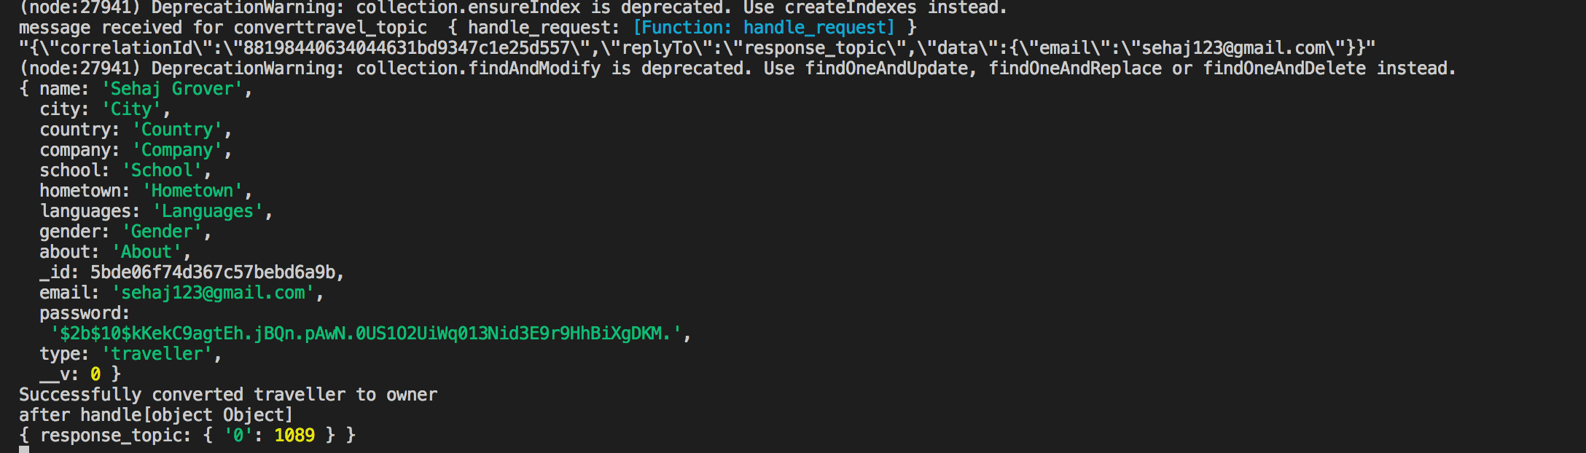

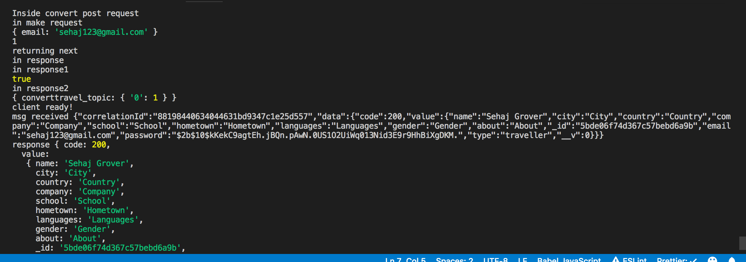

Traveler is now an Owner and he will be redirected to list a property page which is the page which opens when we also login as an owner.

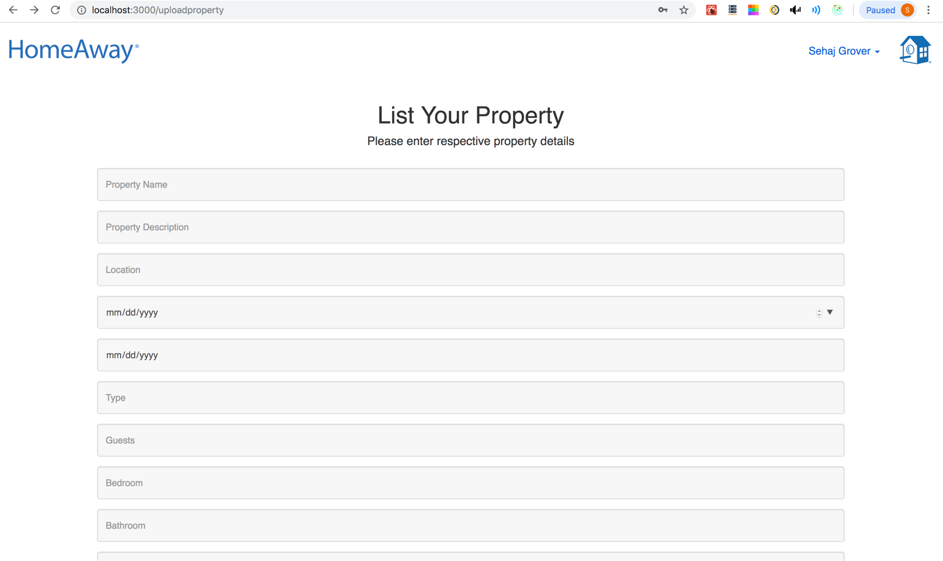

**i) Owner Signup and Login Page (If a person wants to create owner account directly. He is a traveler by default )**

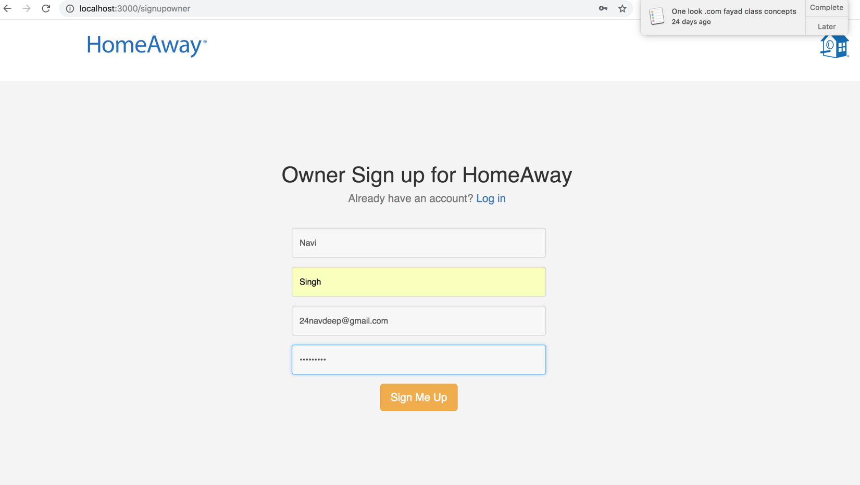

Kafka Backend –

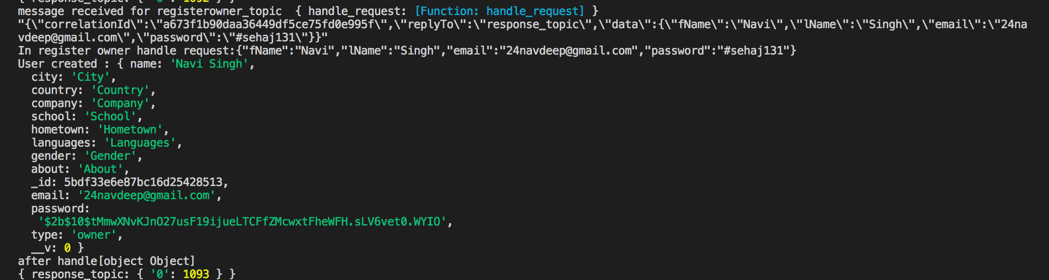

Node Backend –

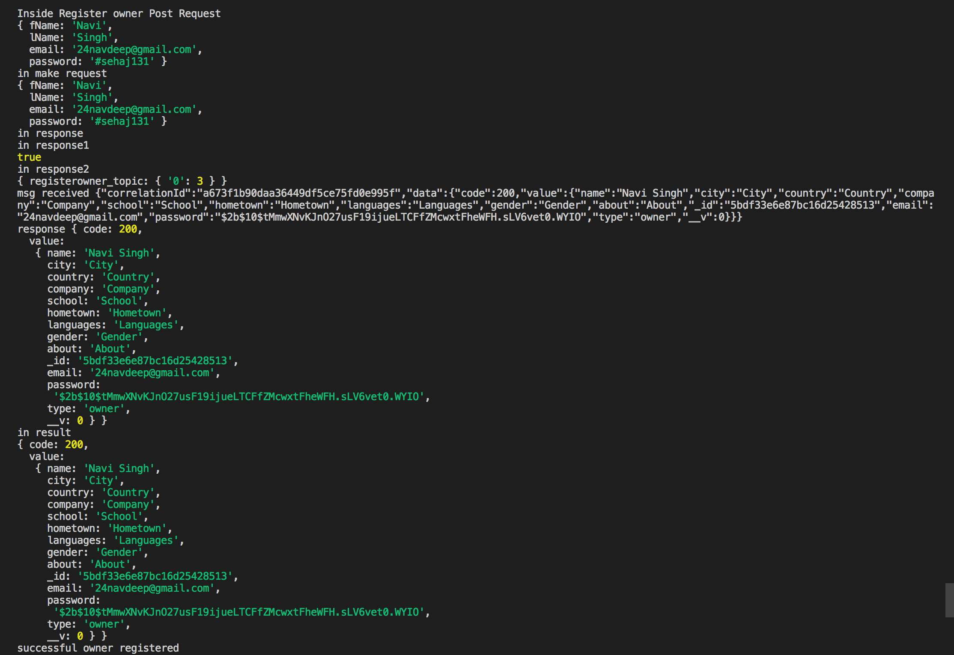

Validation if user already exists -

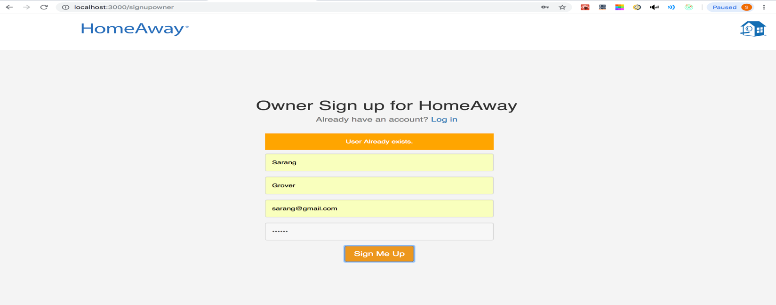



Node Backend –

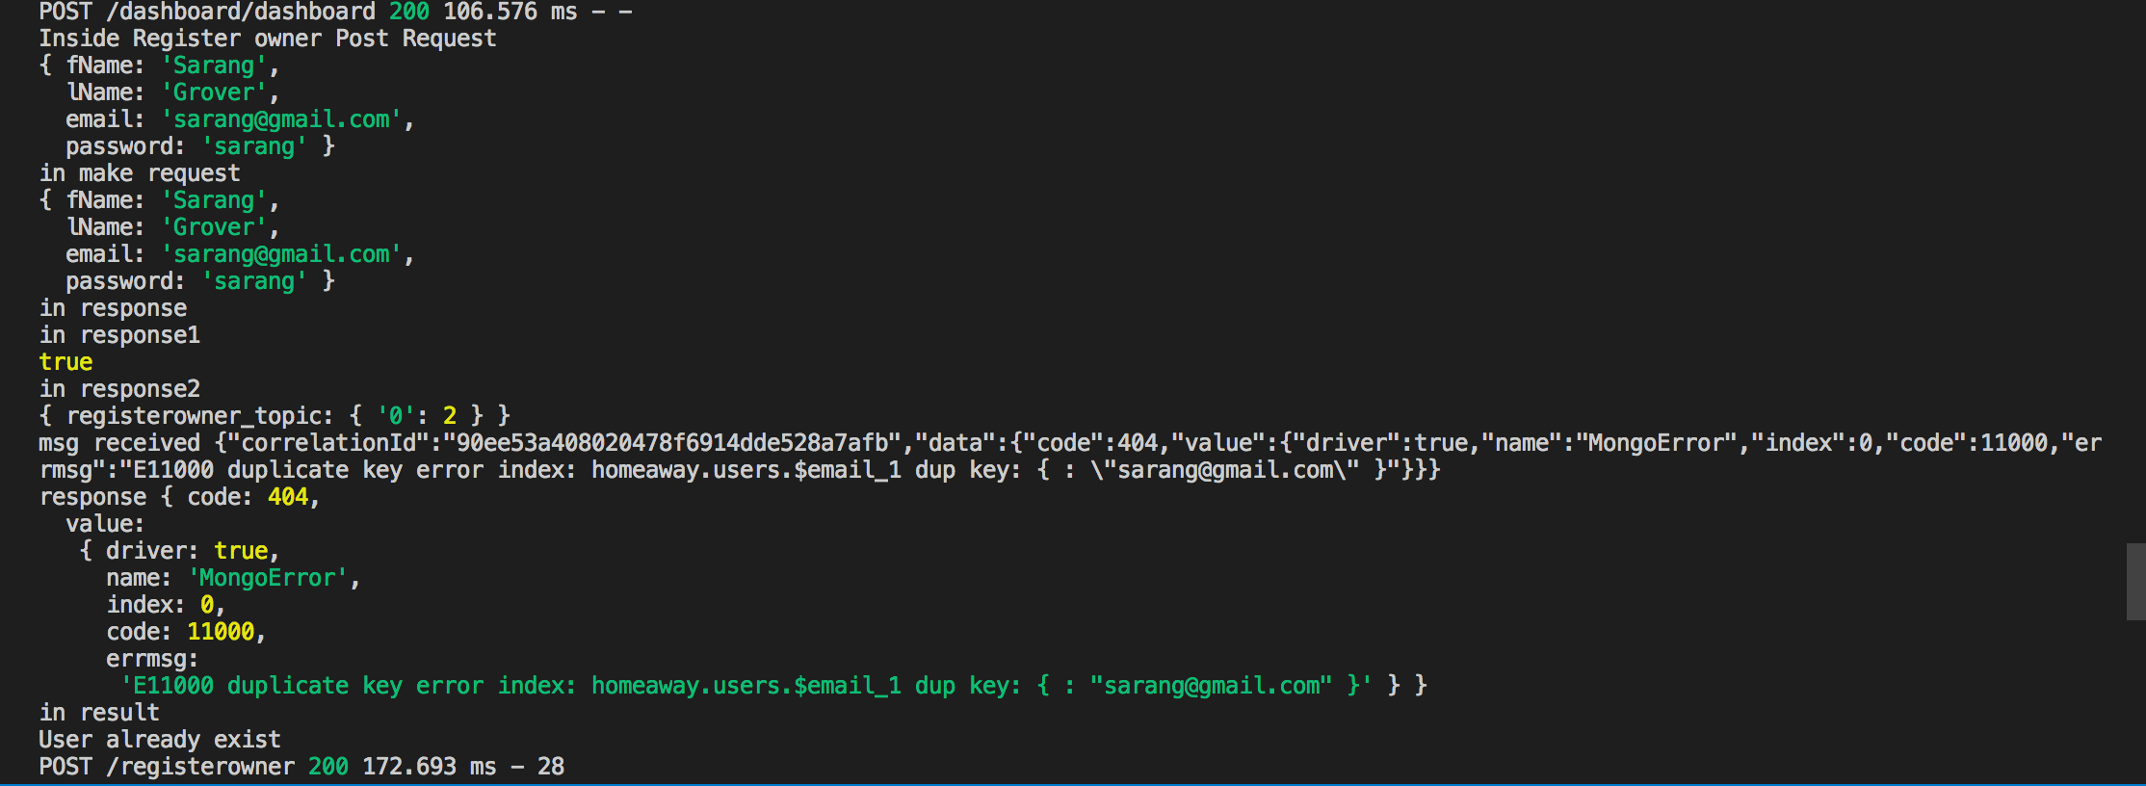

Login Page –

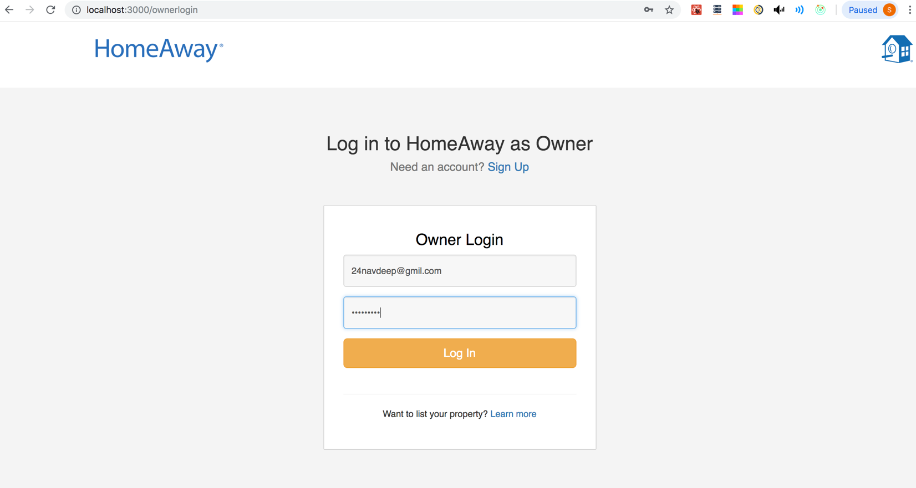

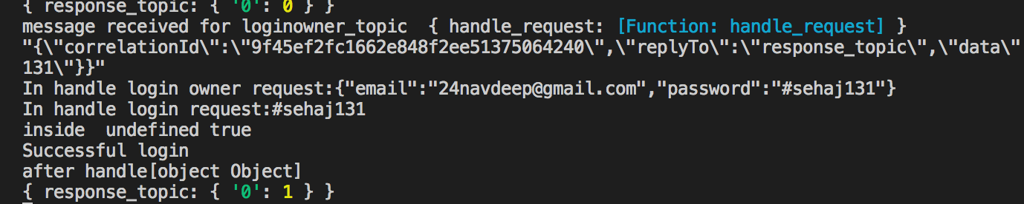

Node Backend

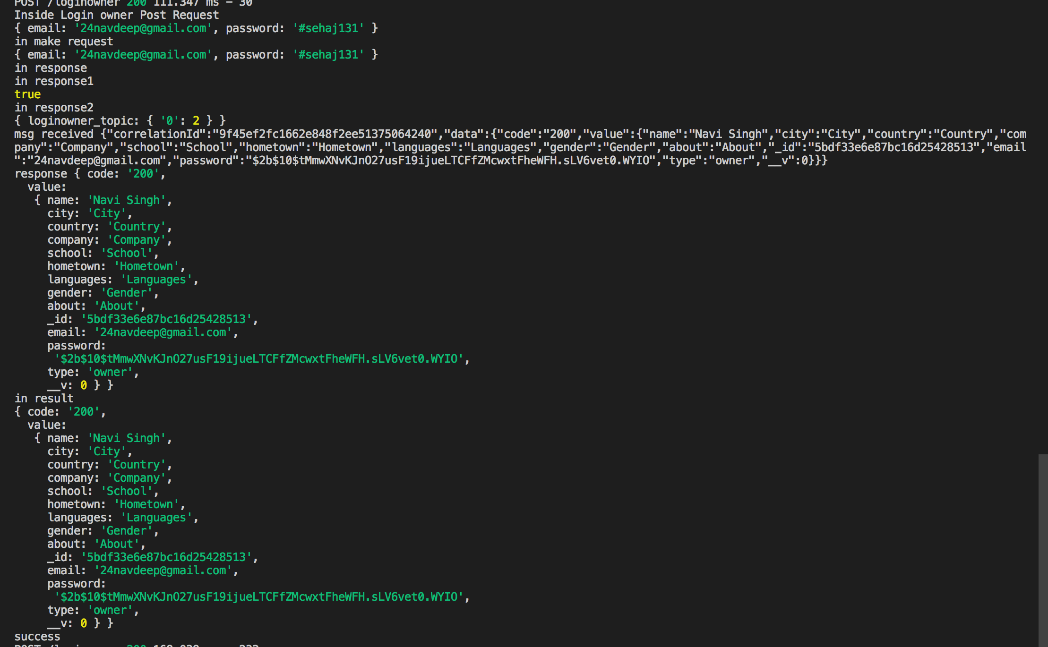

After Login Owner is directed to List your Property Page( Same page traveler is directed to when he confirms owner account and wants to list a property)

**i) List a property Page (If a person wants to create owner account directly. He is a traveler by default)**

**Owner Fills the form and lists his property. He can view this property in the dashboard and this property is available for search.**

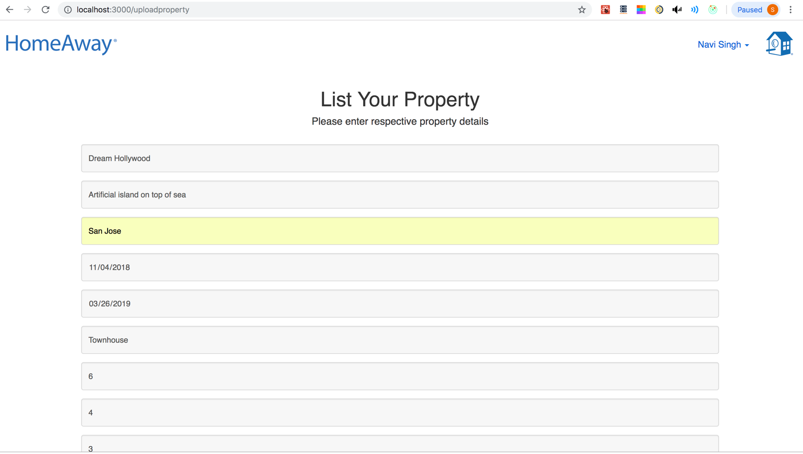

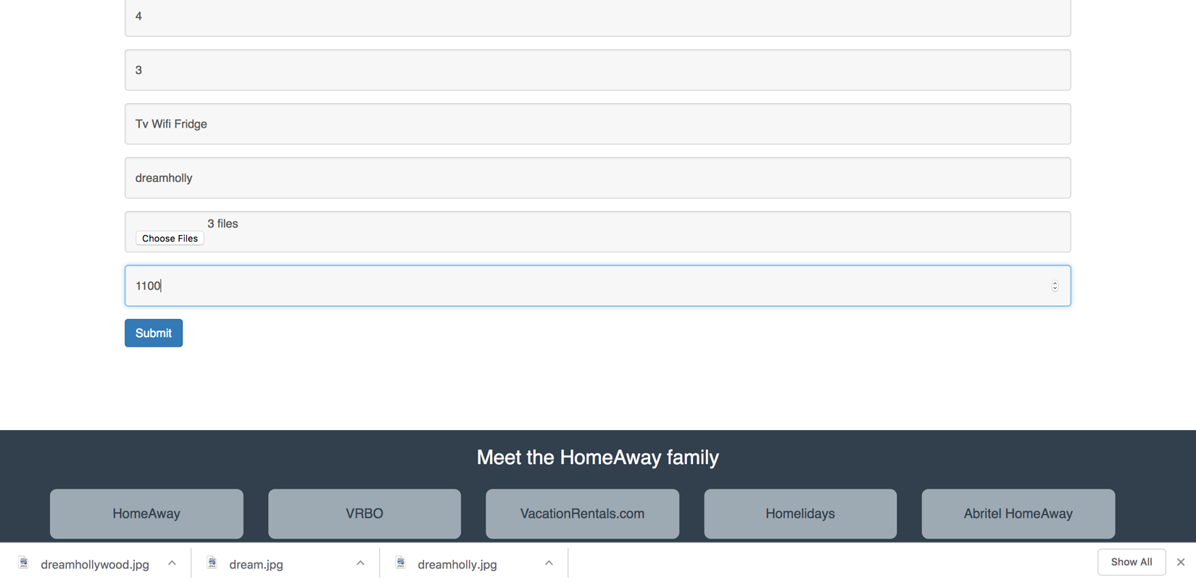

Kafka backend –

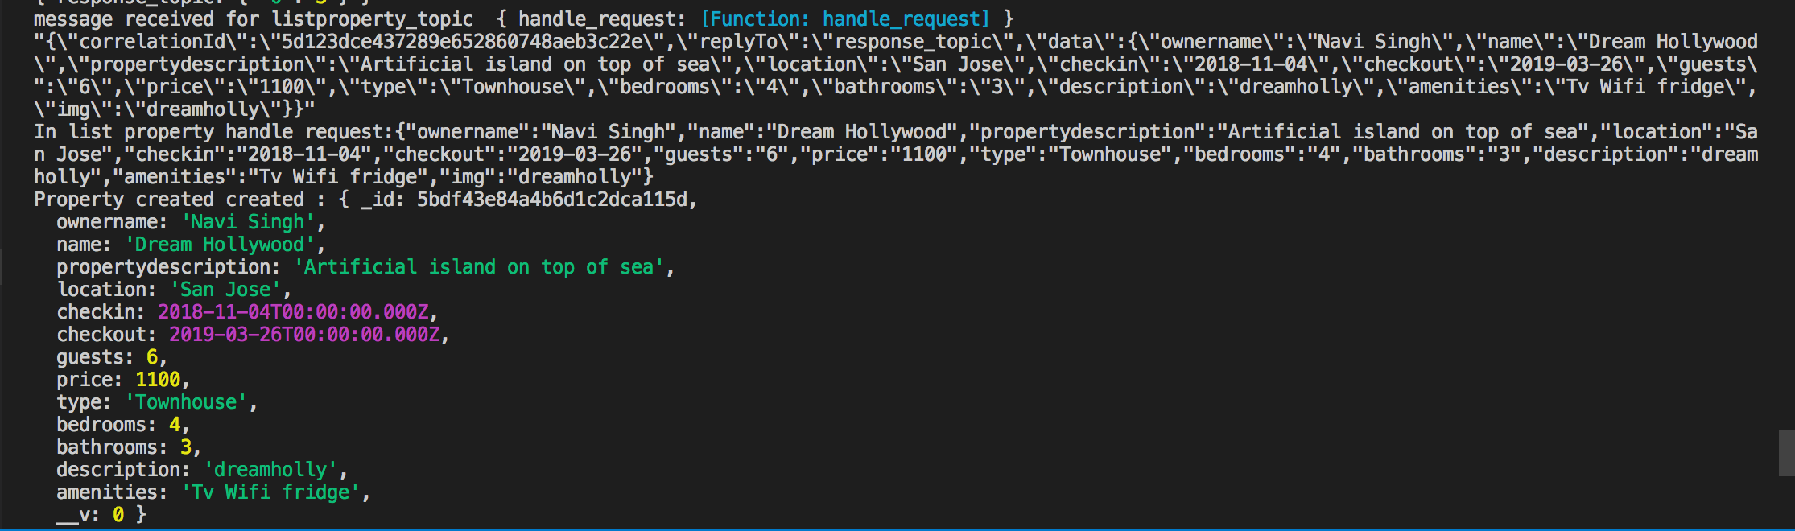

Node Backend –

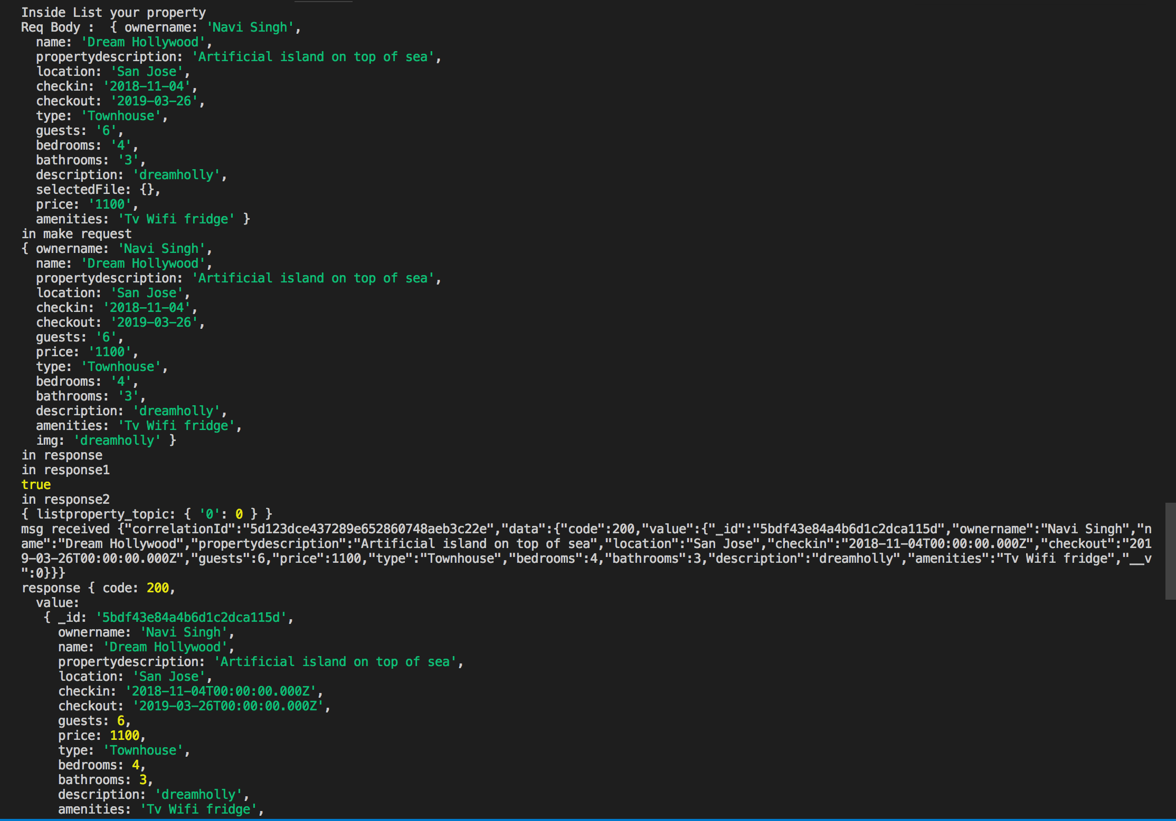

Property added can be viewed in the search results -

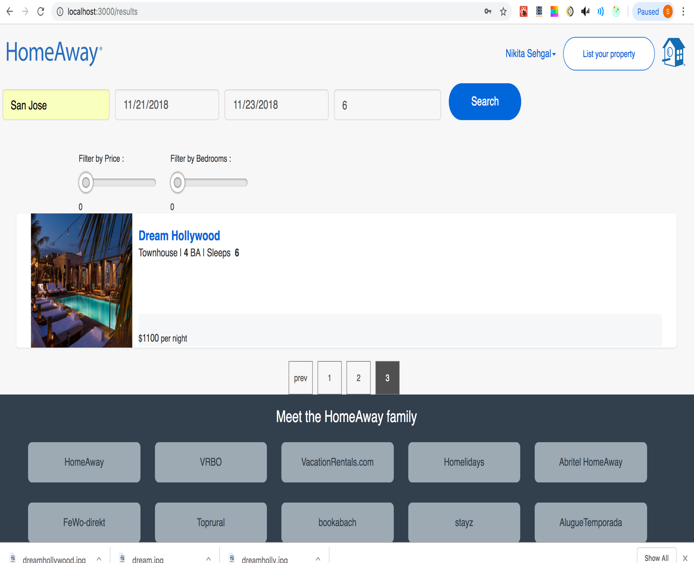

**j) Owner Dashboard-**

**Property added by owner can be viewed in Owner Dashboard**

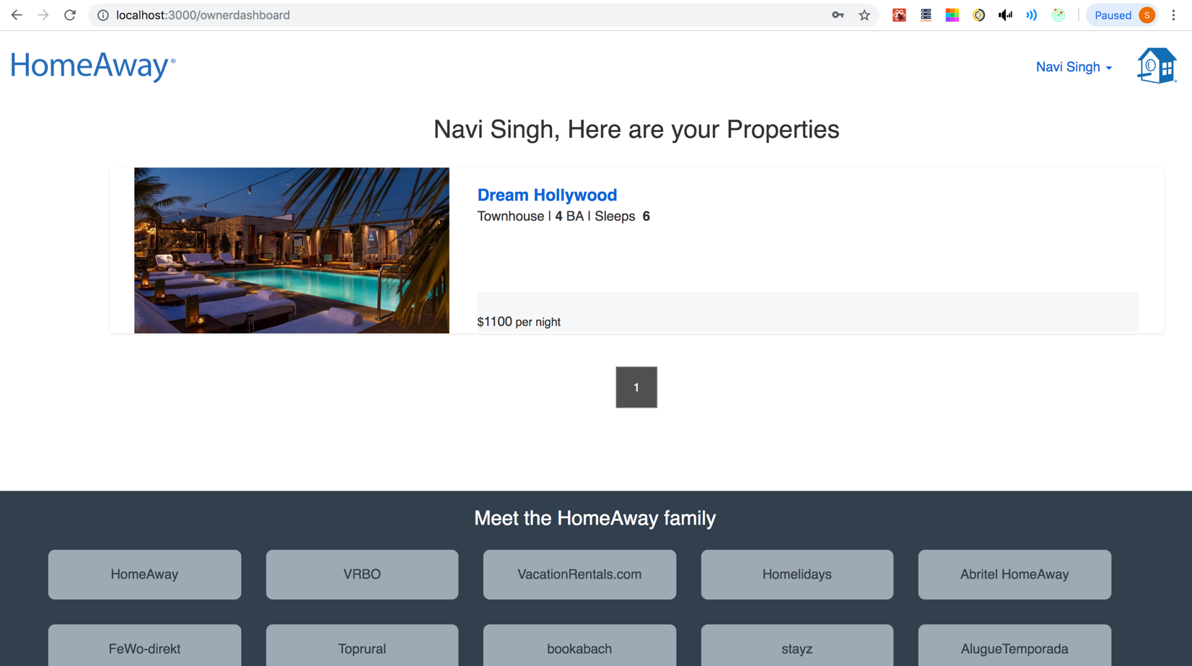

Kafka Backend –

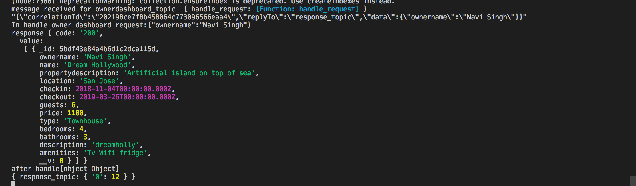

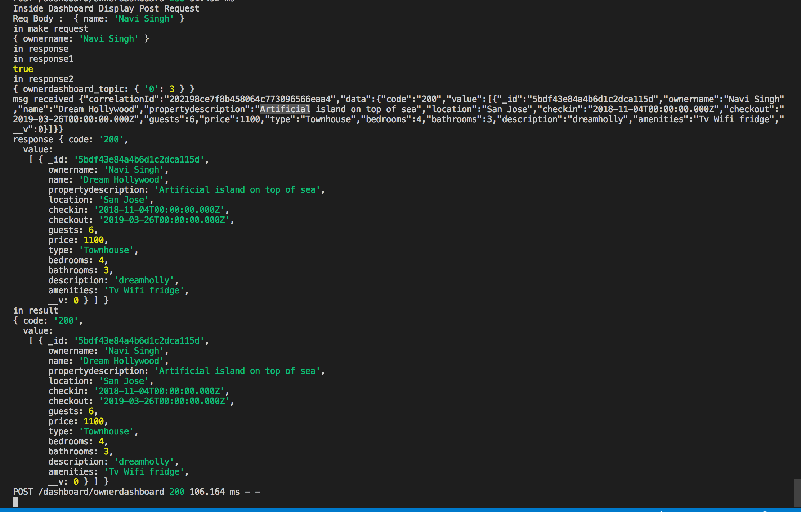

**Displaying Dashboard of Another user which more than 5 properties has to demonstrate pagination facility**

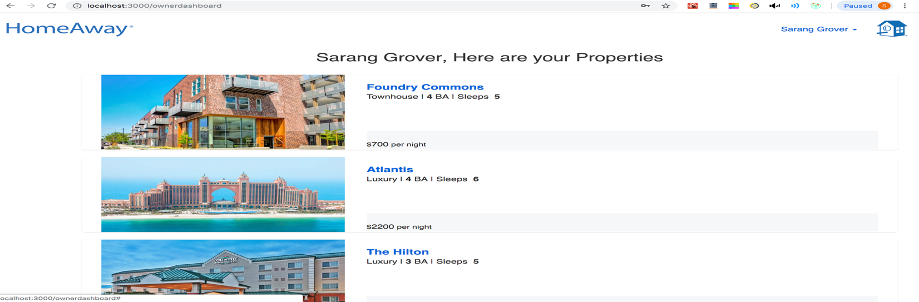

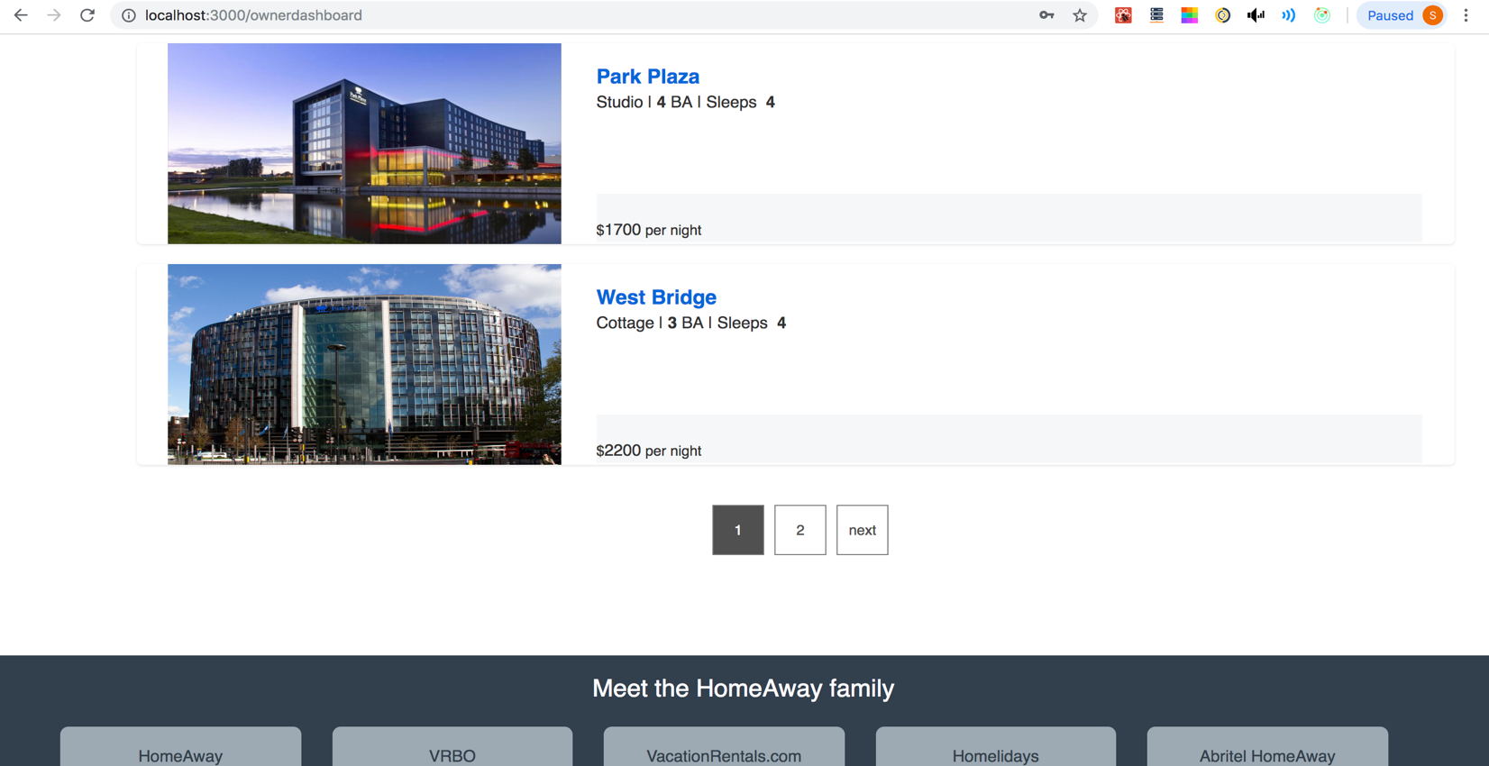

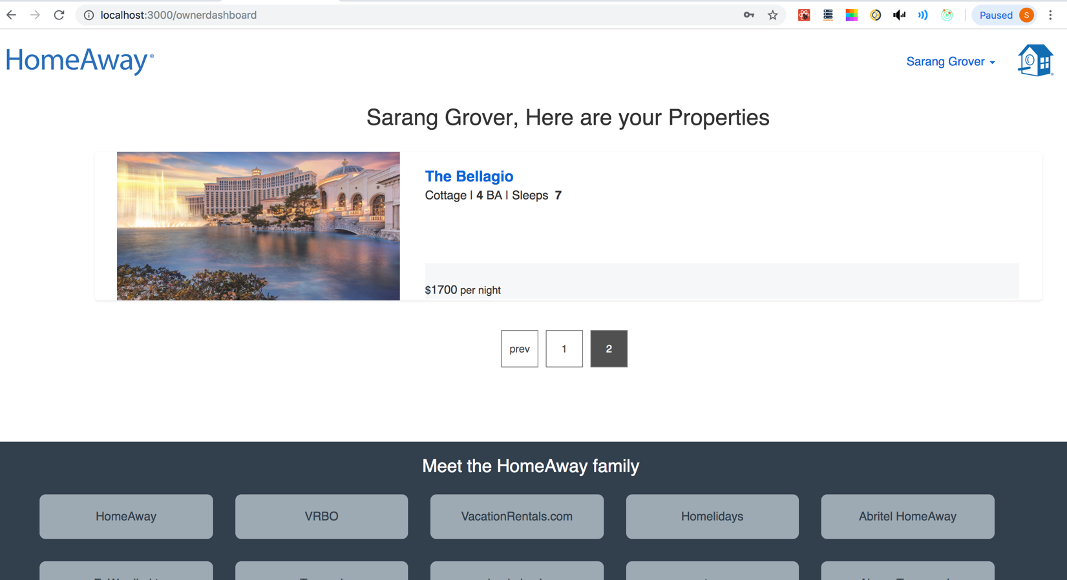

**Redux state containing the owner properties –**

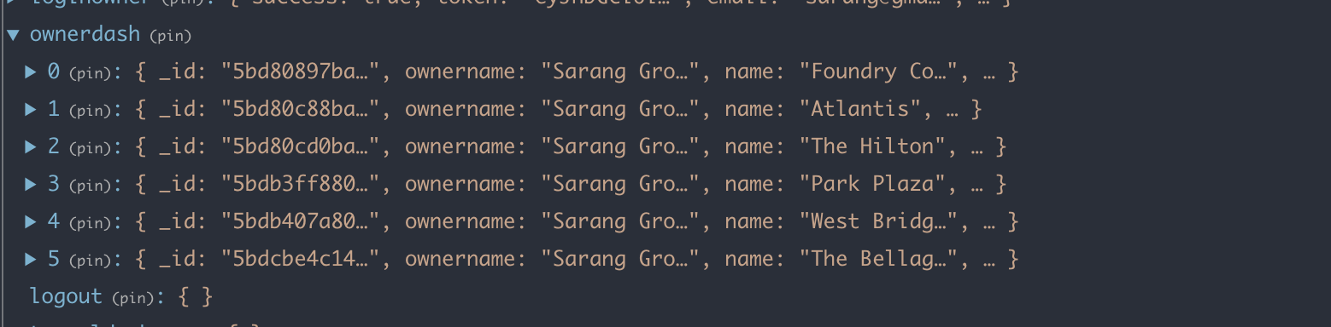

**Kafka backend –**

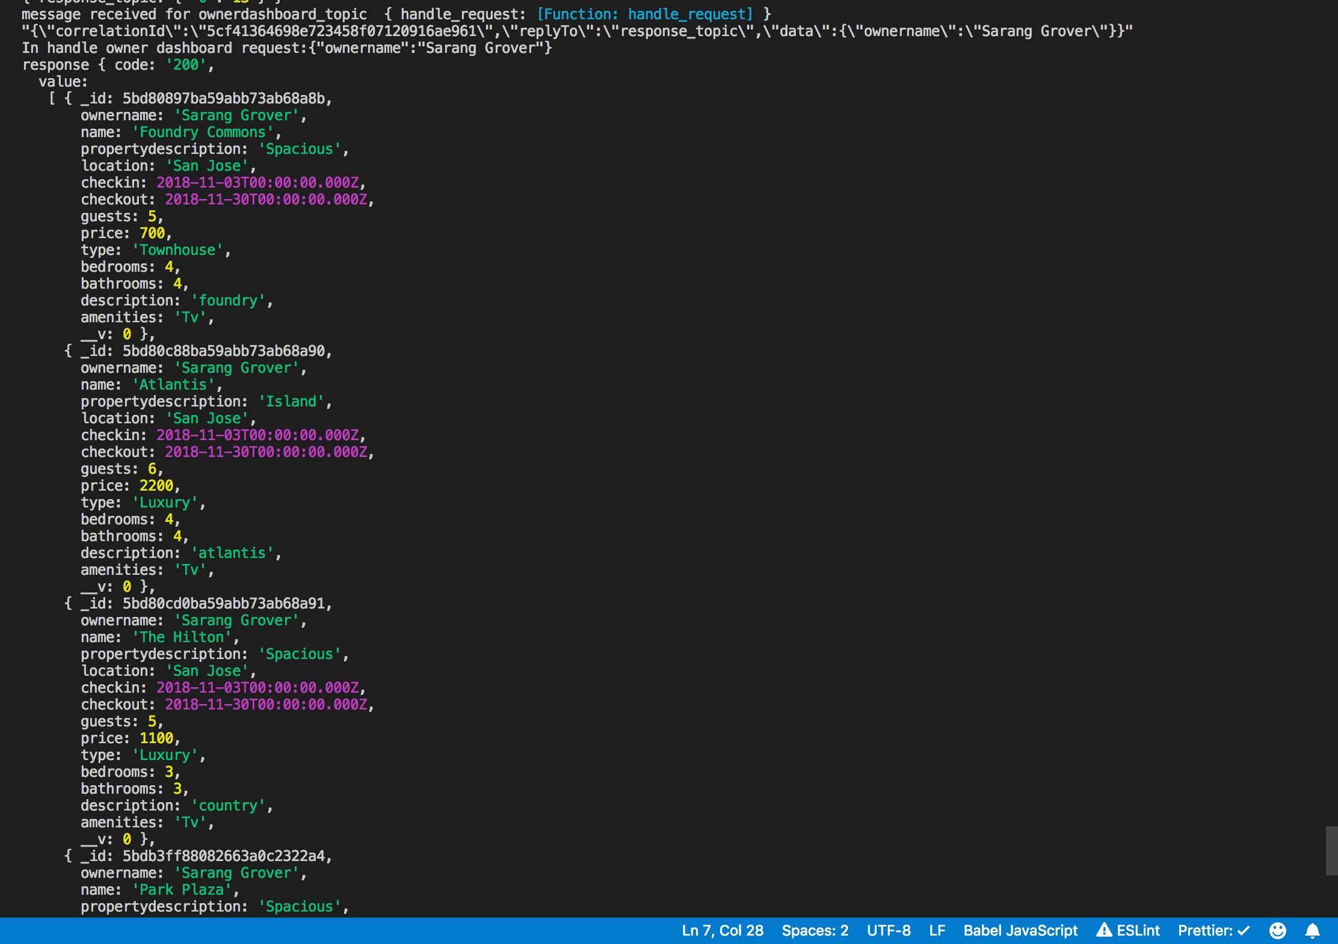

**Node backend-**

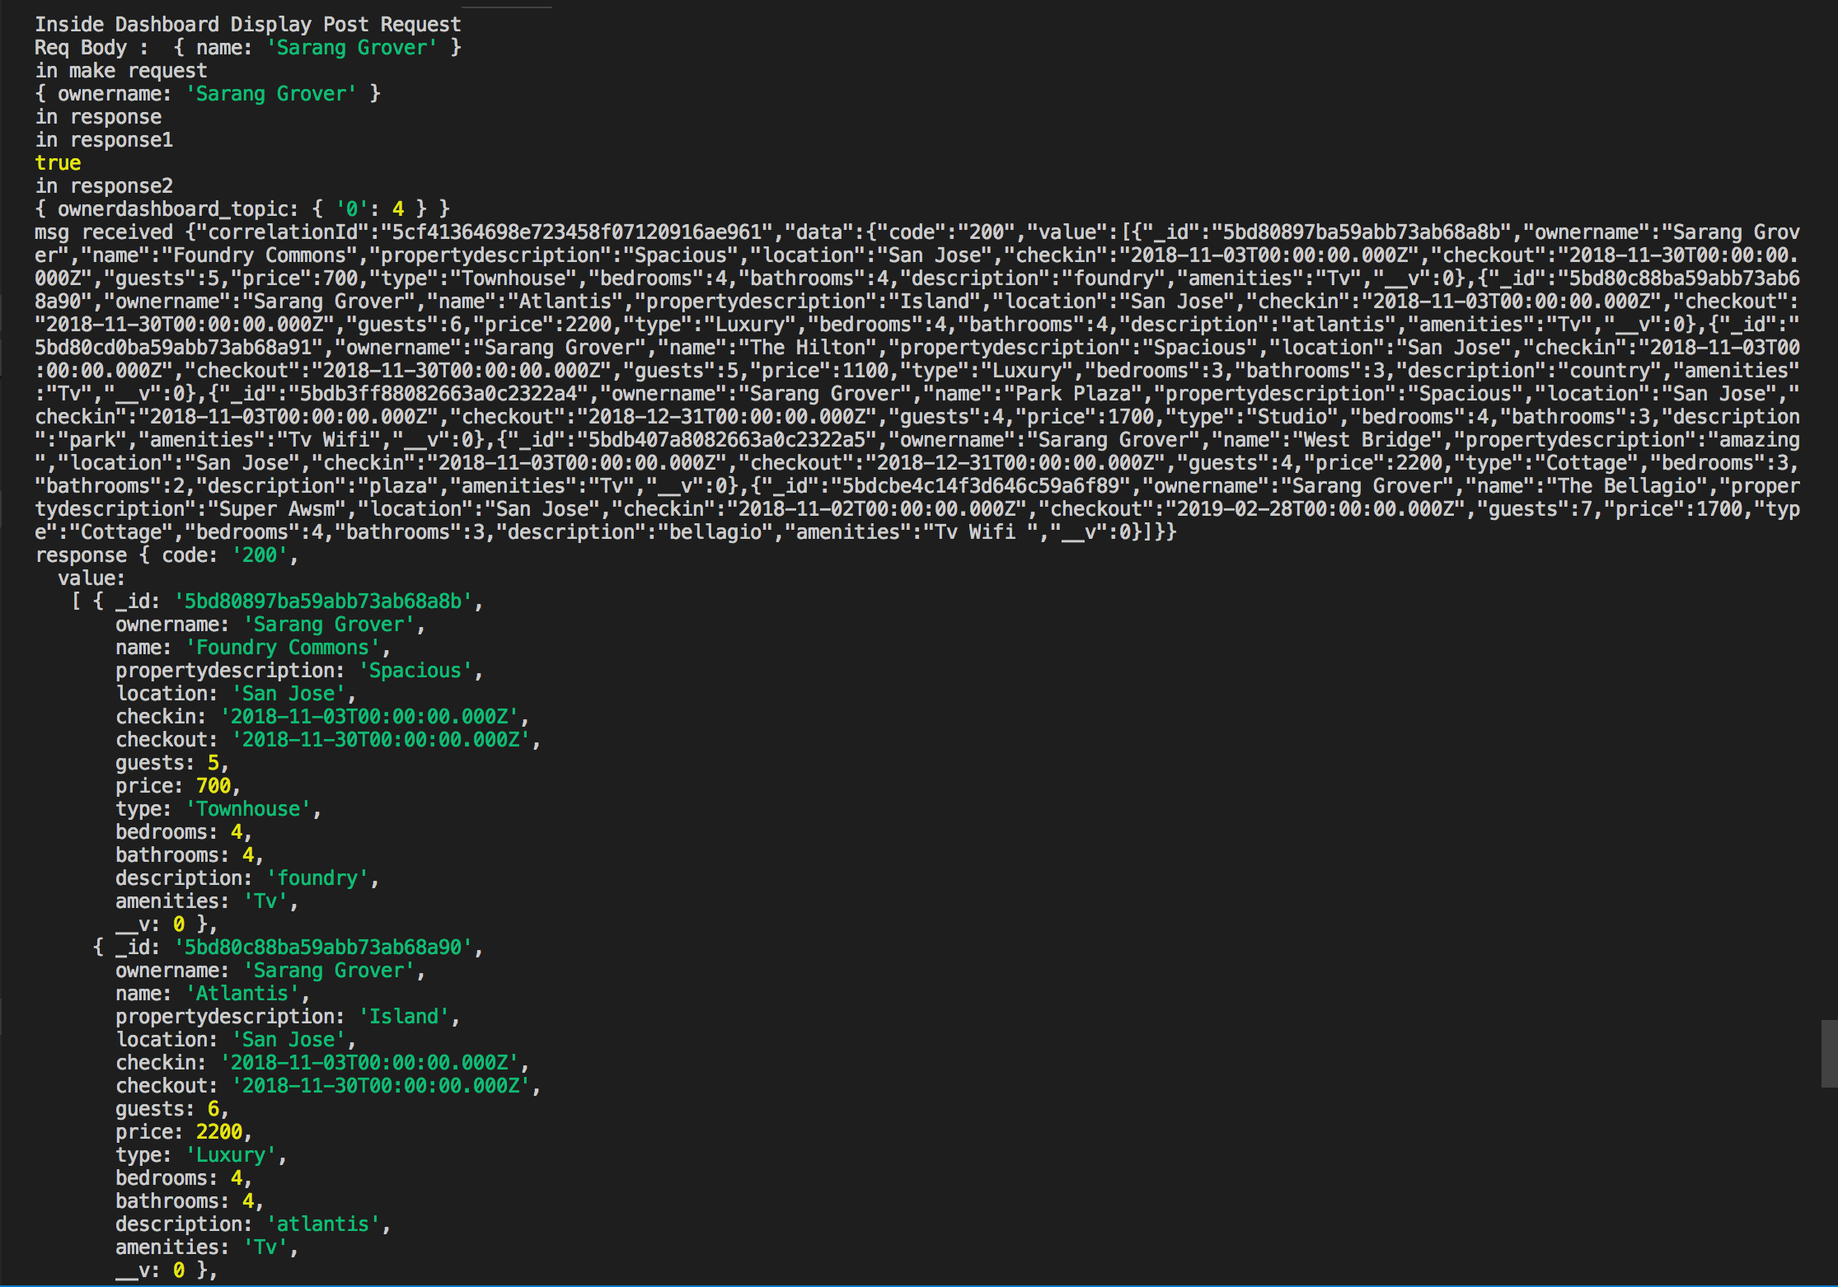

**k) Commit History –**

**Following is the commit history from GitHub desktop**

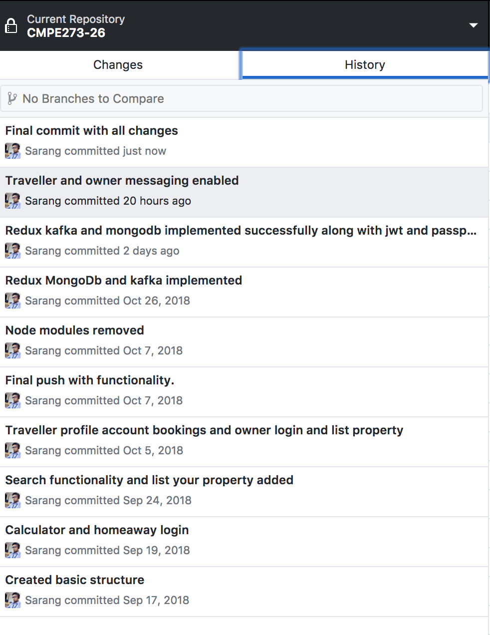

**l) Mocha testing–**

**Screenshots of mocha test cases on 5 API calls**

**i) Login**

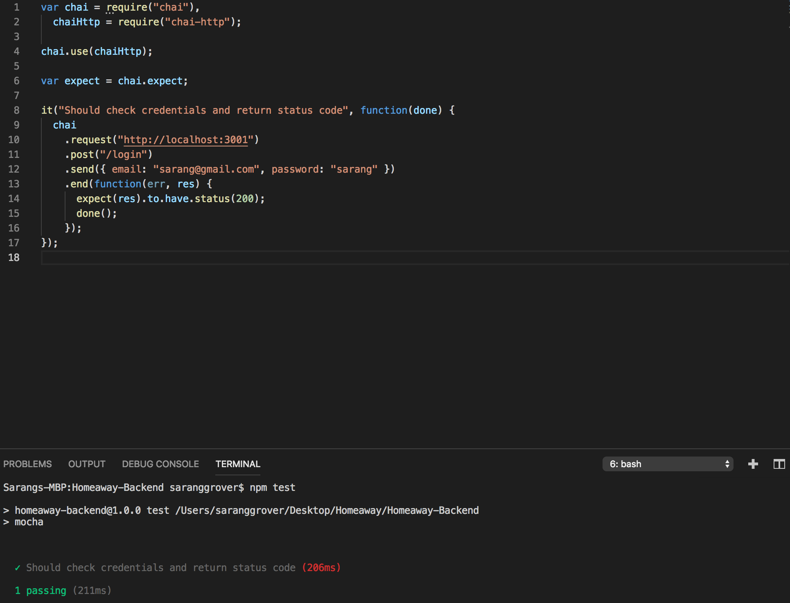

ii) Register

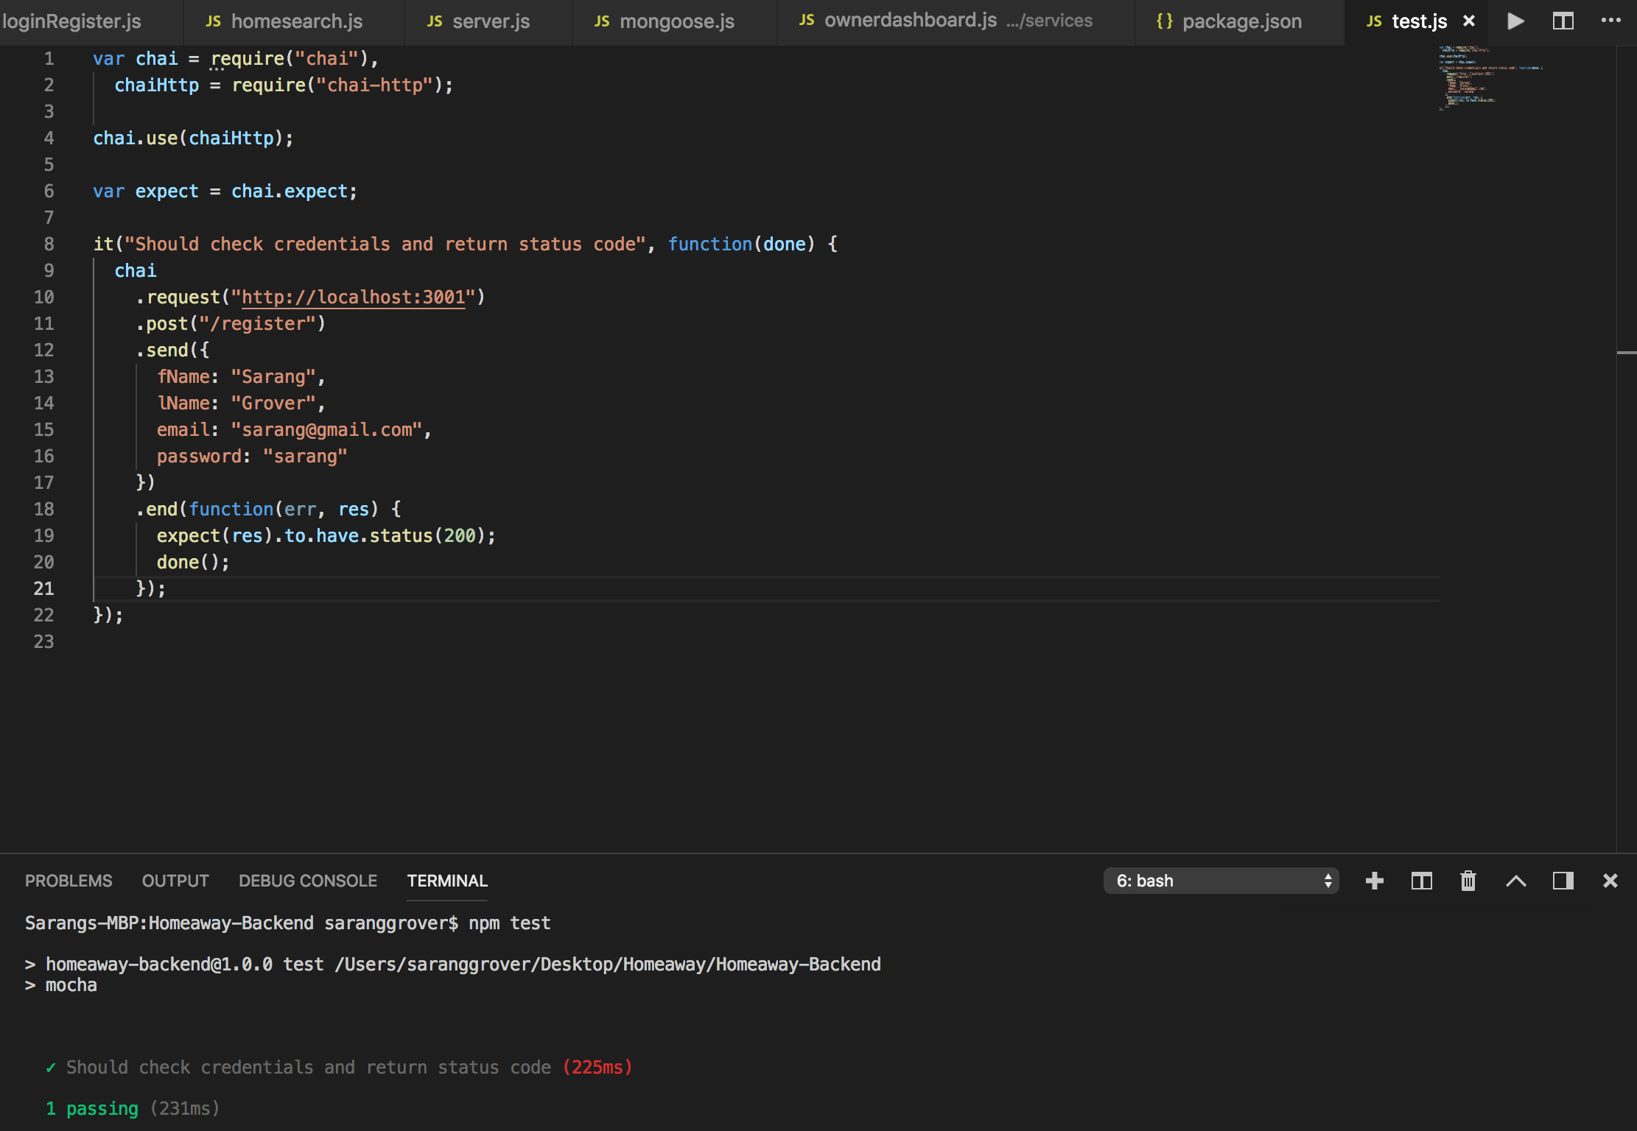

**iii) Search**

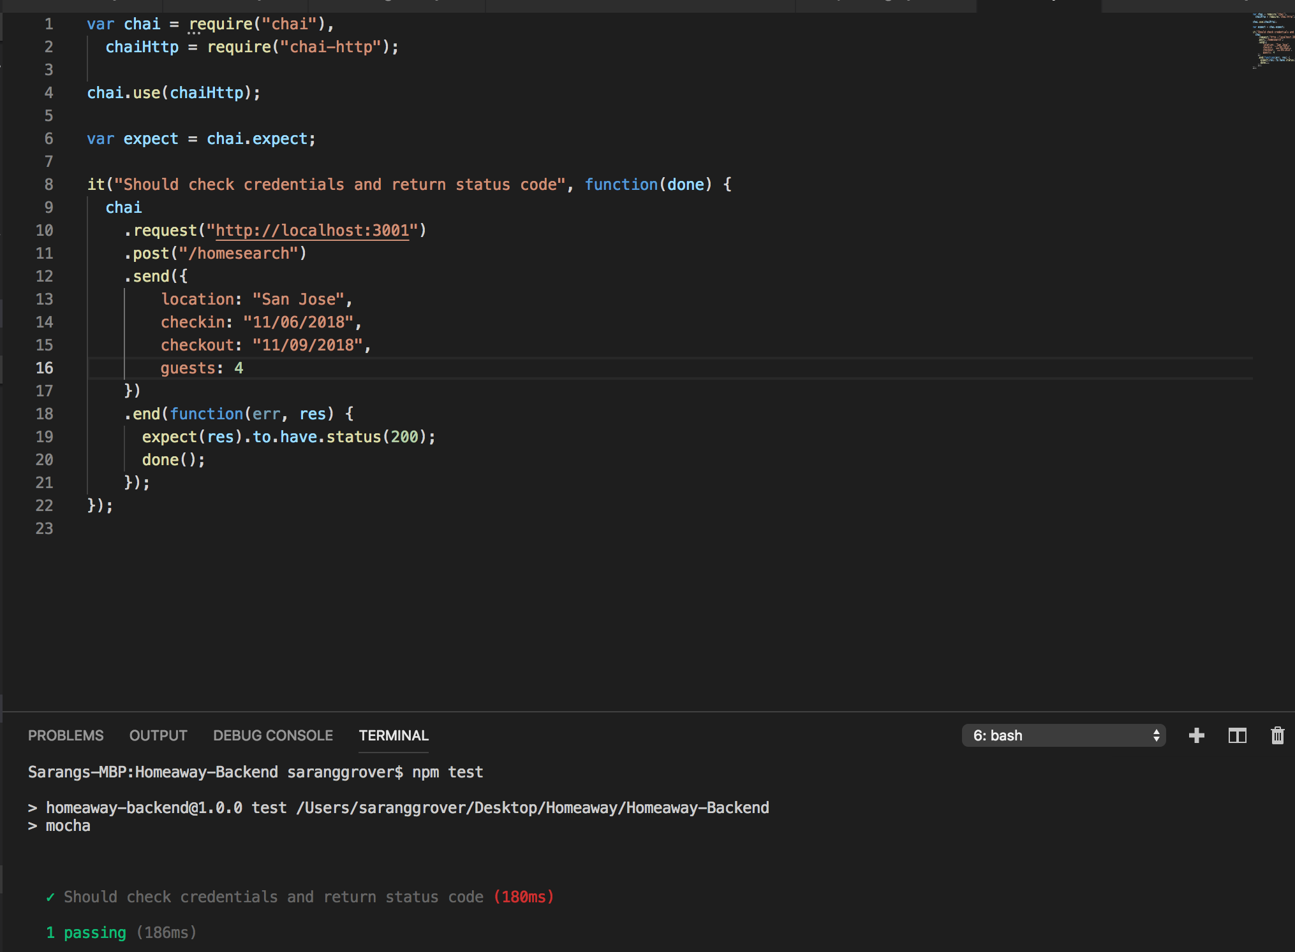

iv) Book Property

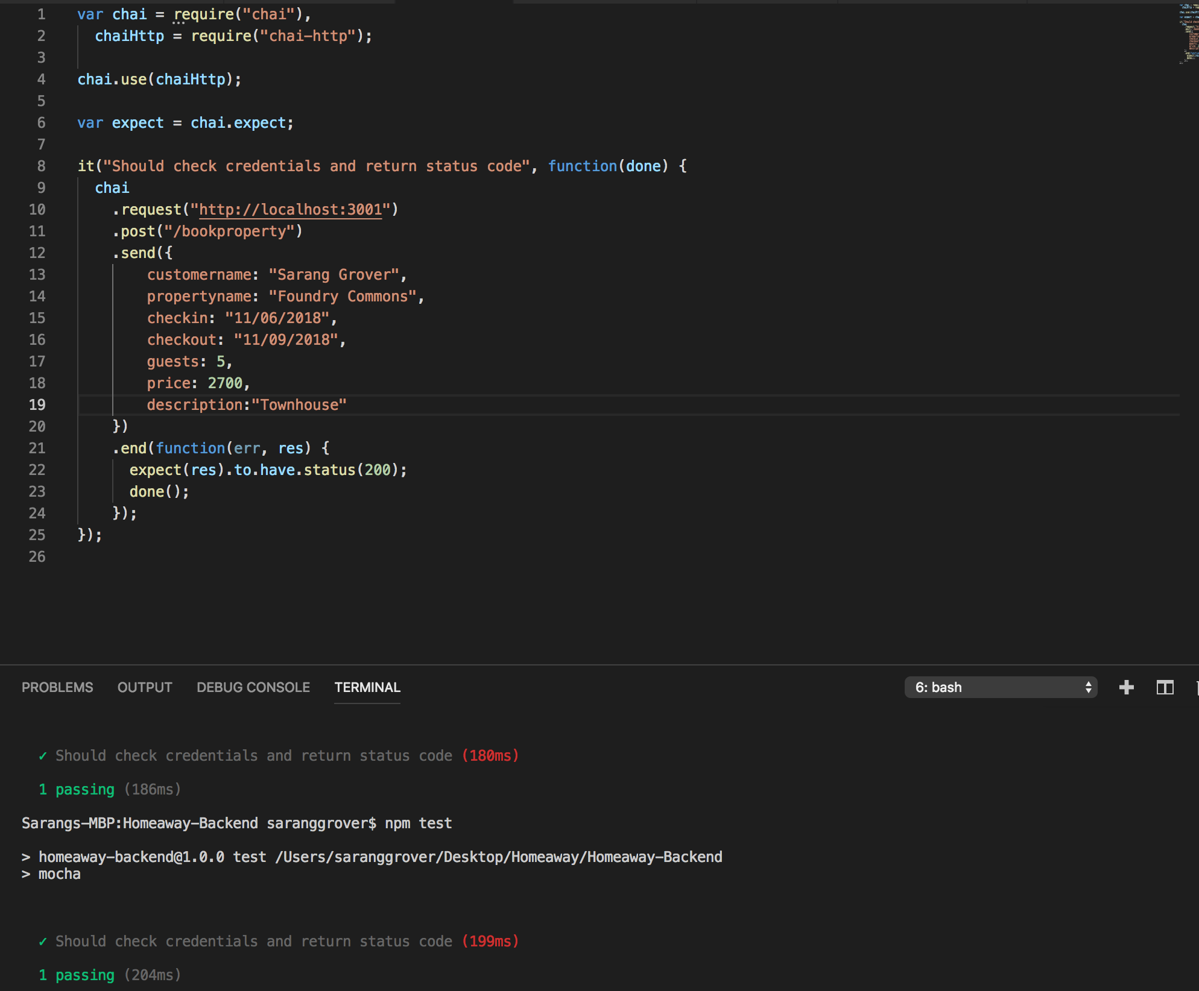

v) Question from traveller

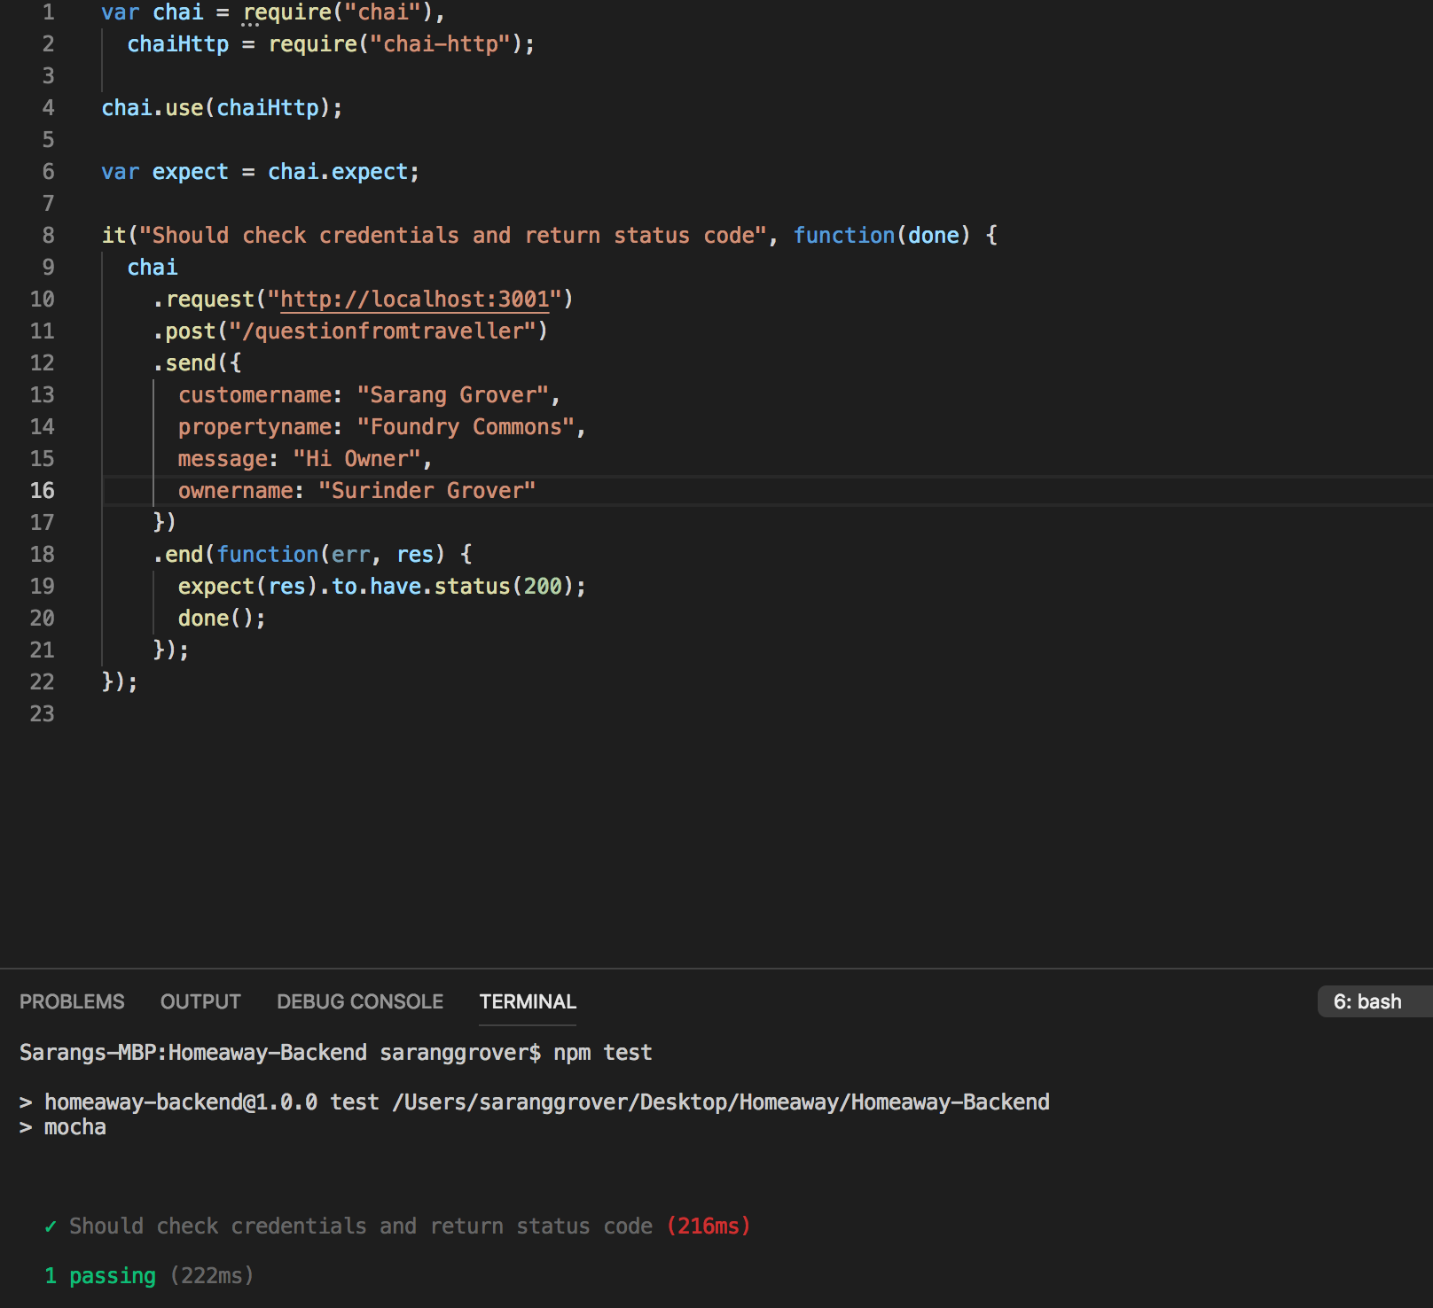

**m) jmeter testing**

**Screenshots of junit test cases for 100,200,300 users on 5 api routes**

**i) Login**

**100 users**

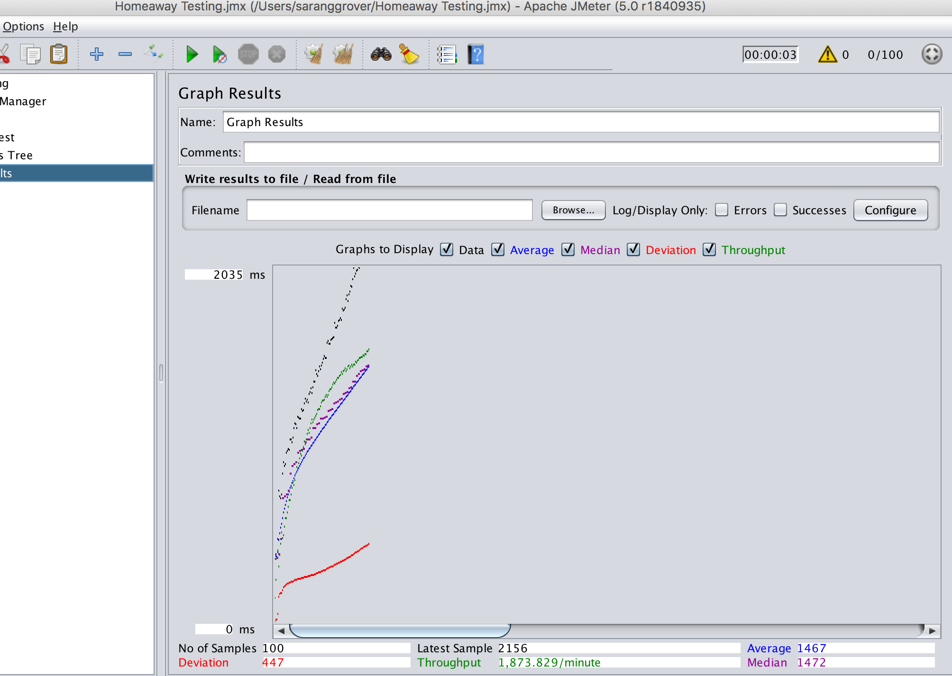

**200 users**

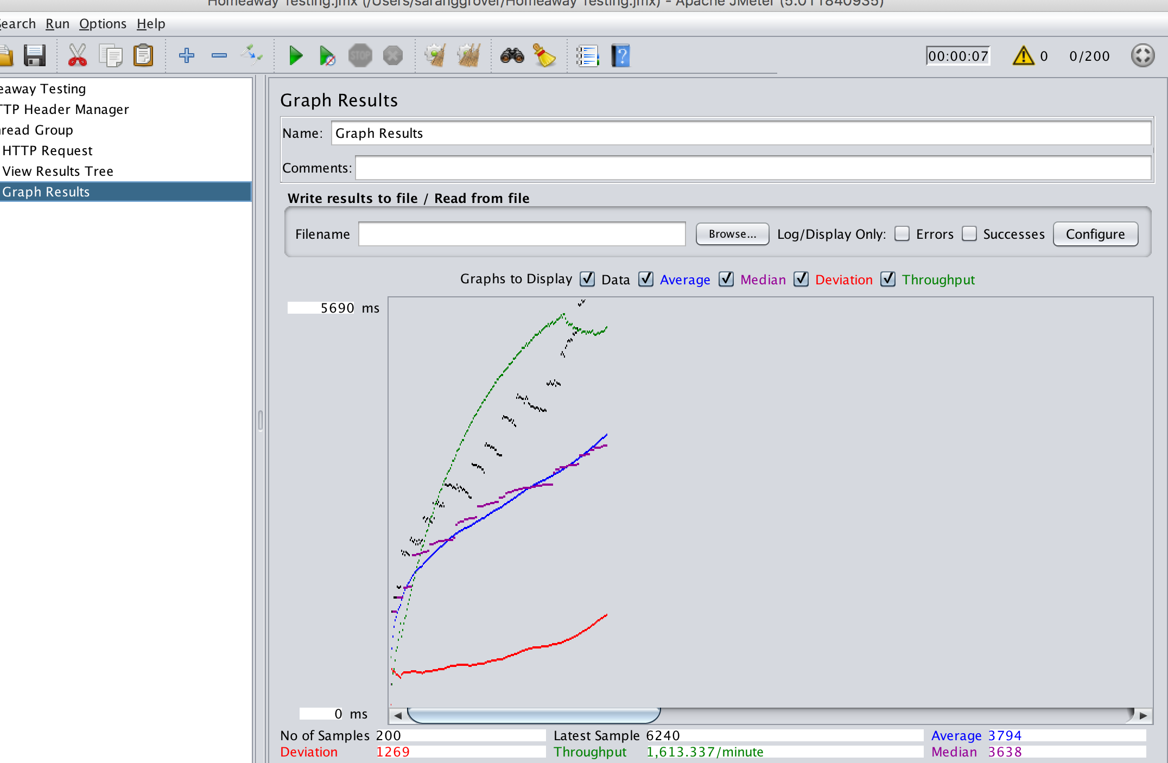

**300 users**

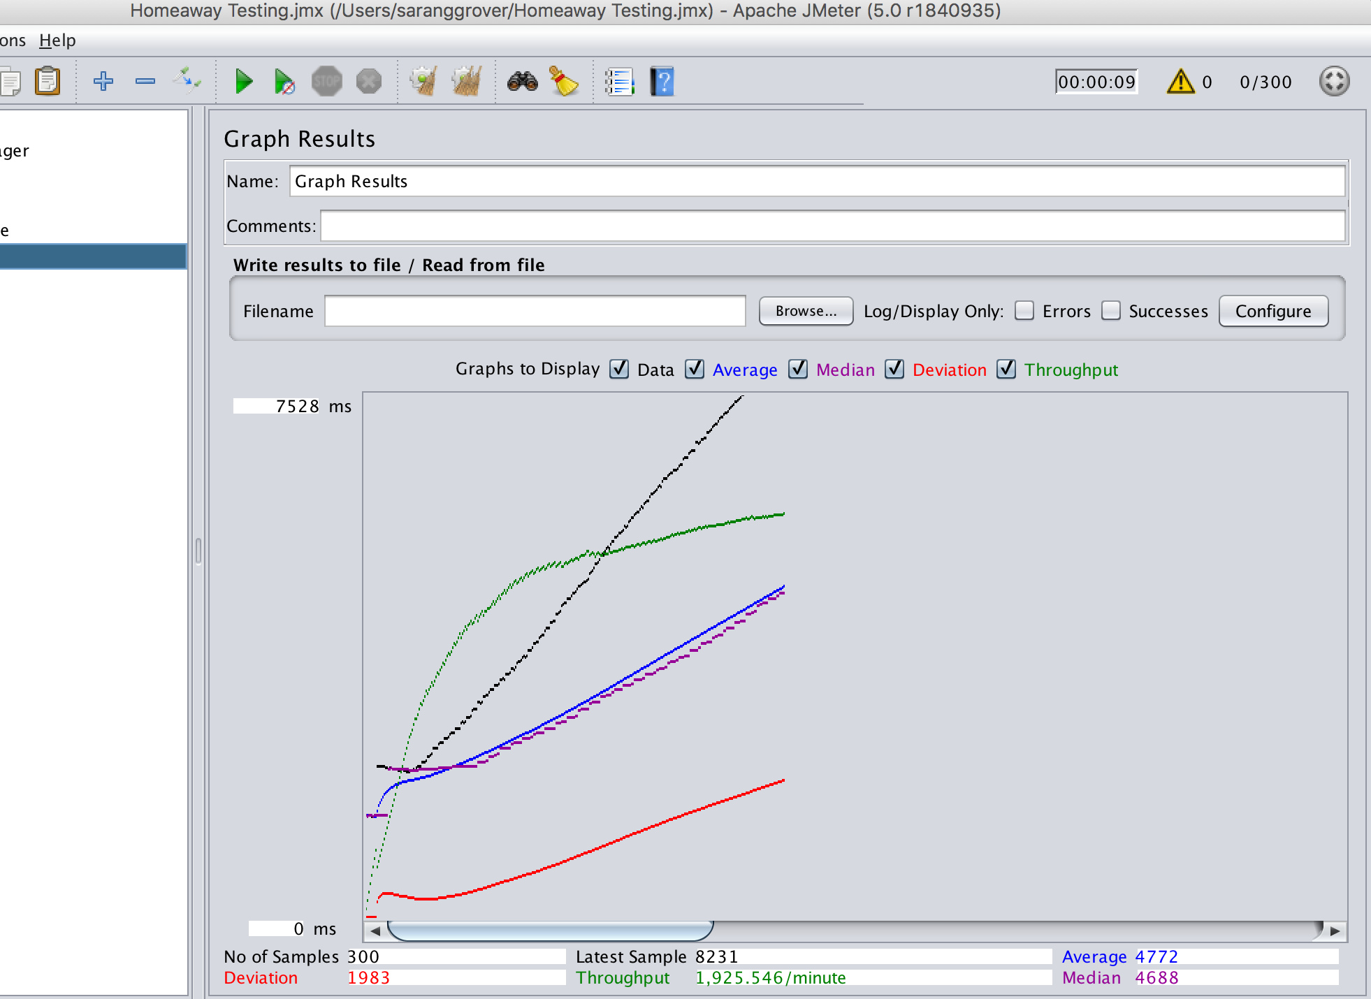

**ii) Register**

**100 users**

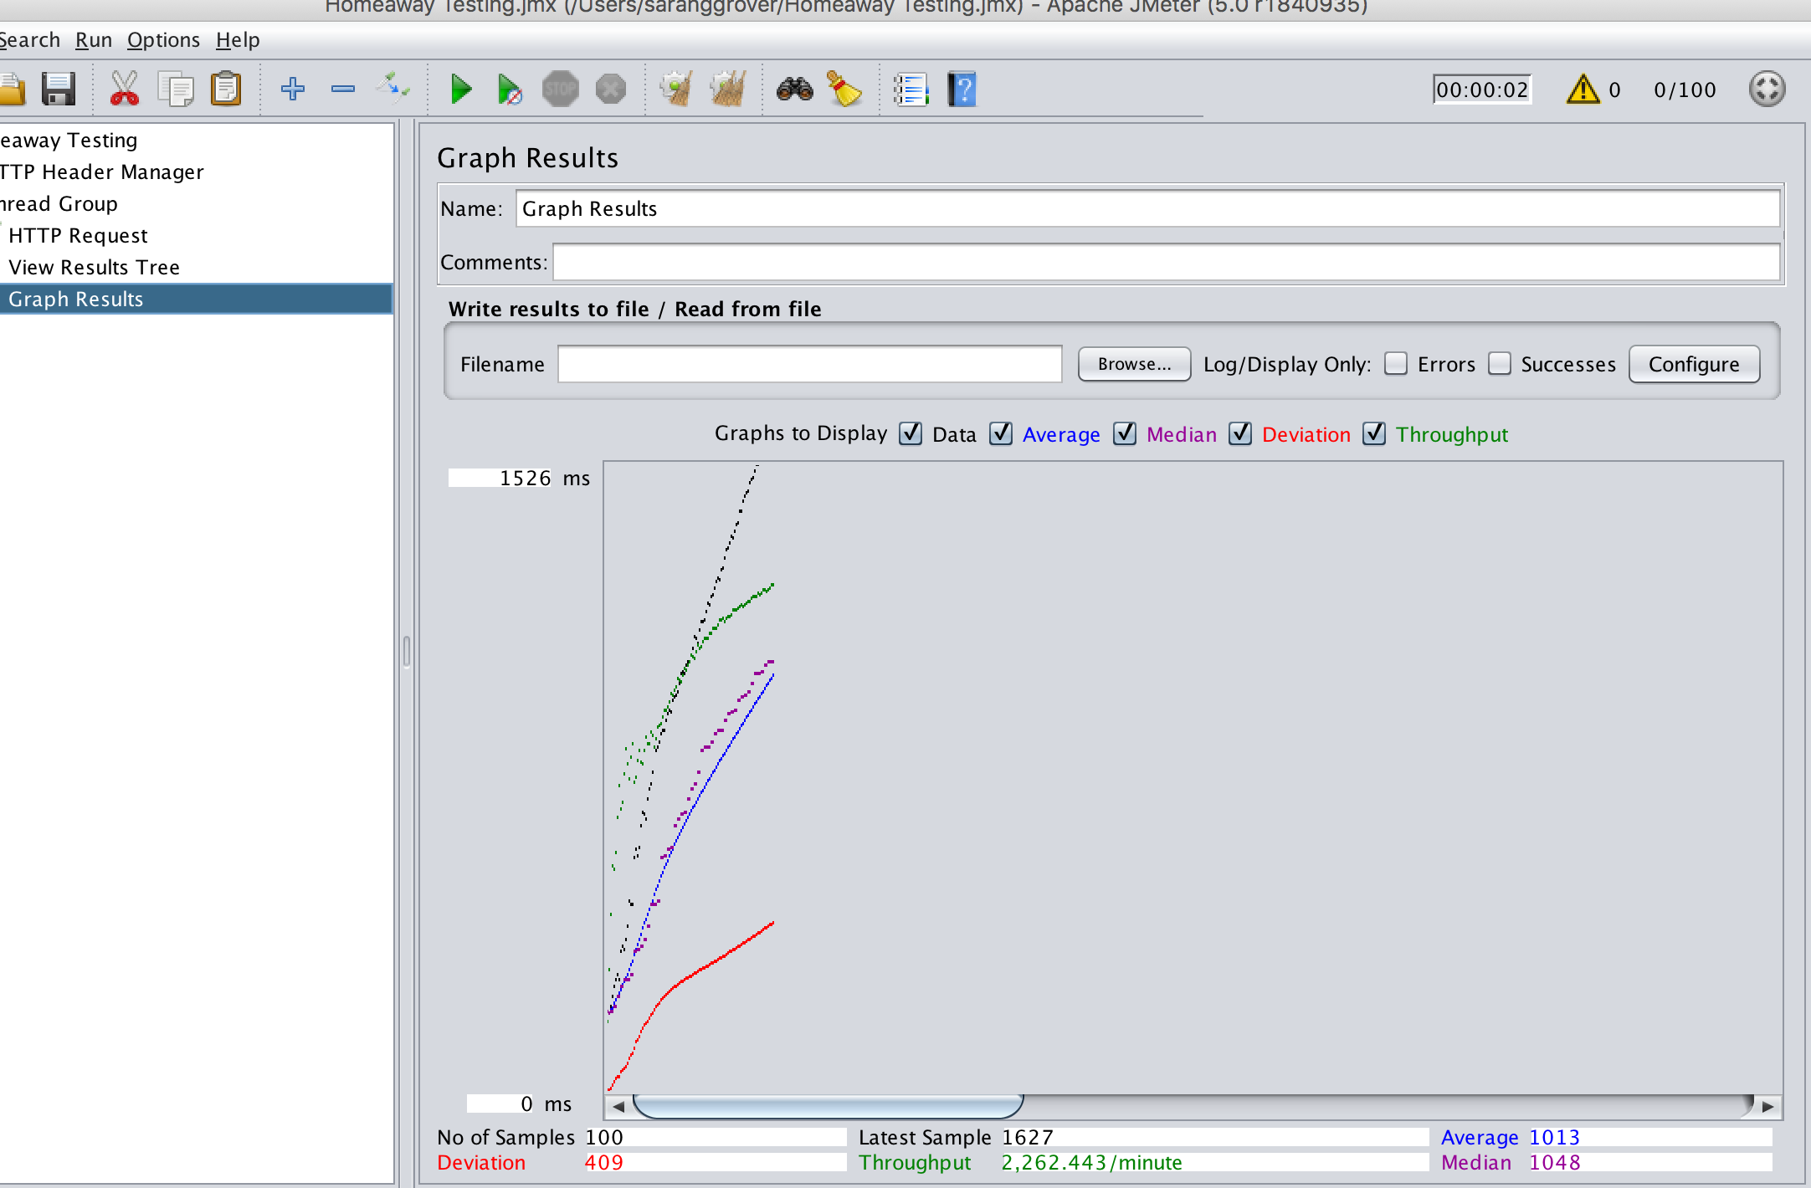

**200 users**

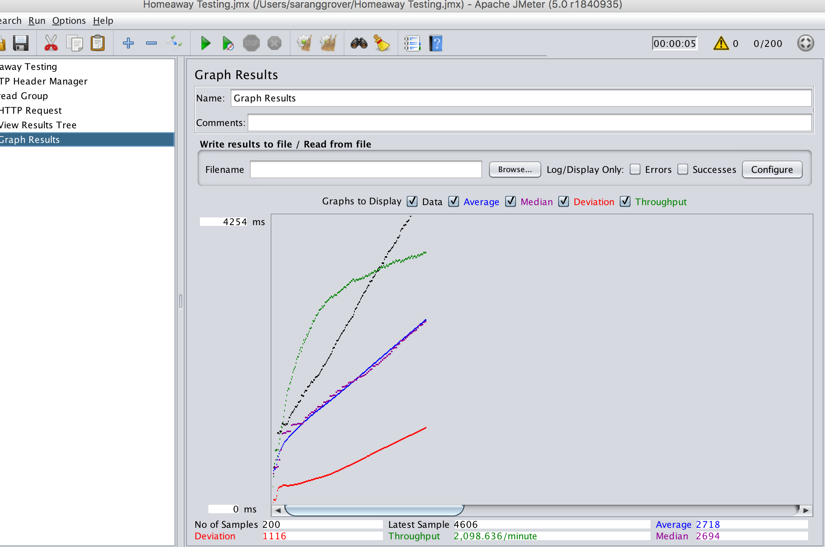

**300 users**

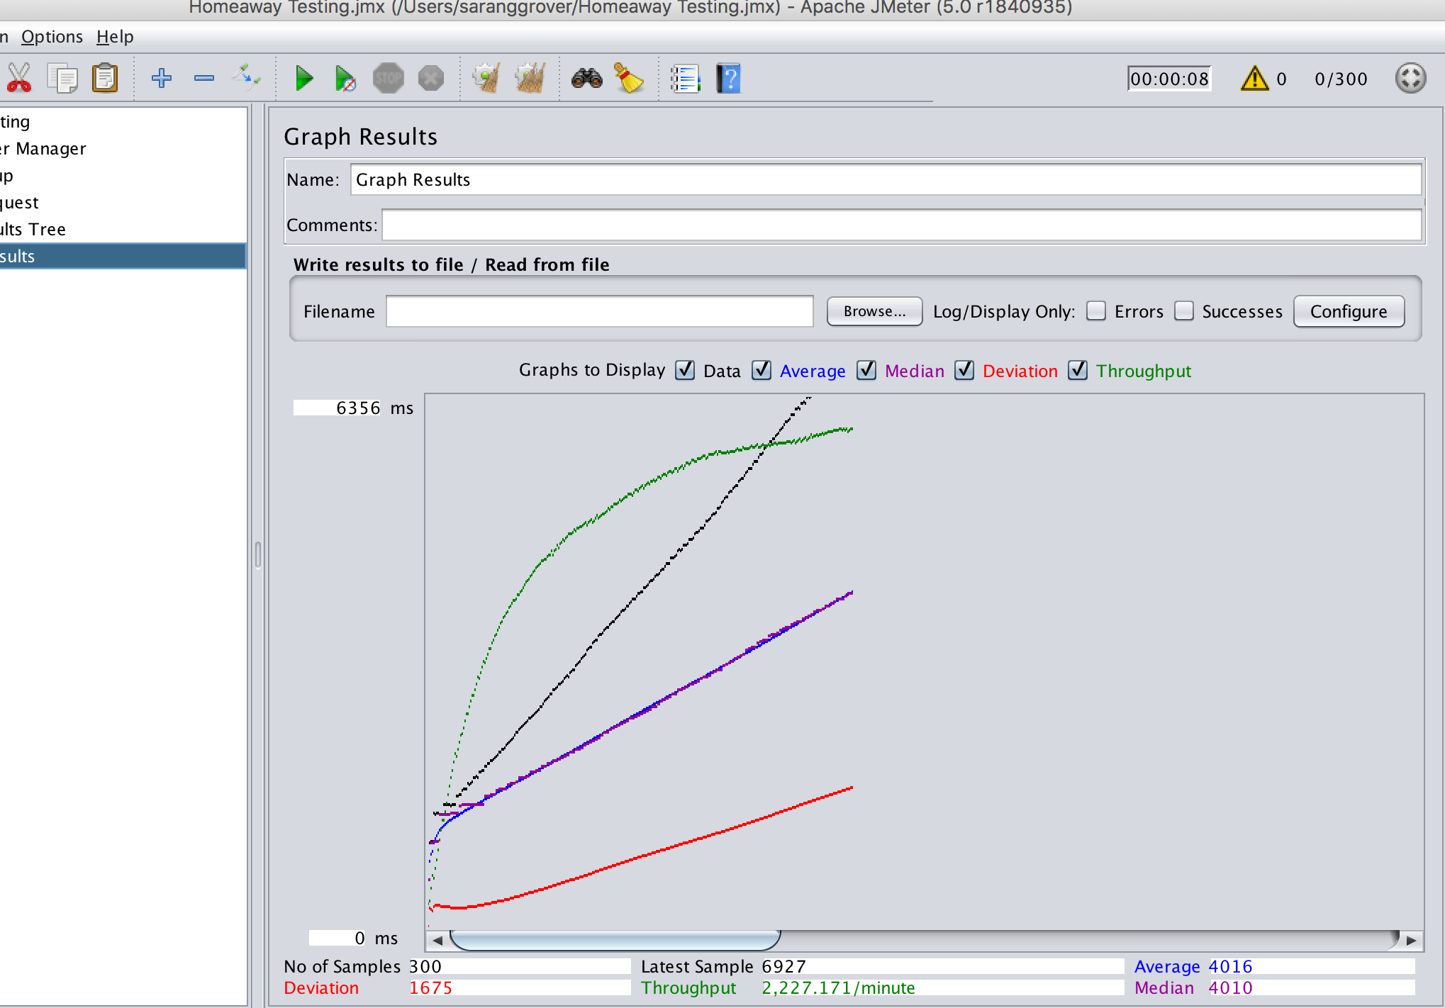

**iii) Search**

**100 users**

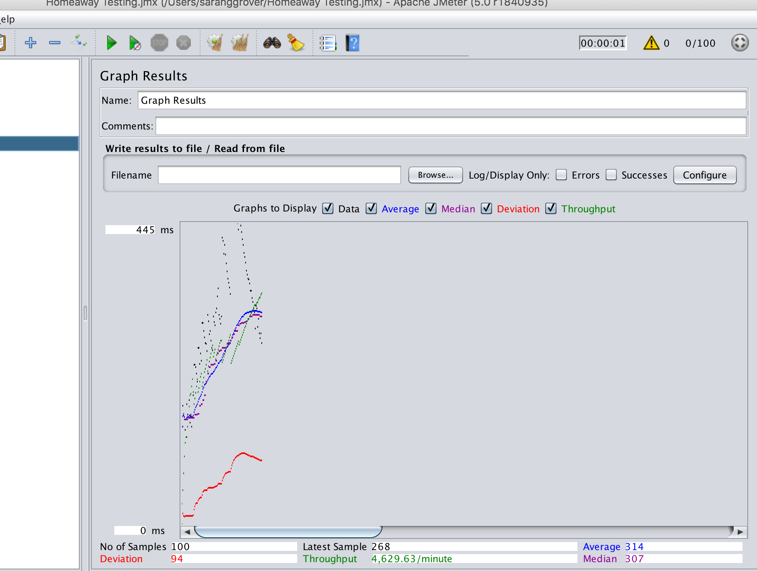

**200 users**

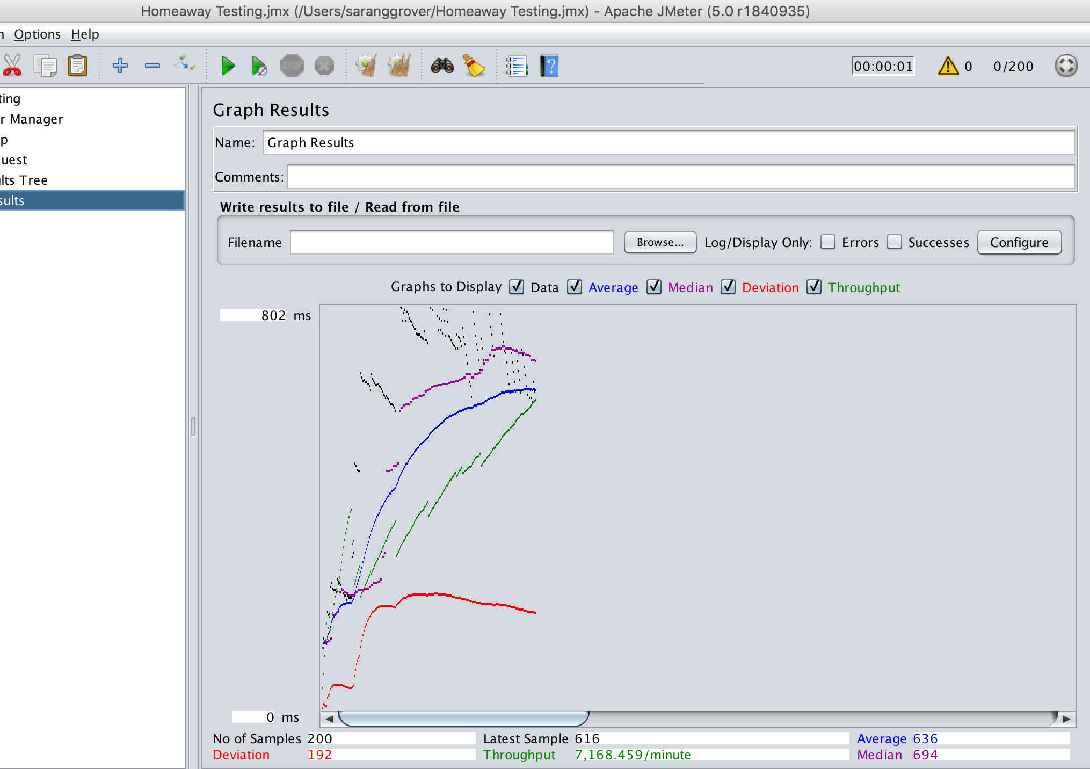

**300 users**

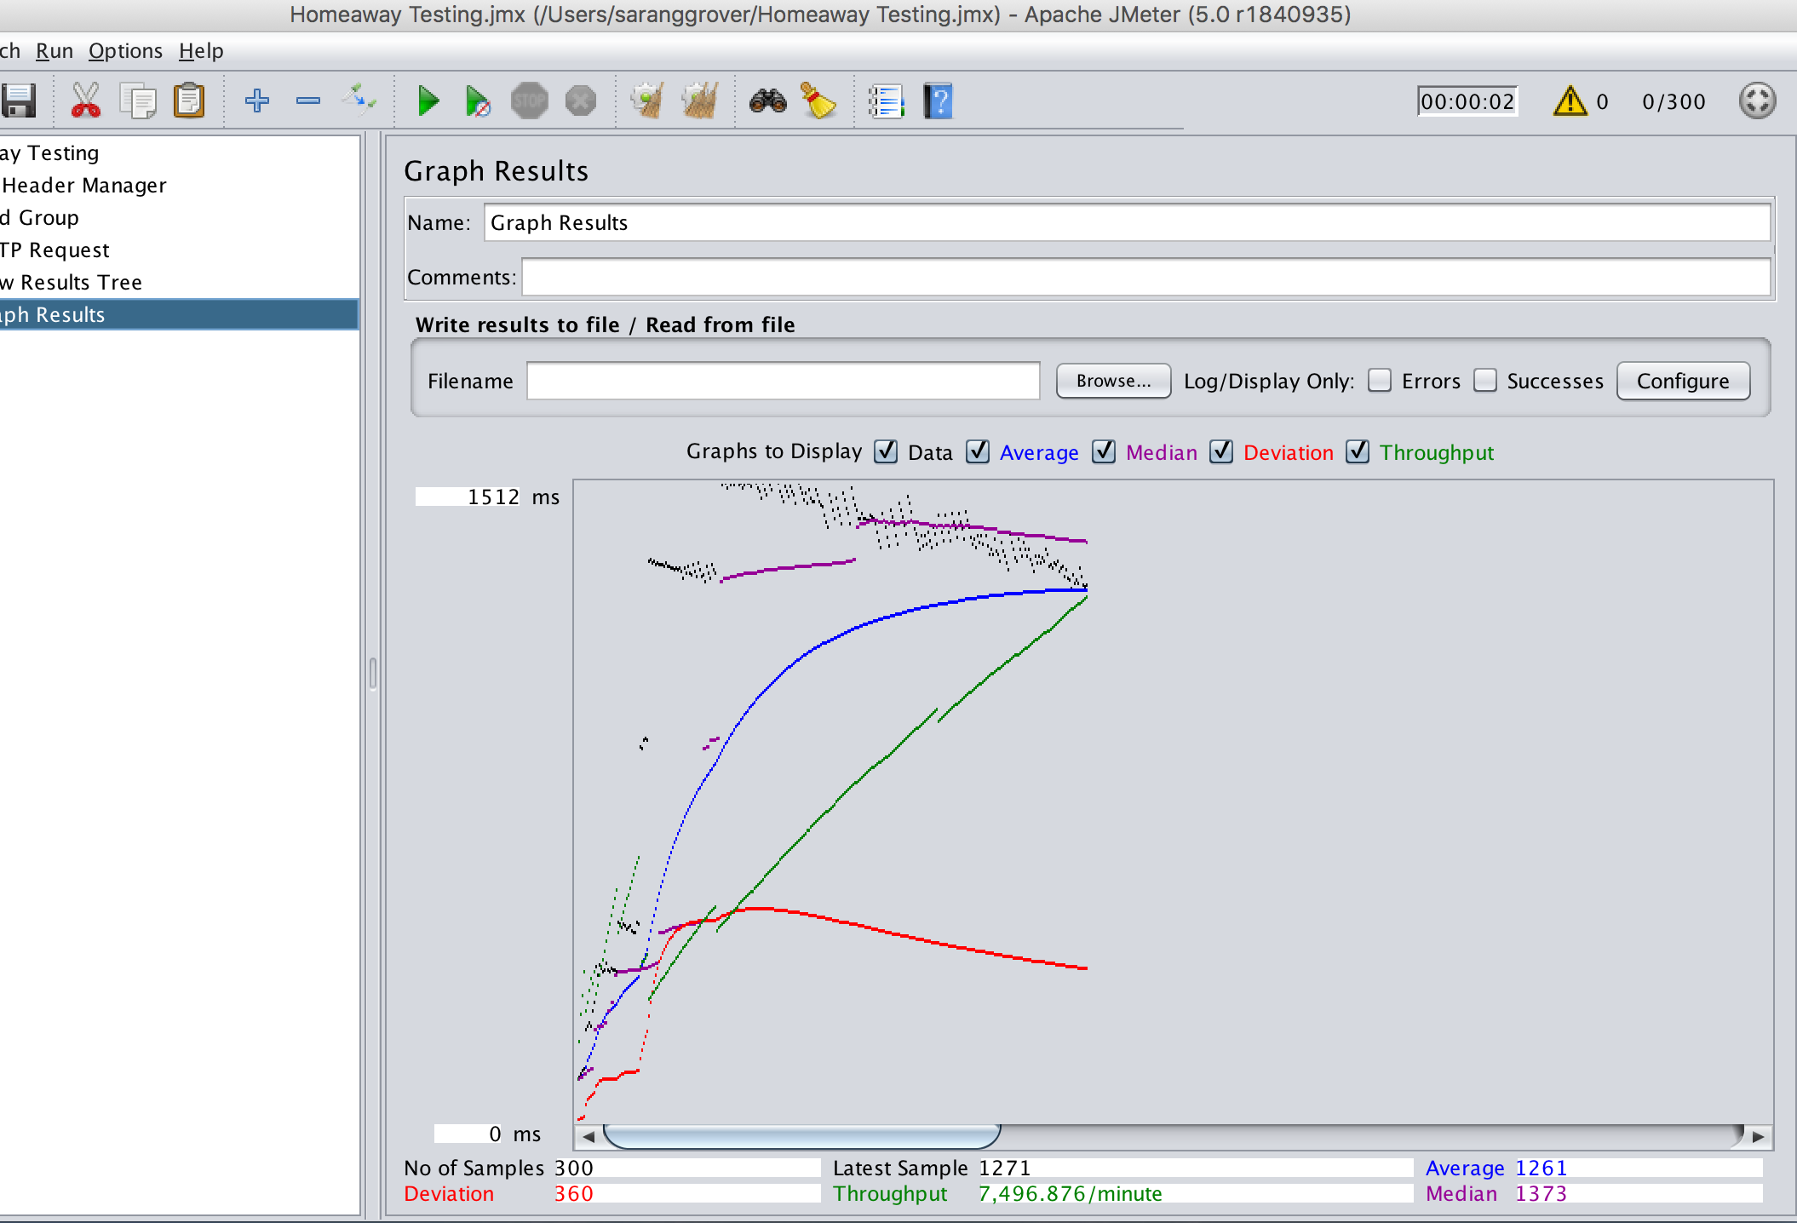

**iv) Book Property**

**100 users**

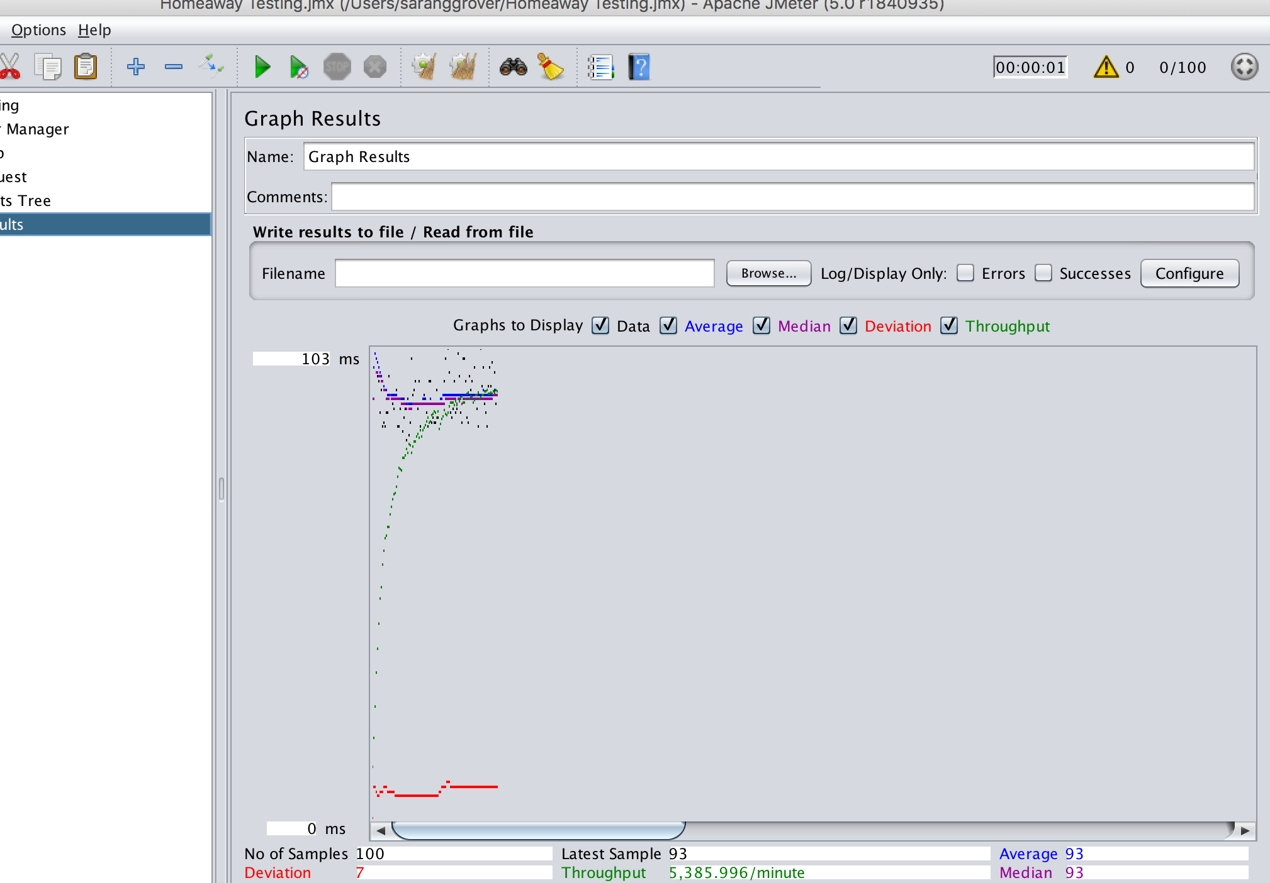

**200 users**

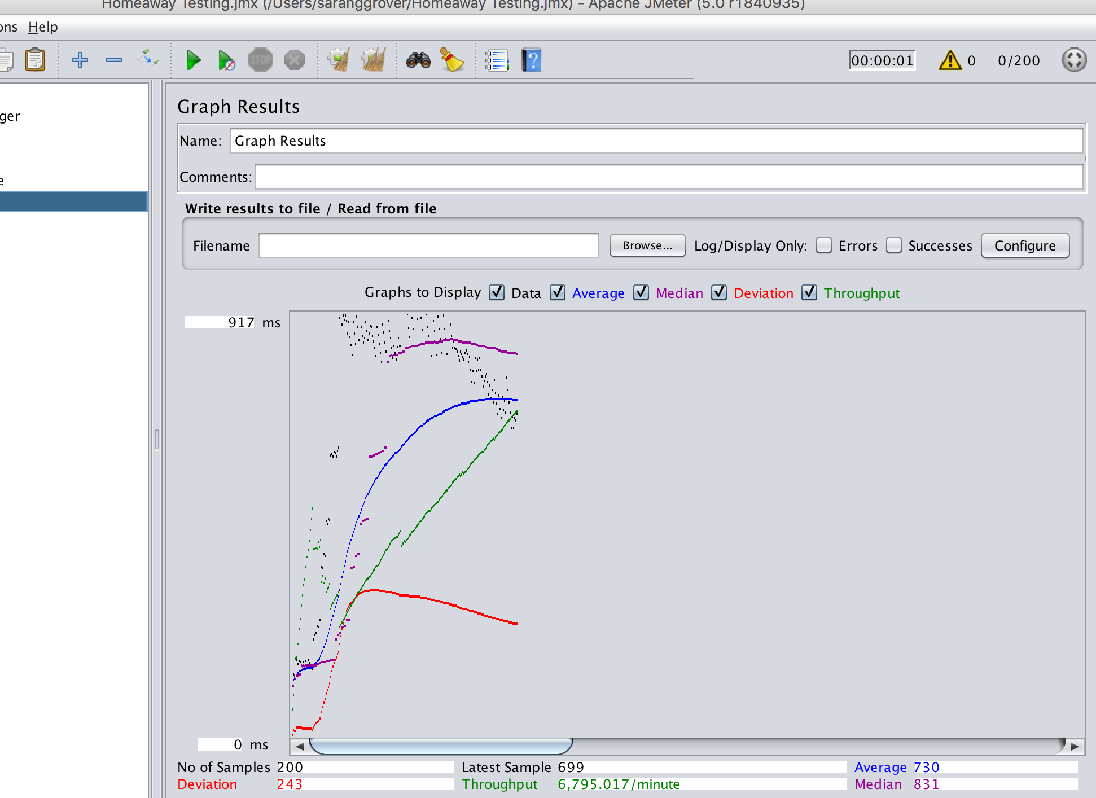

**300 users**

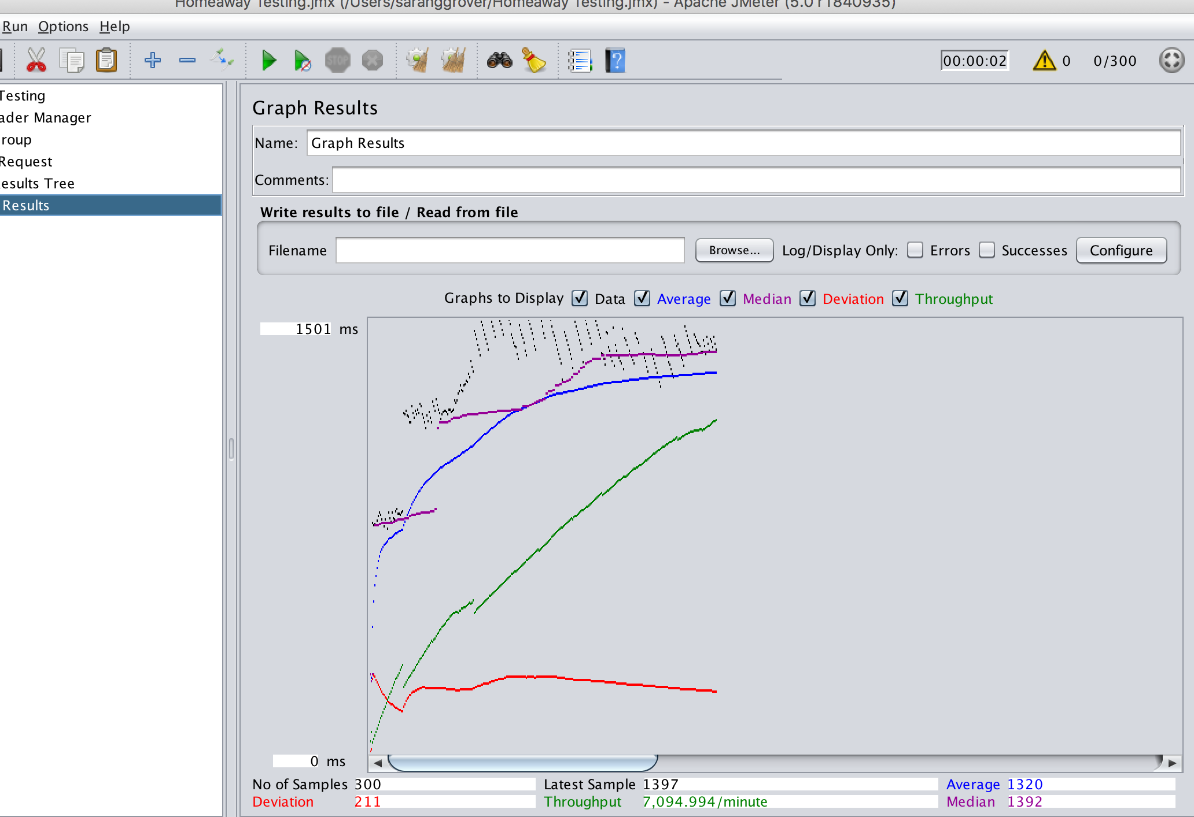

**v) Question from traveler**

**100 users**

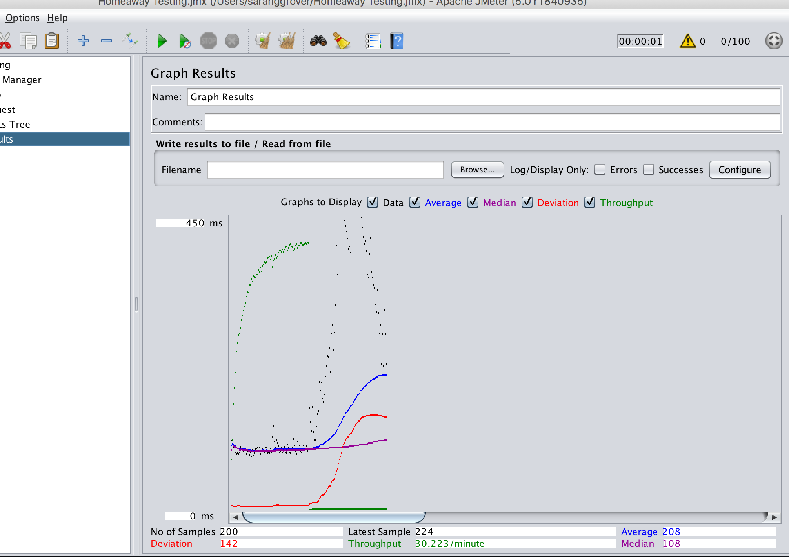

**200 users**

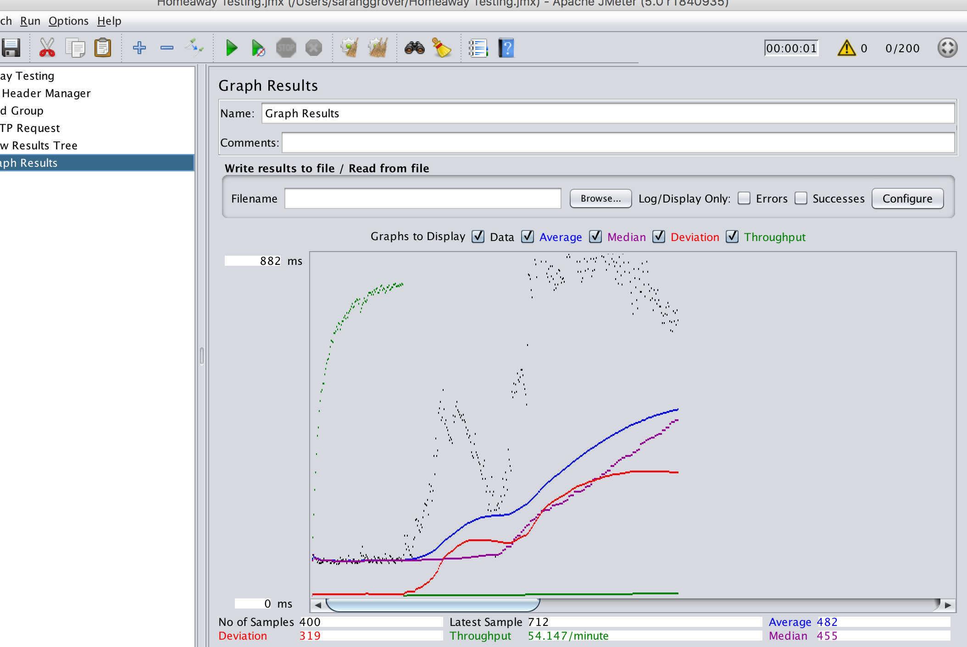

**300 users**

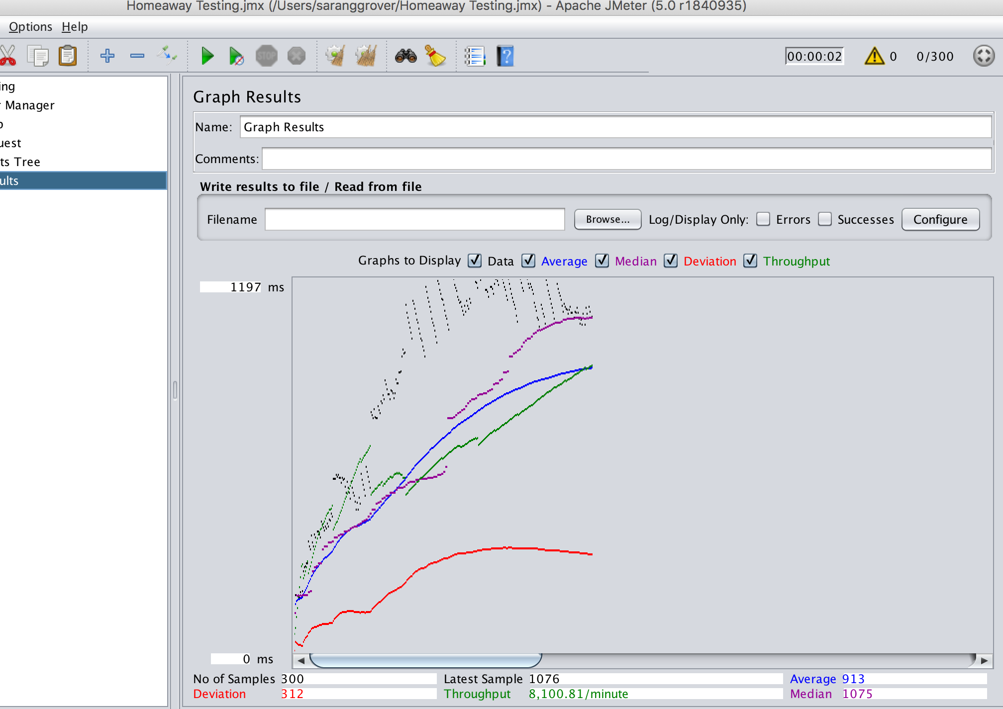

**n. Questions –**

**i) Compare the passport authentication process with the authentication process used in Lab 1**

HTTP requests are stateless. If we would like our states to be remembered.

we can use a session or a token.

In the session-based authentication, the server will create a session for the user after the user logs in. The session id is then stored on a cookie on the user’s browser. While the user stays logged in, the cookie would be sent along with every subsequent request. The server can then compare the session id stored on the cookie against the session information stored in the memory to verify user’s identity and sends response with the corresponding state.

In the token-based authentication, the server creates JWT with a secret and sends the JWT to the client. The client stores the JWT (usually in local storage) and includes JWT in the header with every request. The server would then validate the JWT with every request from the client and sends response.

The biggest difference between the two is that the user’s state is not stored on the server, as the state is stored inside the token on the client side instead. JWT based authentication is a more scalable strategy as token is stored on client side whereas in session-based authentication, sessions are stored on the servers and scaling becomes an issue for large number of users. JWT is also greatly used for mobile device authentication. Also Cookies normally work on a single domain or subdomains and they are disabled by browser if they work cross-domain .

**ii) Compare performance with and without kafka. Explain in detail the reason for difference in performance.**

The performance of the application increased substantially with kafka as can be seen in the Jmeter screenshots. The average and median of the test apis is almost similar and the throughput is high even for a high number of users.

The reason for this amazing performance is the High-Throughput of Kafka. Without having not so large hardware, Kafka is capable of handling high-velocity and high-volume data and able to support message throughput of thousands of messages per second. Kafka is capable of handling the messages with the very low latency of the range of milliseconds, demanded by most of the new use cases. The distributed architecture of Kafka makes it scalable using capabilities like replication and partitioning. Kafka is able to handle thousands of messages per second and that too in low latency conditions with high throughput. In addition, it permits the reading and writing of messages into it at high concurrency.

**iii) If given an opportunity to implement both mysql and mongodb in your application, which data will you store in mysql and mongodb respectively?**

MongoDB is a document database in which one collection holds different documents. Number of fields, content and size of the document can differ from one document to another. There are no complex joins and MongoDB is easy to scale.

MySql is a relational database management that enables you to implement a database with tables, columns and indexes.

In my application, I will use mongodb for traveler, owner and property data management due to high scalability and fast processing of mongodb.

I will use mysql for booking and transaction management as mysql provides full data integrity with features such as complete atomic, consistent, isolated, durable transaction support; multi-version transaction support; and unrestricted row-level locking

-------------------------------------------------------------------------------

Owner and Traveler credentials with more properties and bookings to check pagination

1) Traveler – [nikita.sehgal28@gmail.com](mailto:nikita.sehgal28@gmail.com)

Password – nikita

2) Owner – [sarang@gmail.com](mailto:sarang@gmail.com)

Password – sarang

3) AWS url: 18.221.3.106:3000

**AWS SCREENSHOTS**

The application is deployed on Amazon Web services and the url to access it is **18.221.3.106:3000.**

**Here are the AWS client and server screenshots of the major routes.**

**1) Register Traveler—**

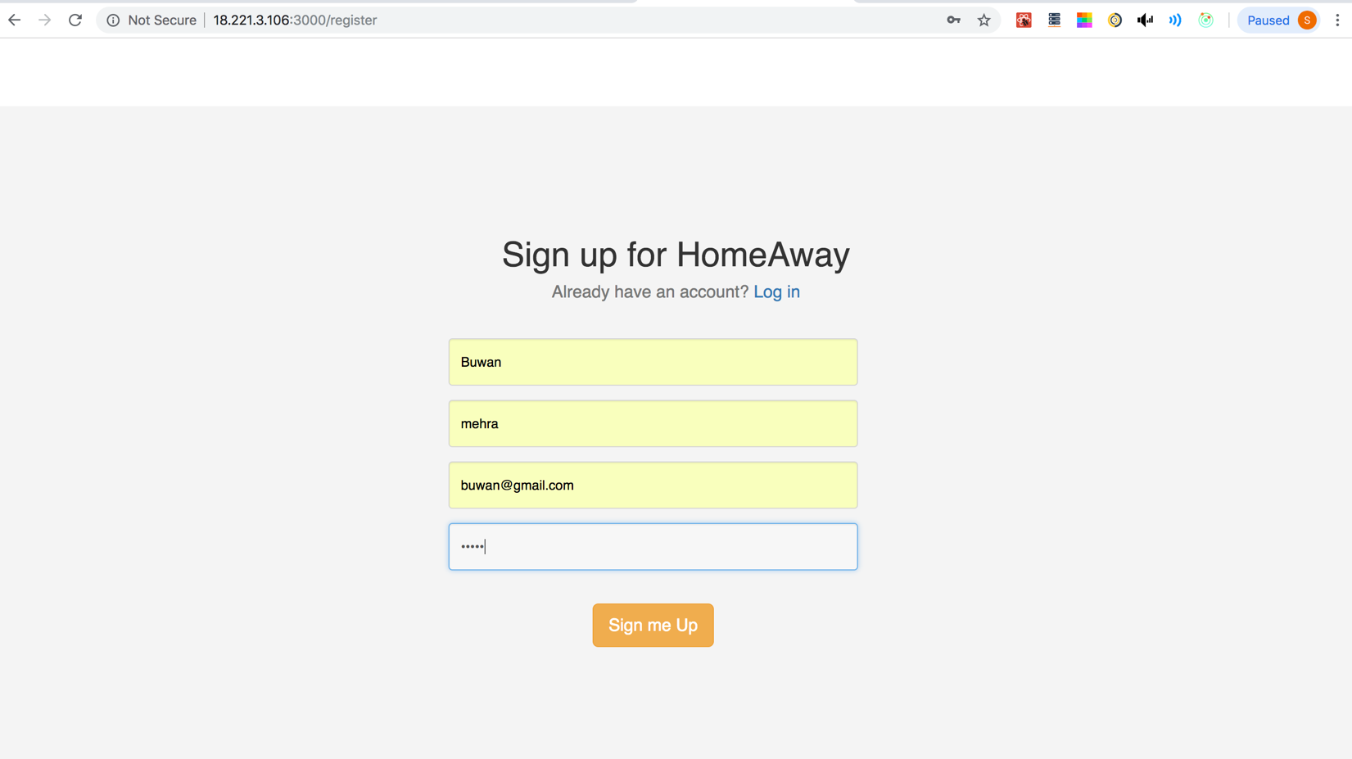

**Kafka Backend –**

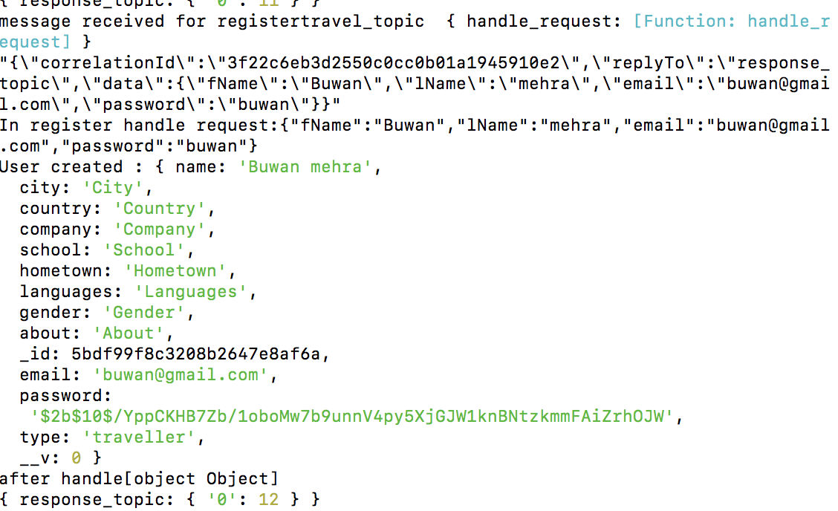

**Node Backend—**

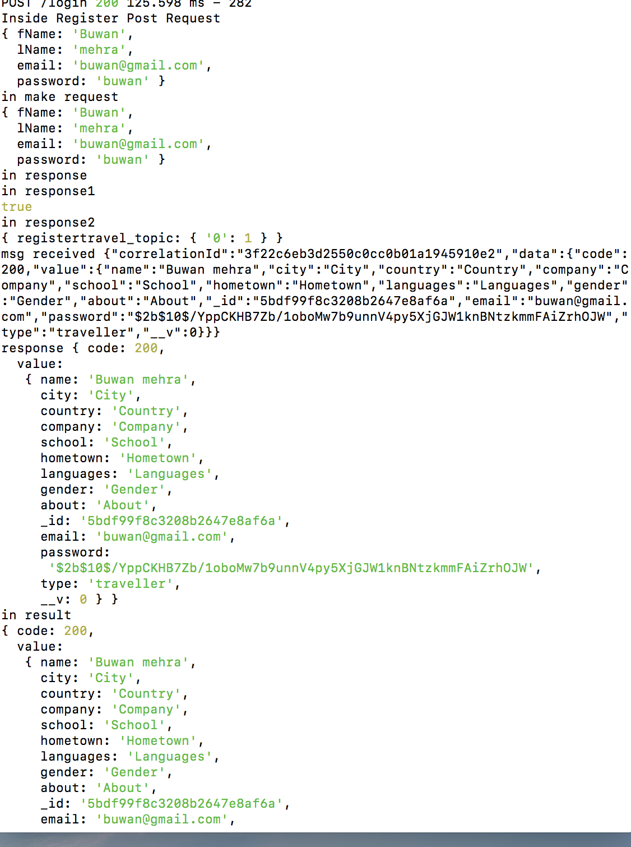

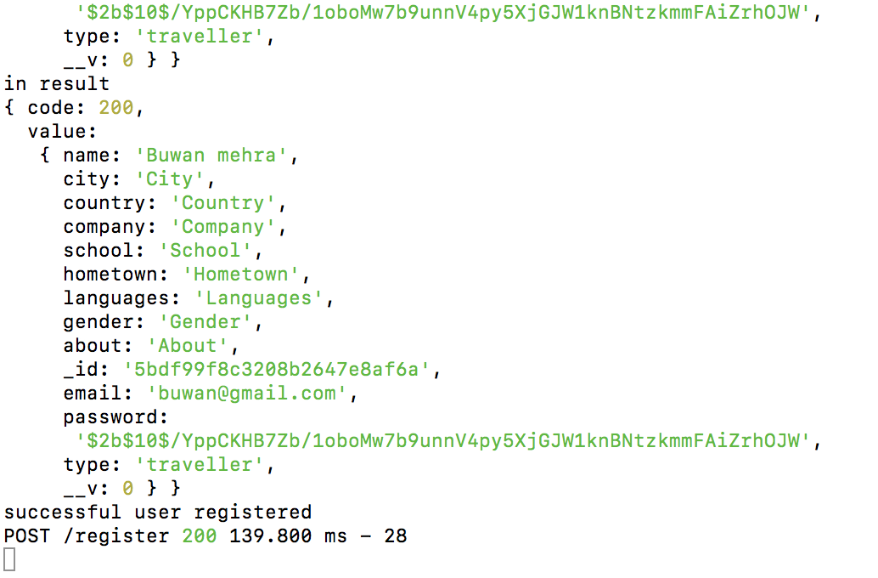

**2) Register Owner**

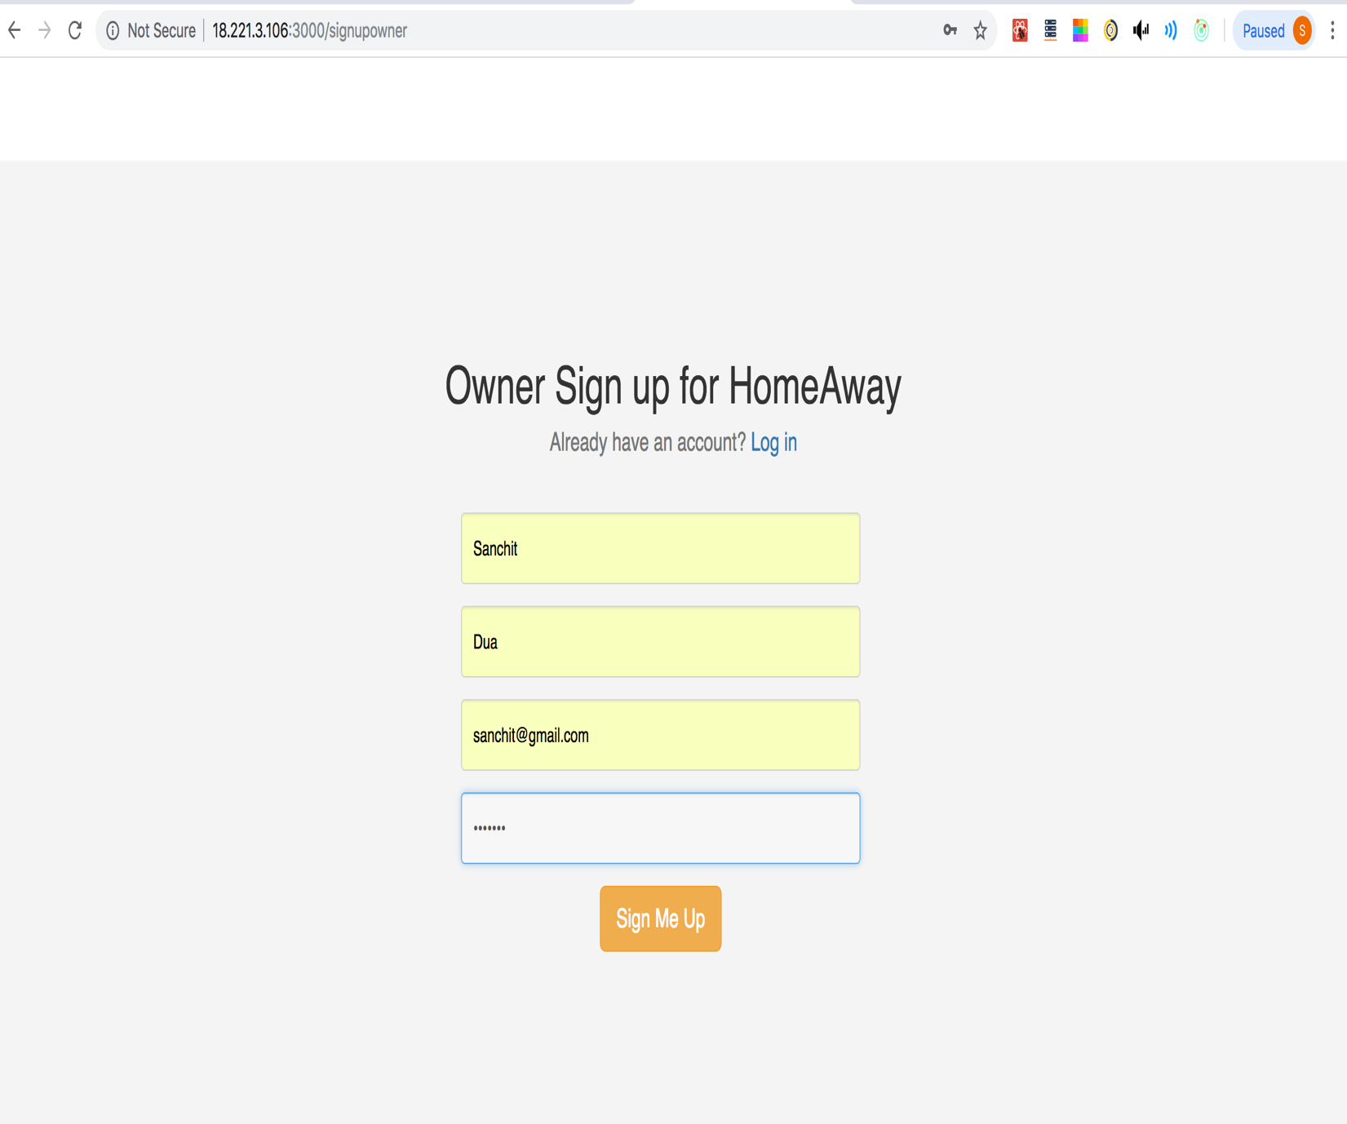

**Kafka Backend**

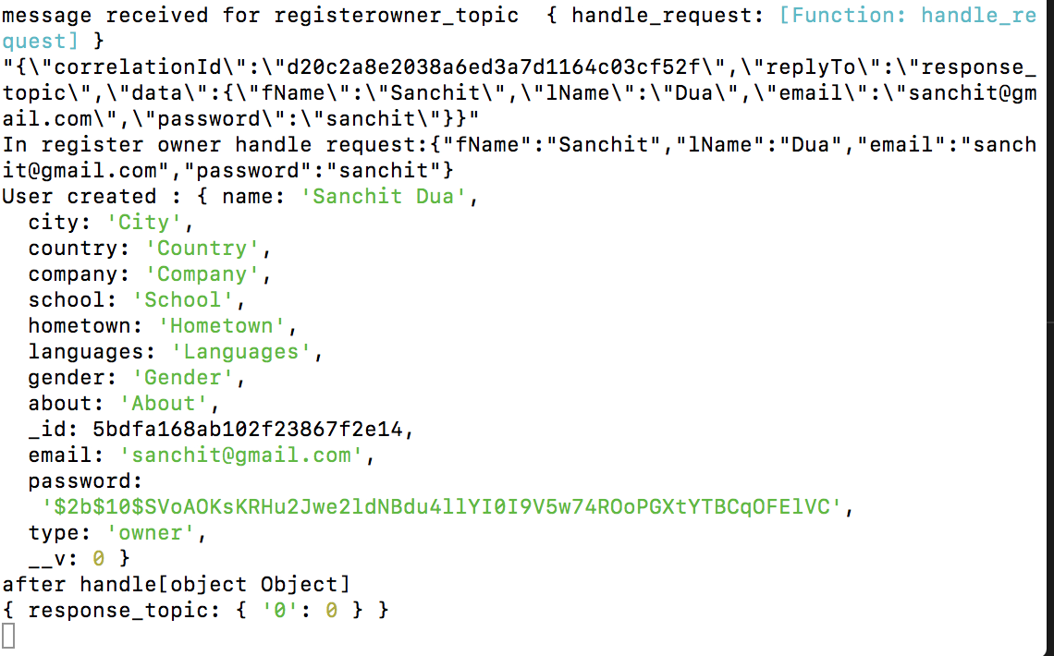

**Node Backend**

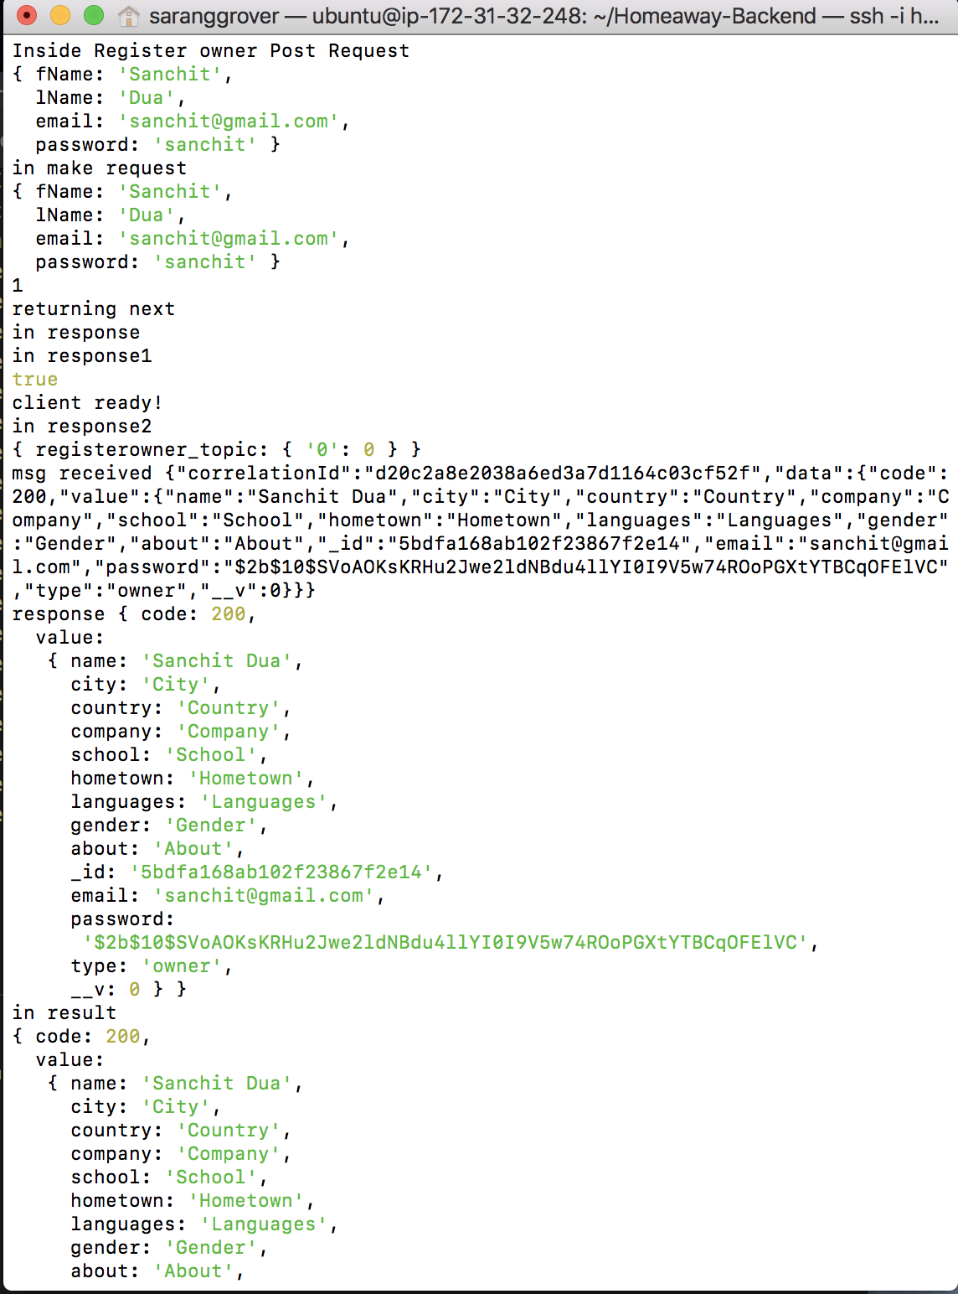

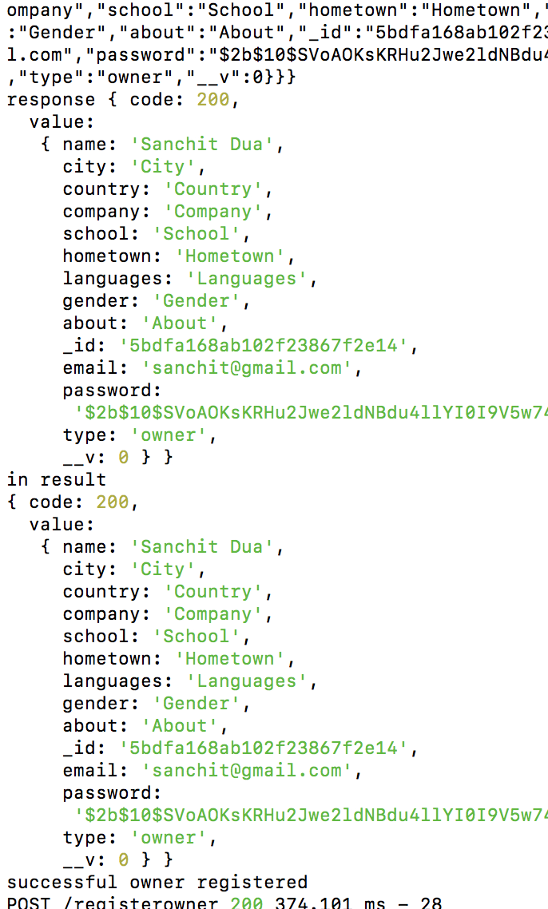

**3) Login Traveller**

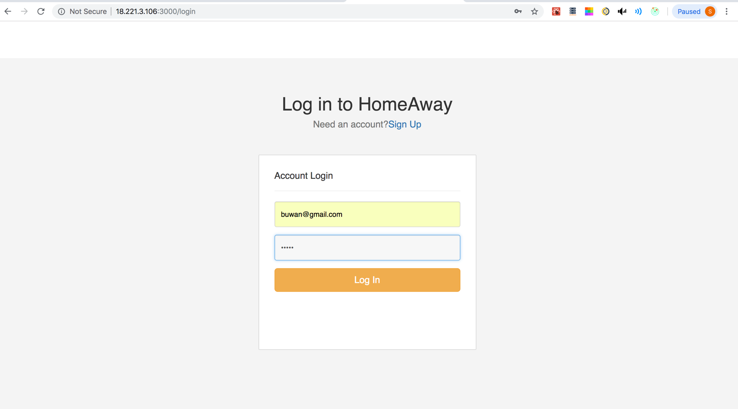

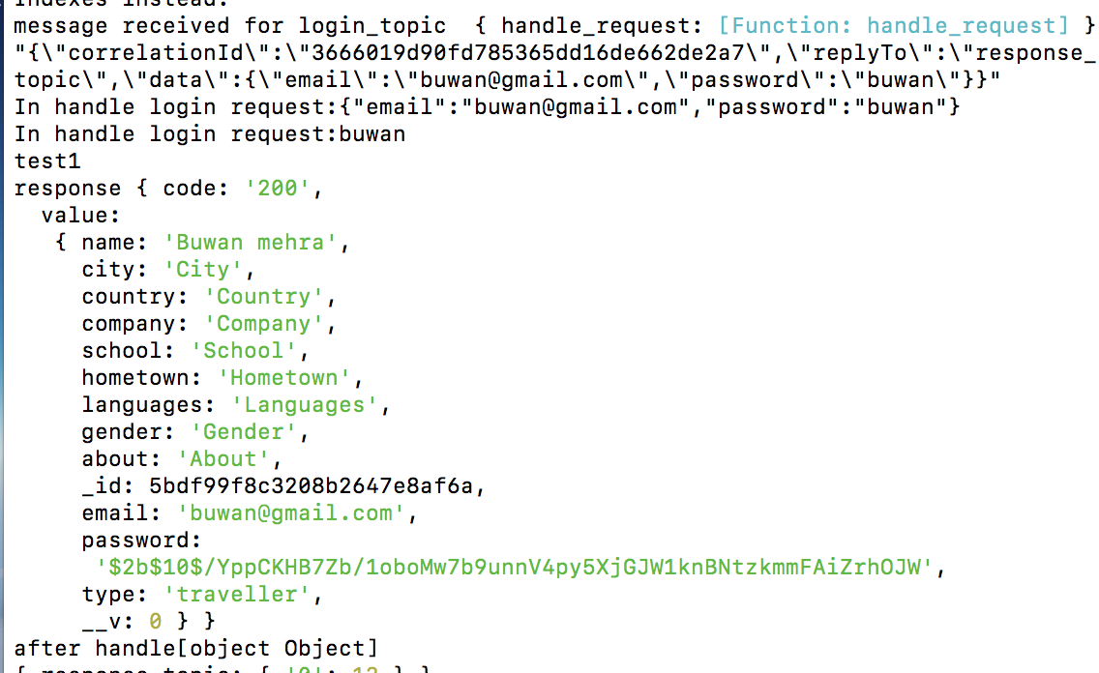

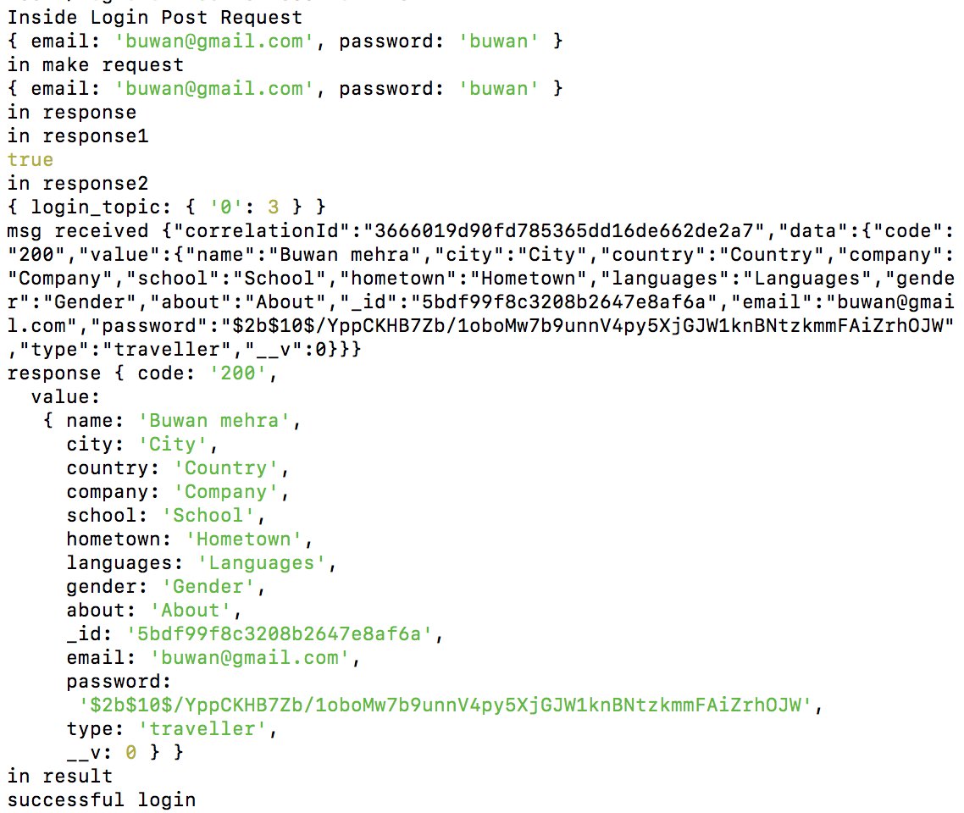

**4) Owner Login**

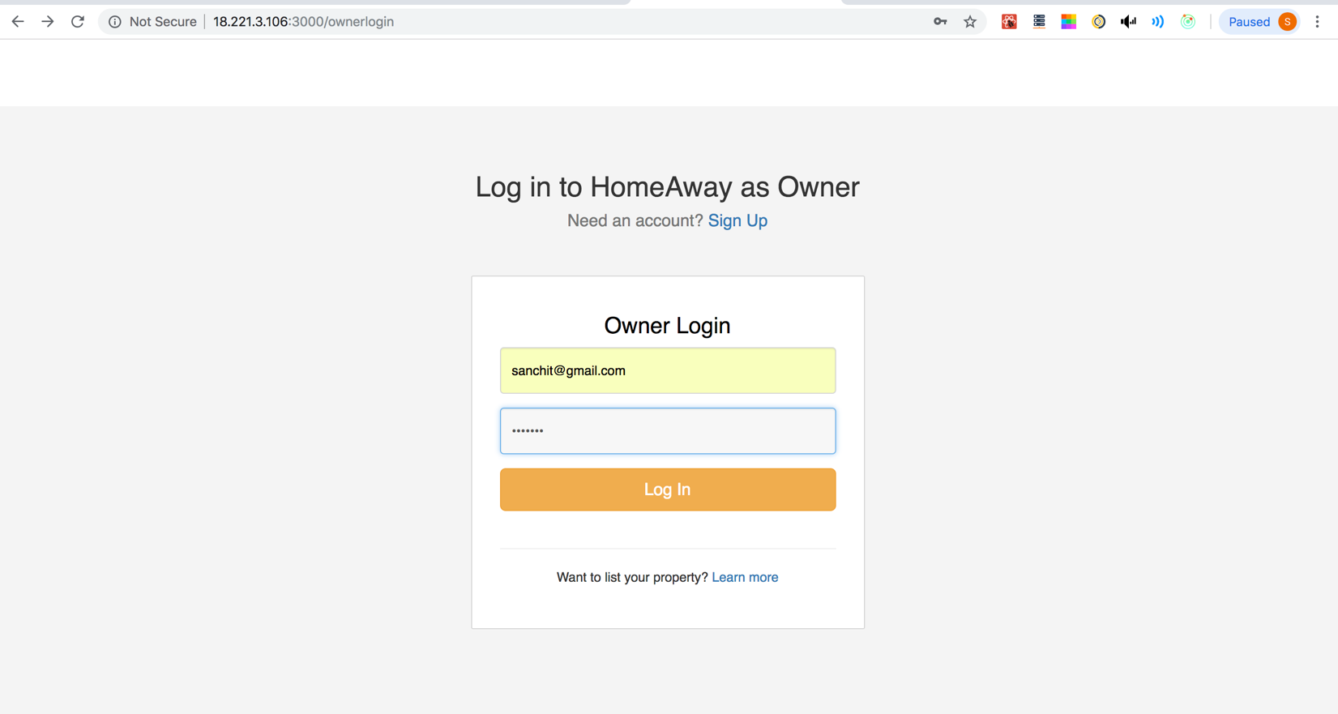

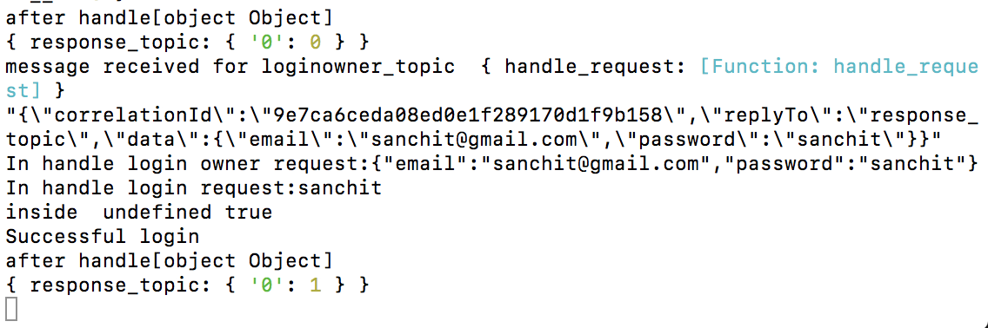

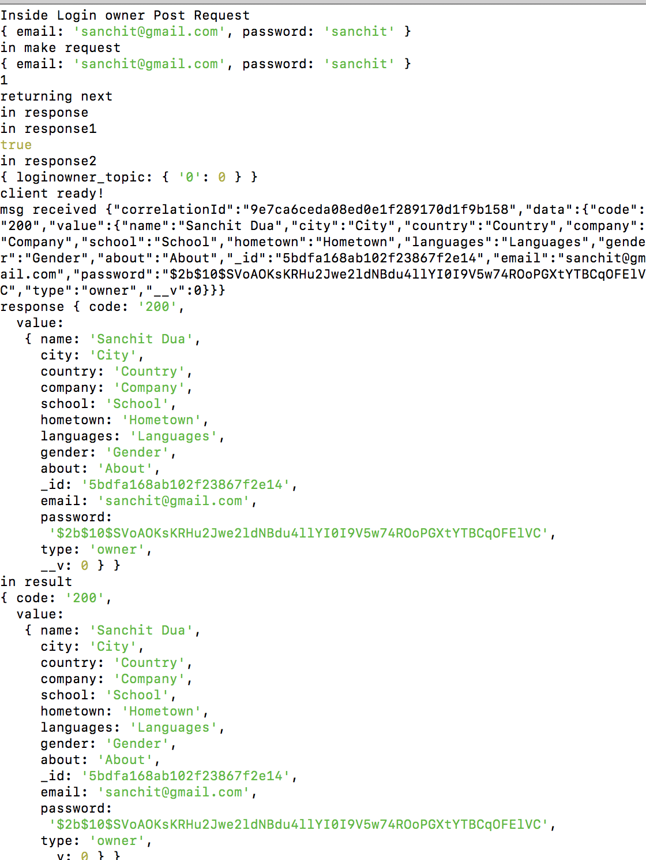

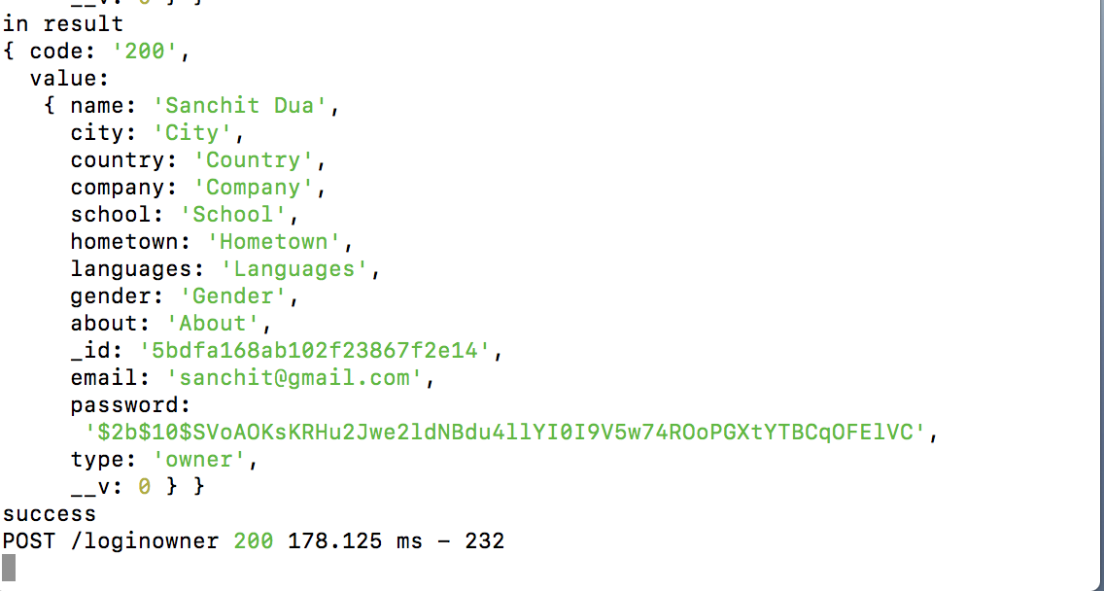

**5) Search for Property**

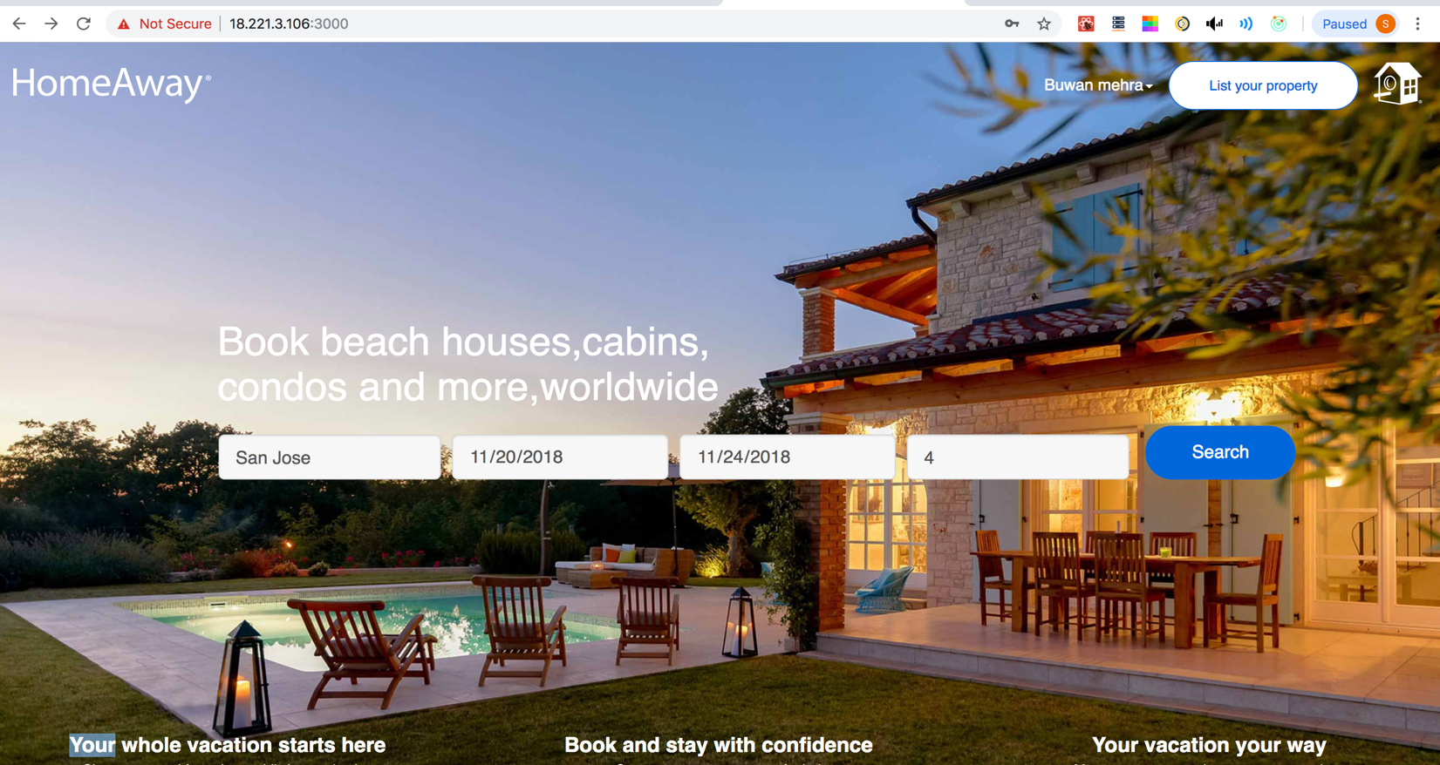

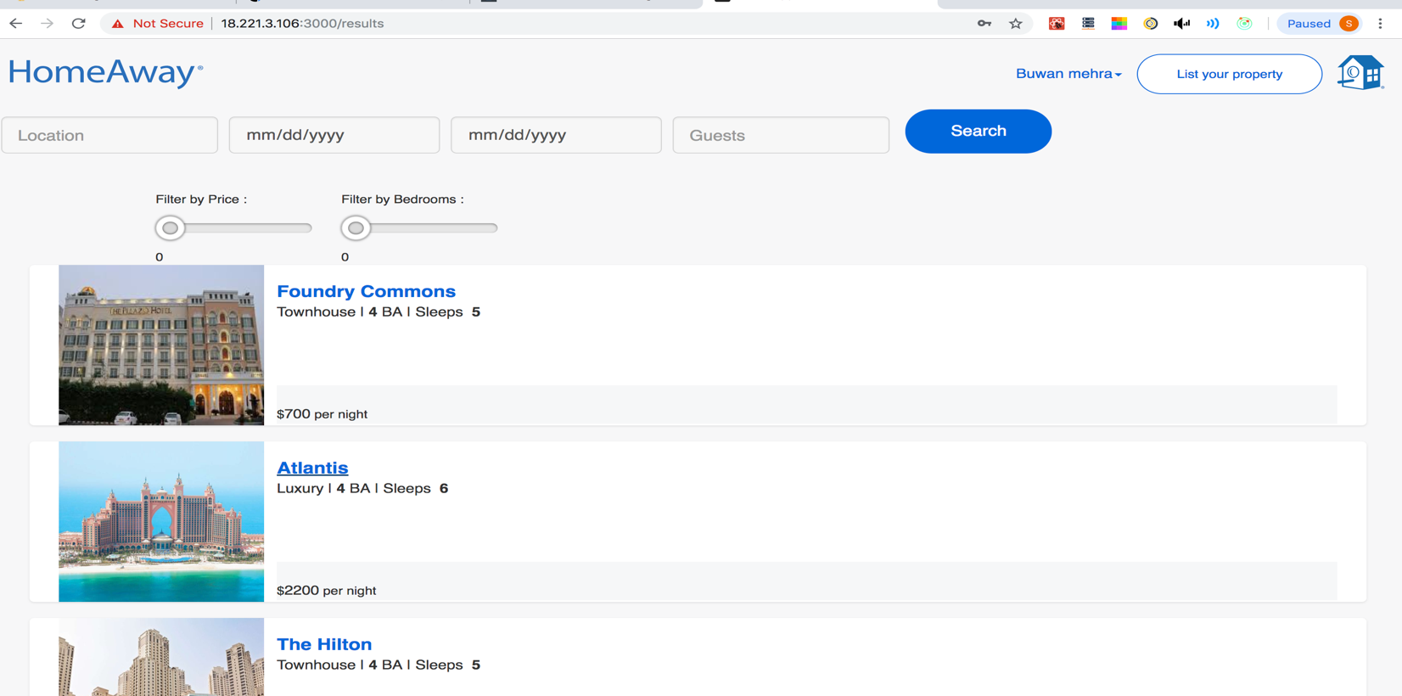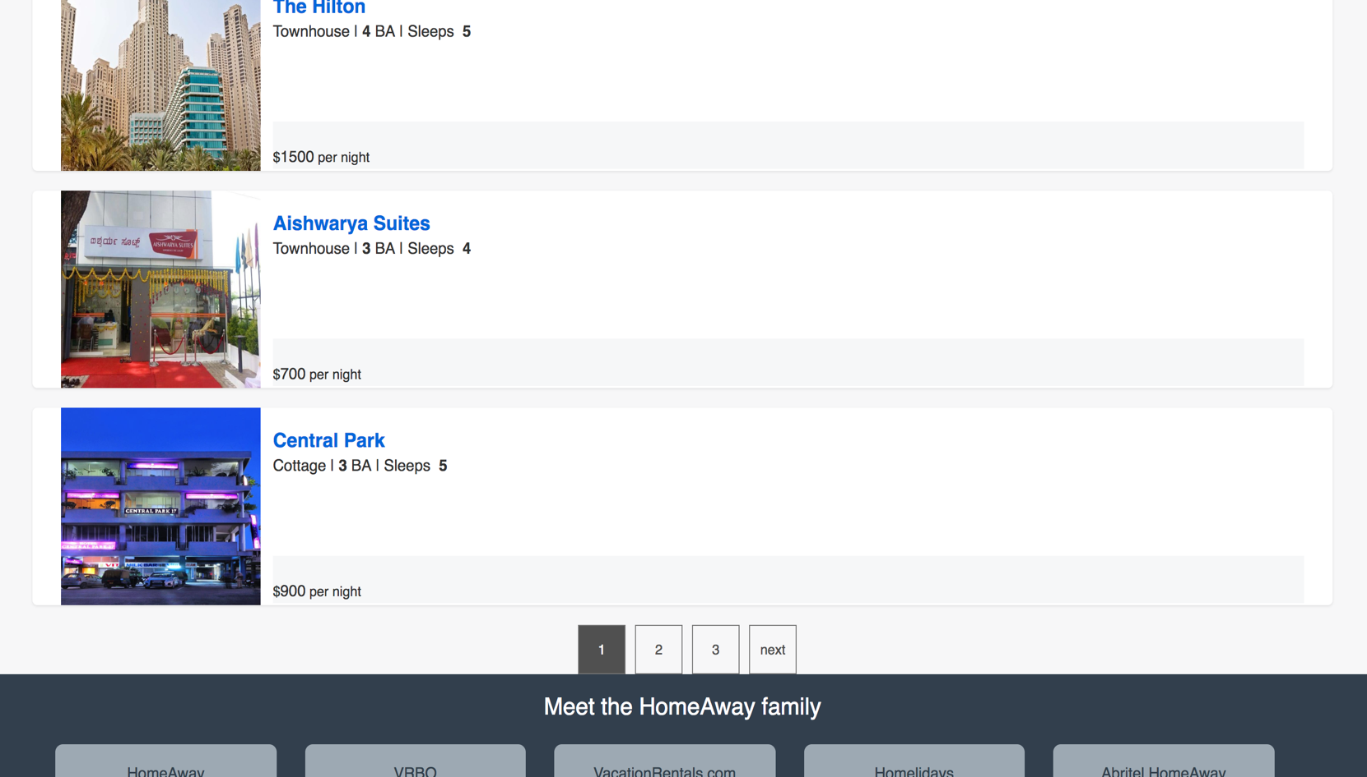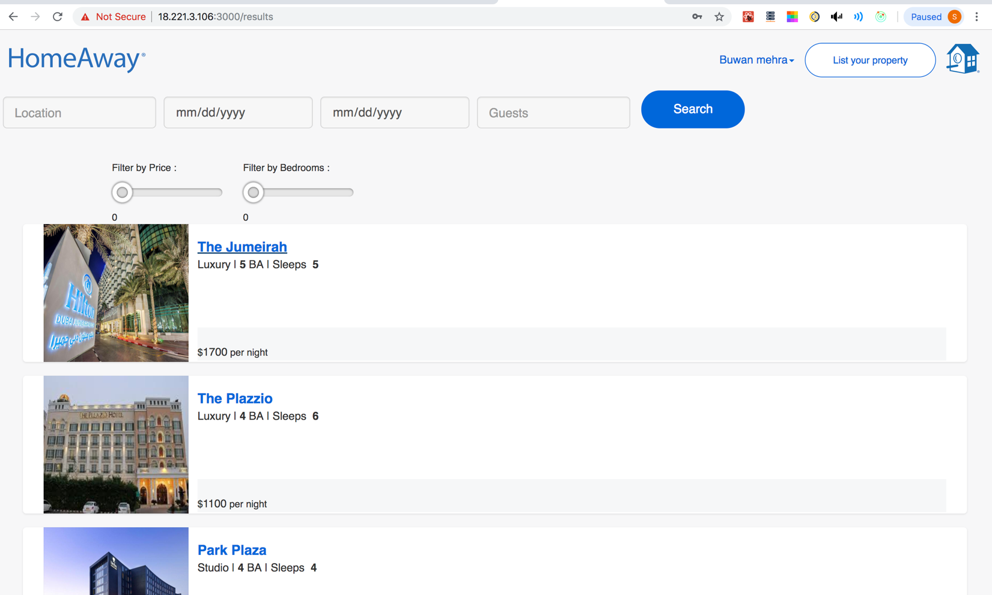

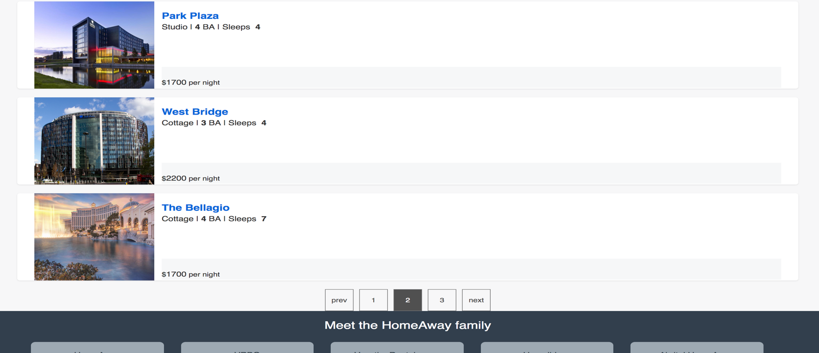

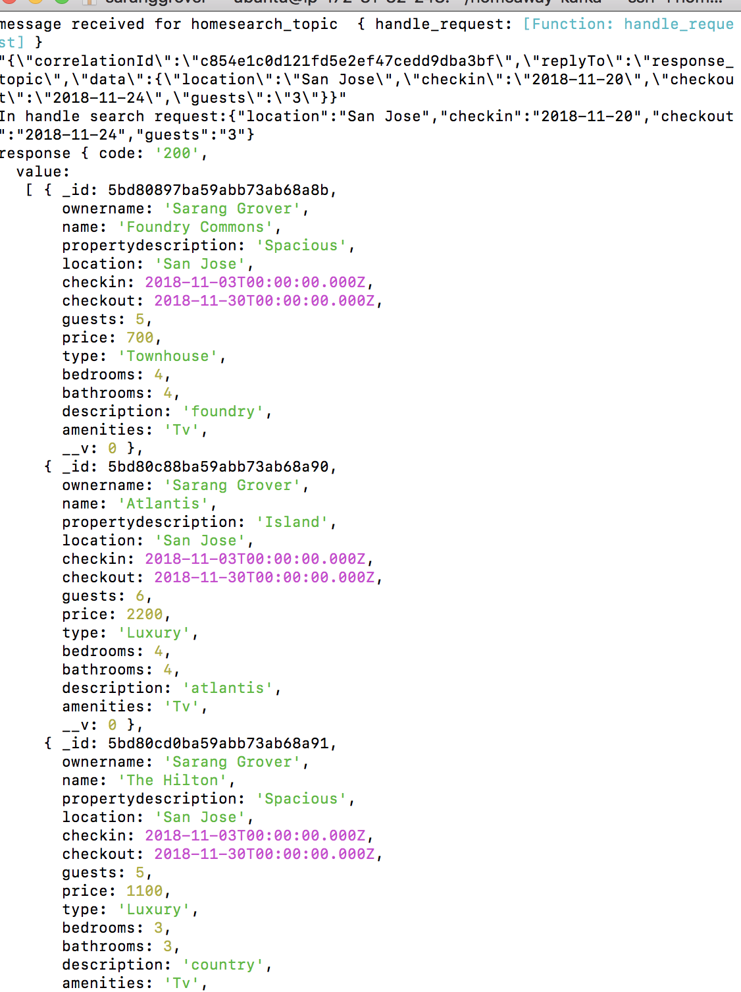

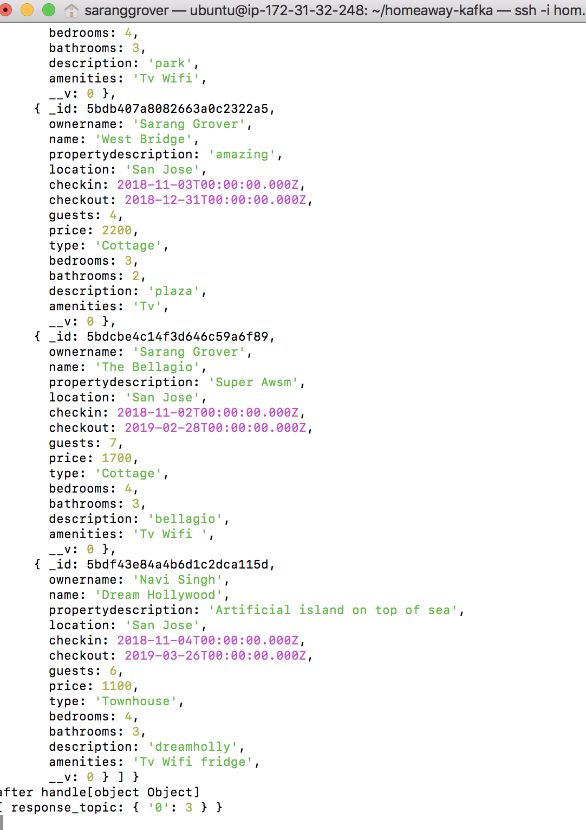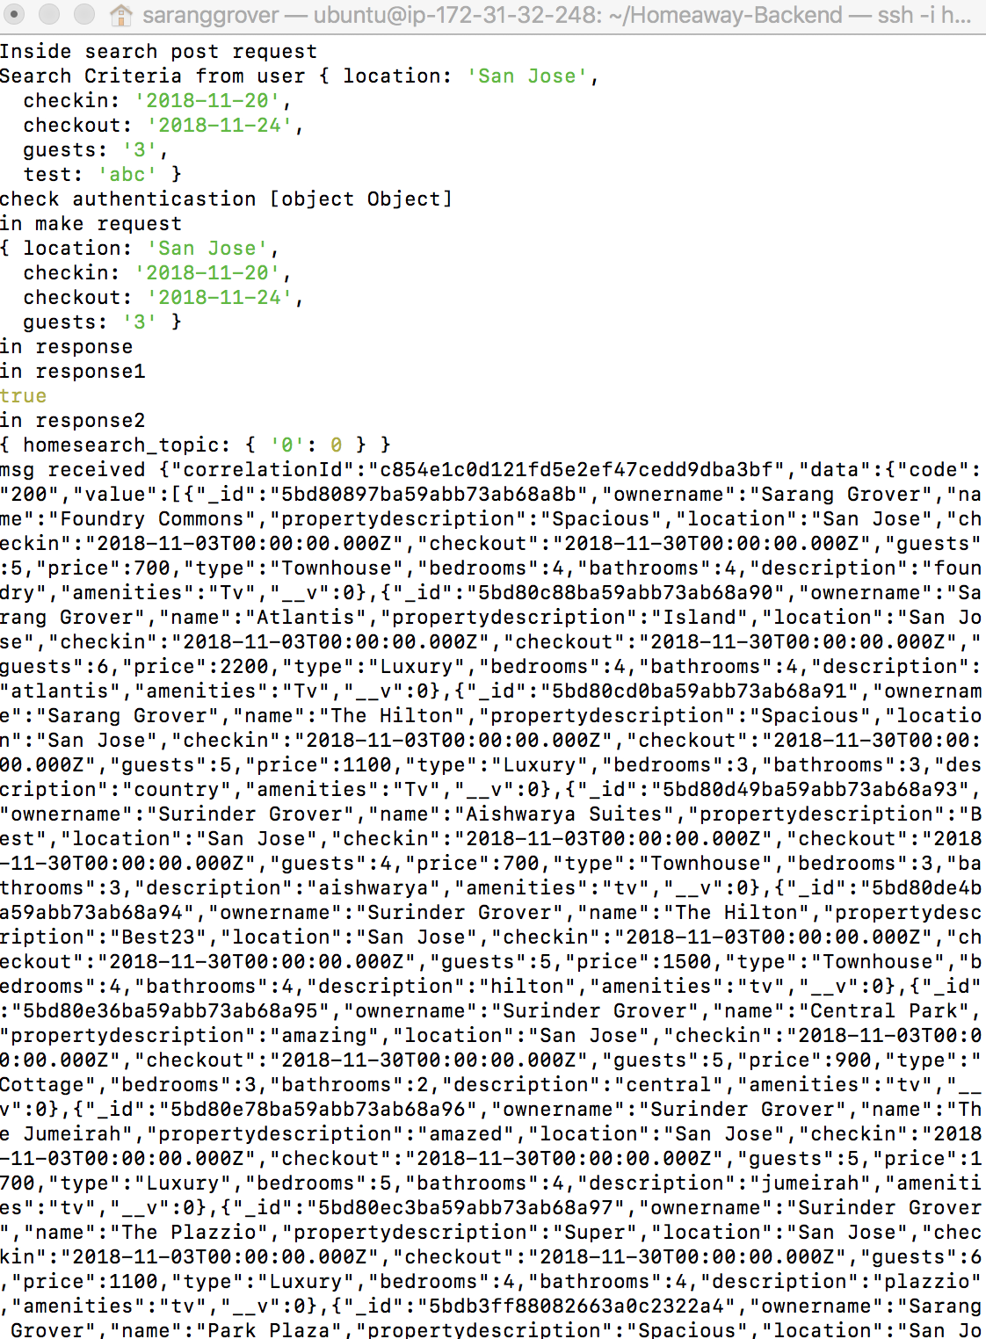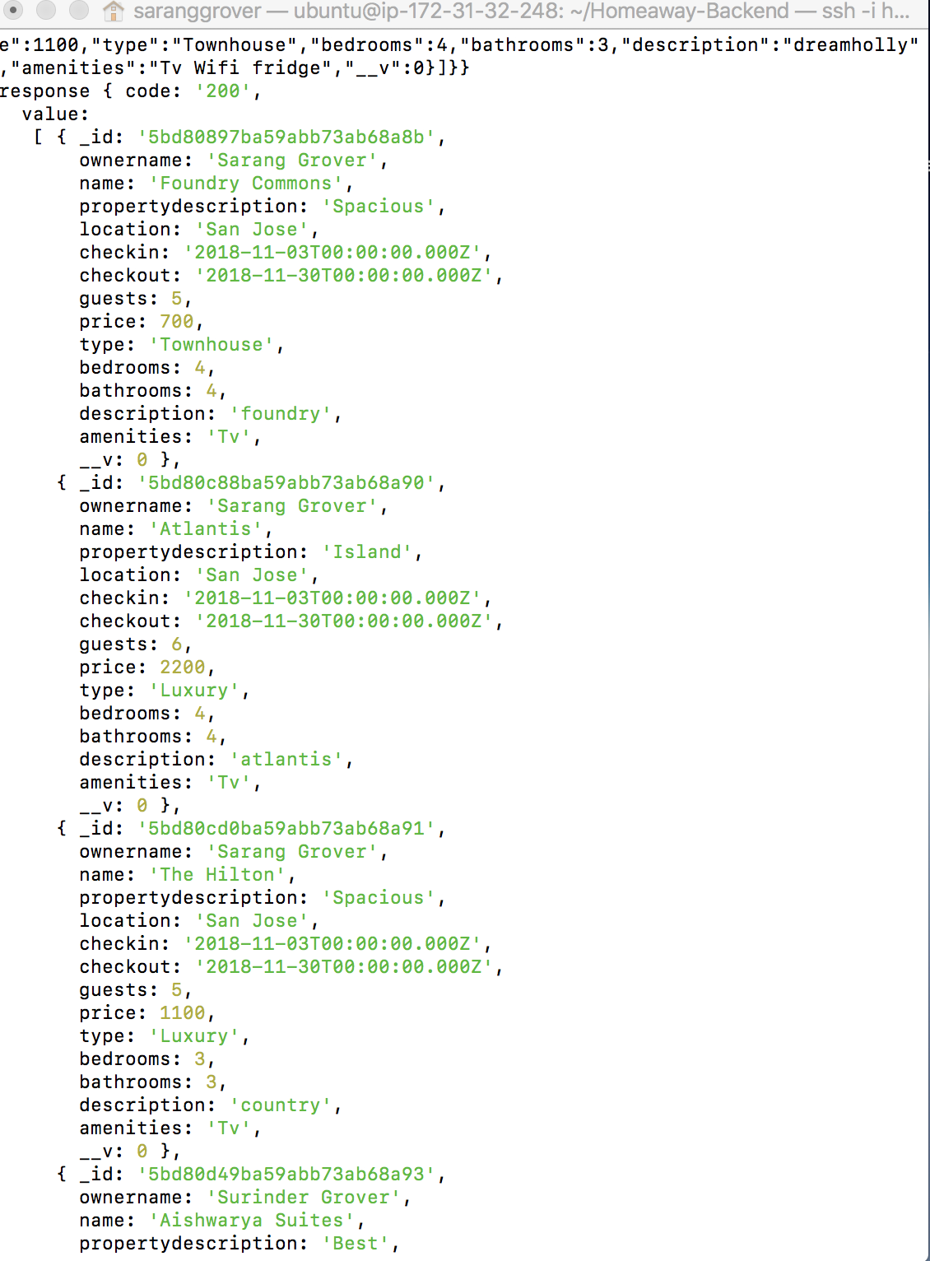

**6) Display Property to Book**

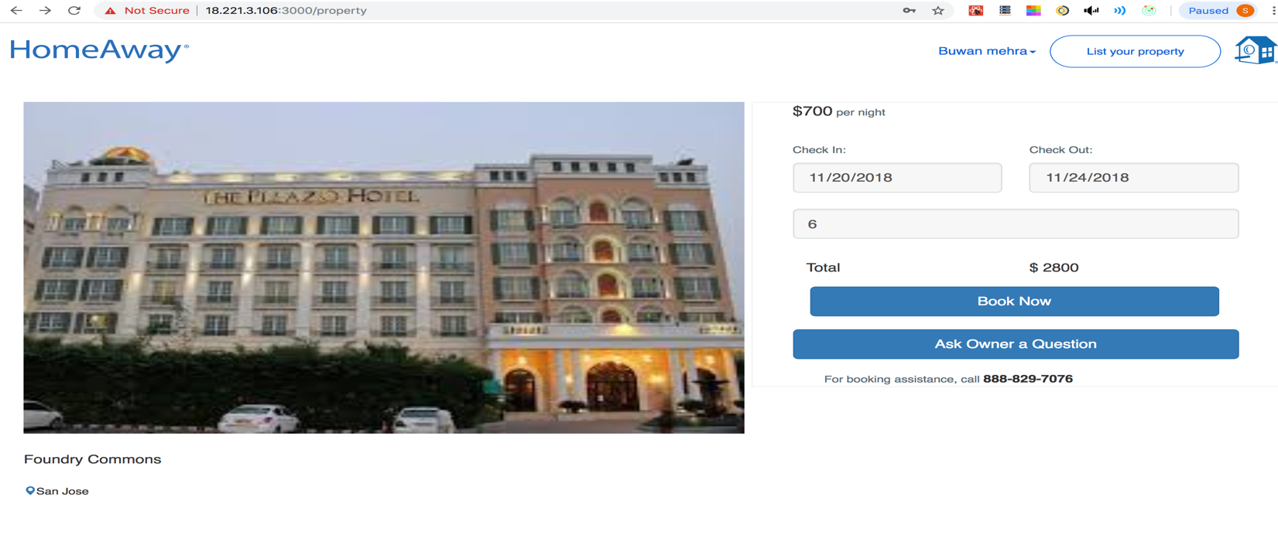

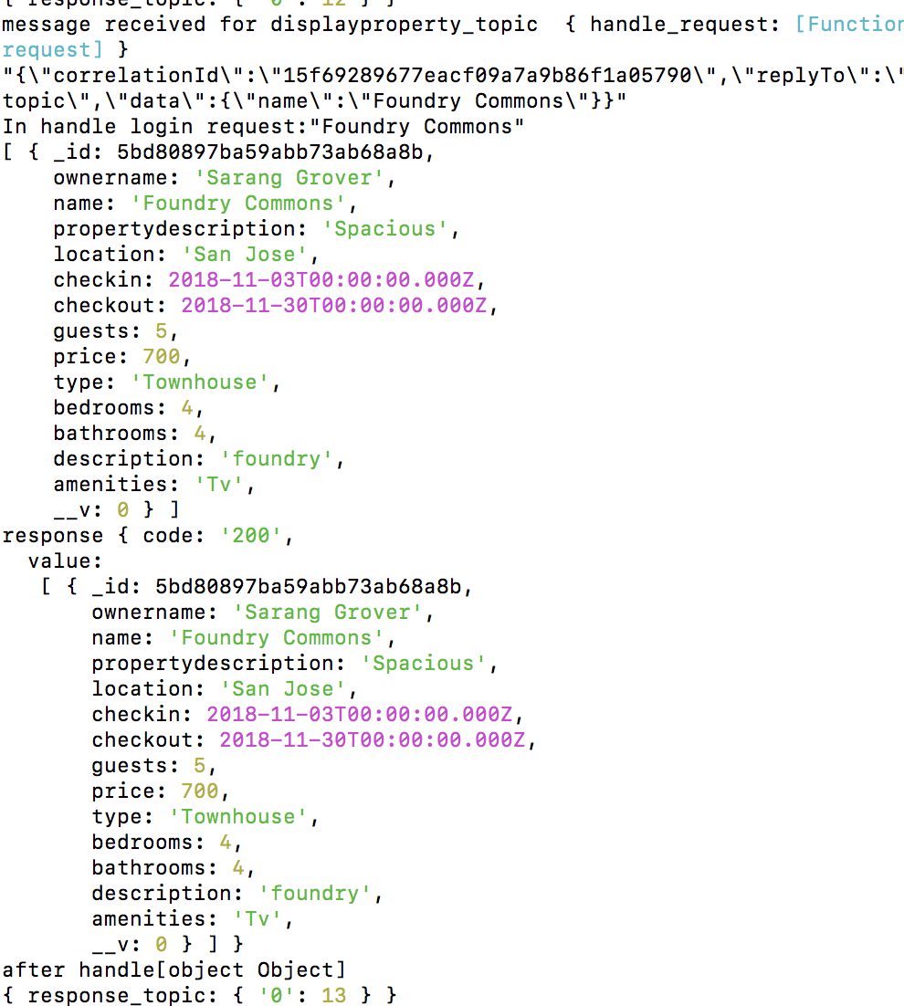

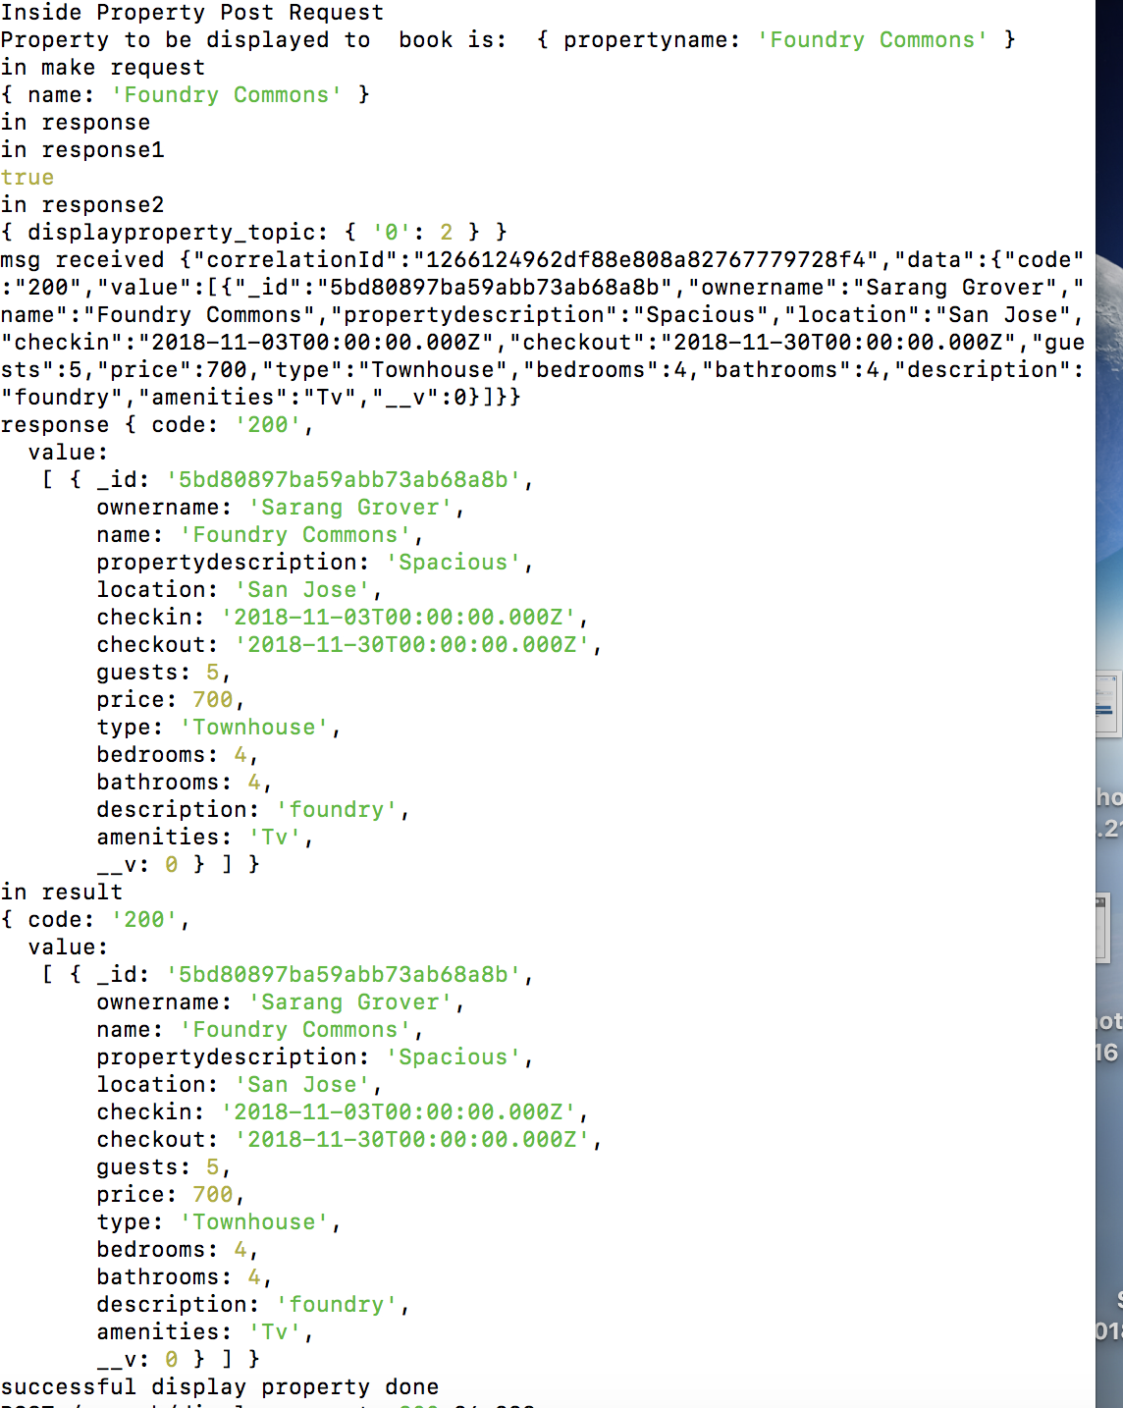

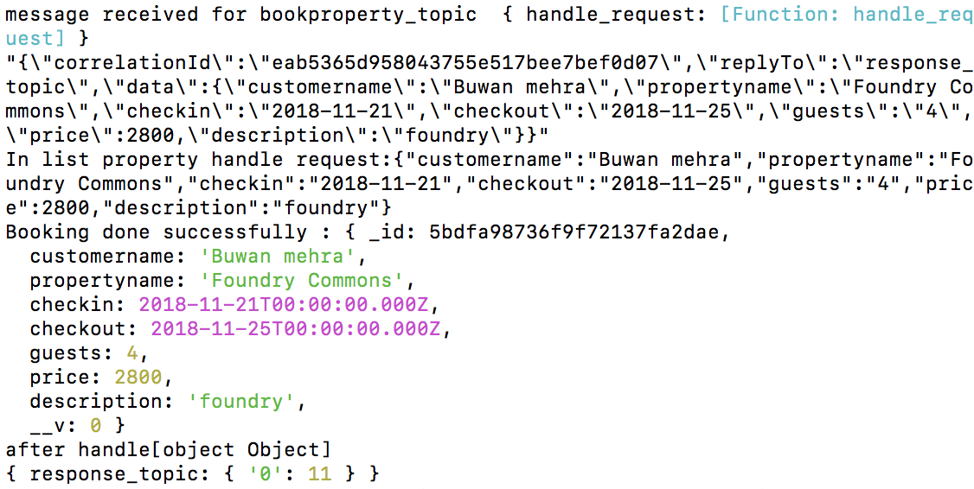

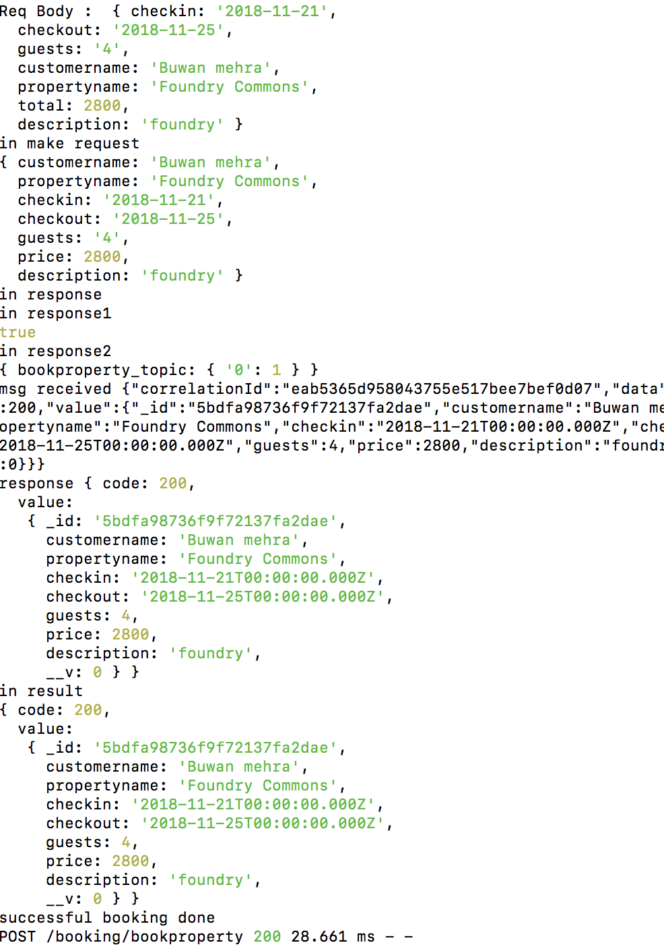

**6) Travel Dashboard**

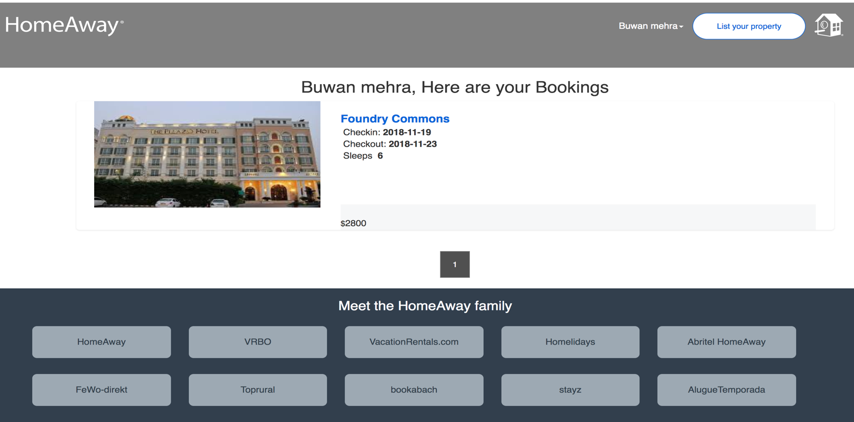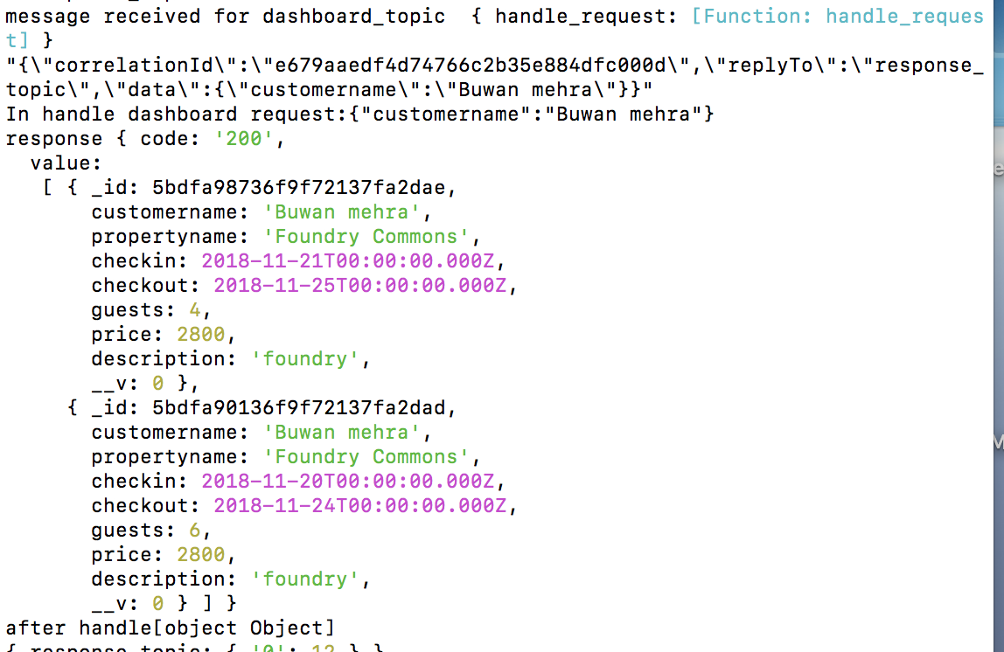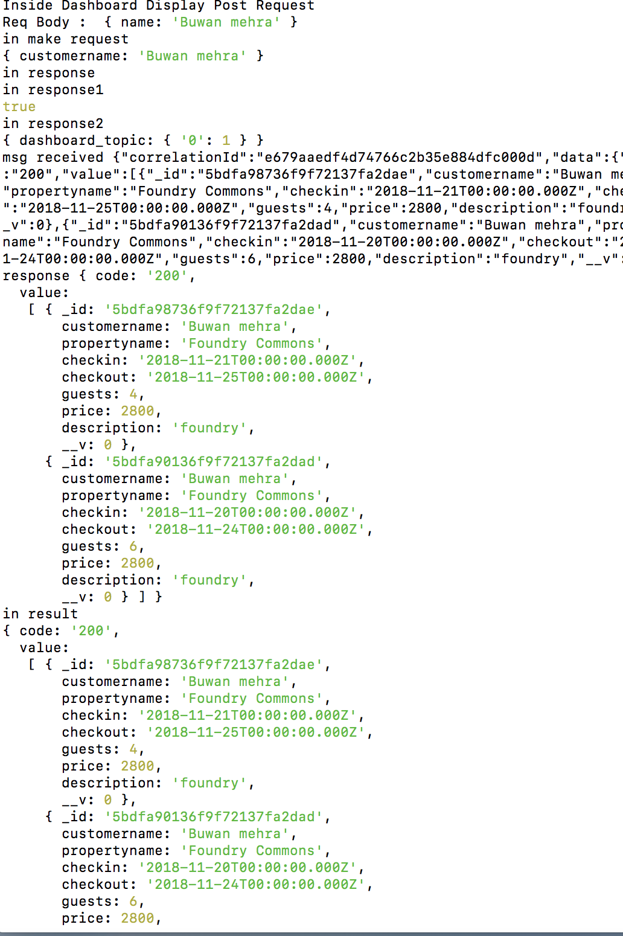

**7) Traveller and Owner message queue**

**Traveller asks a question**

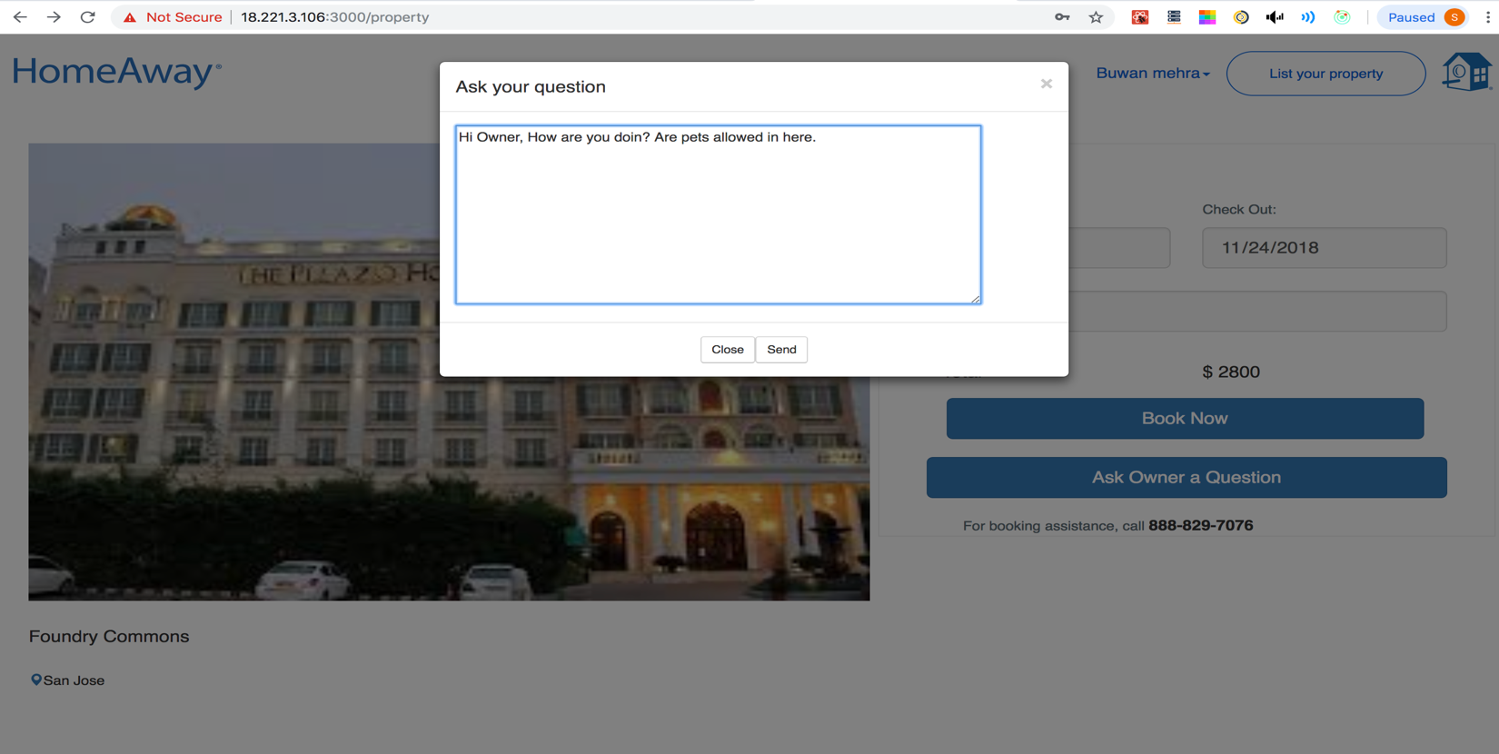

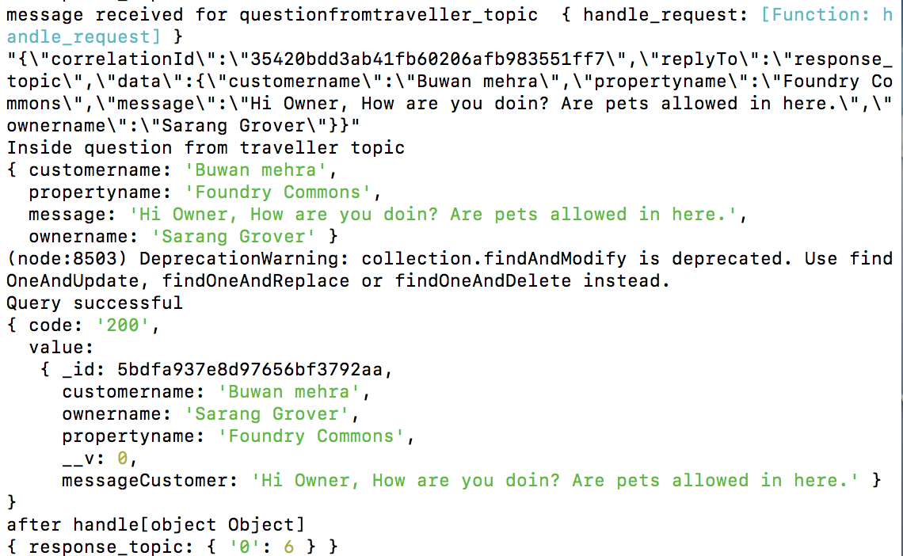

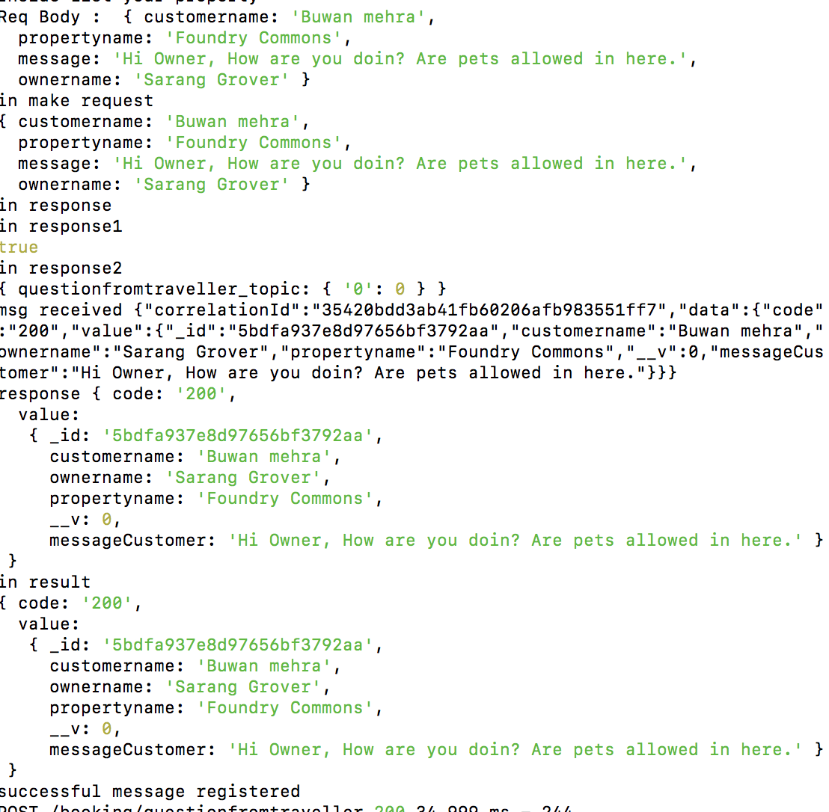

**Message Goes in Owner Inbox**

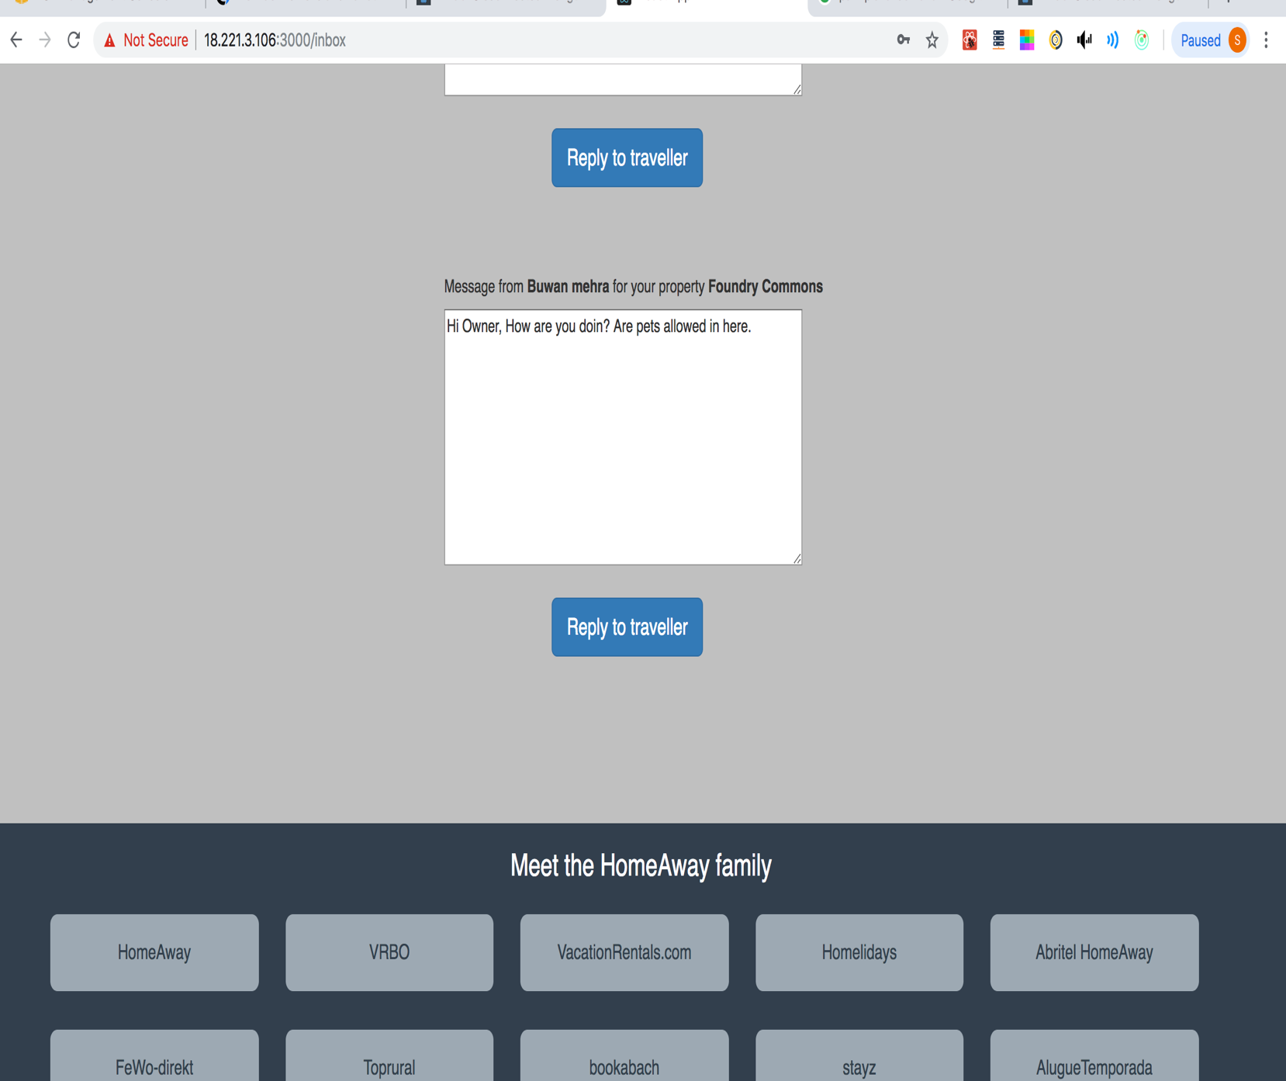

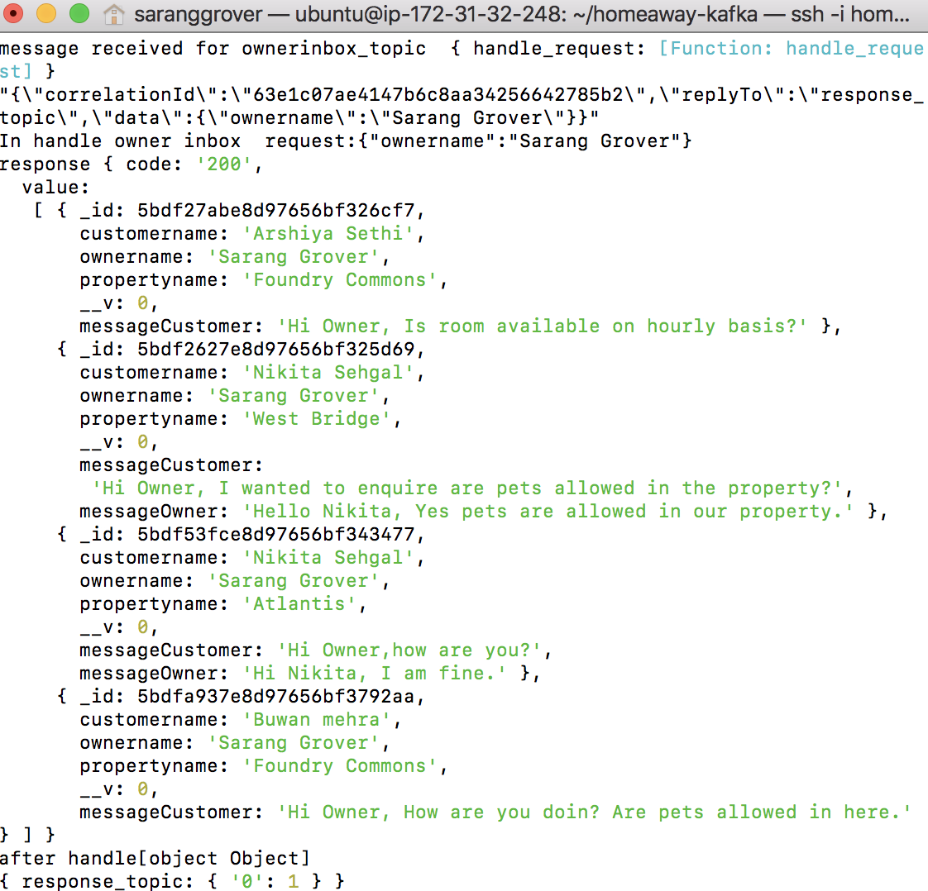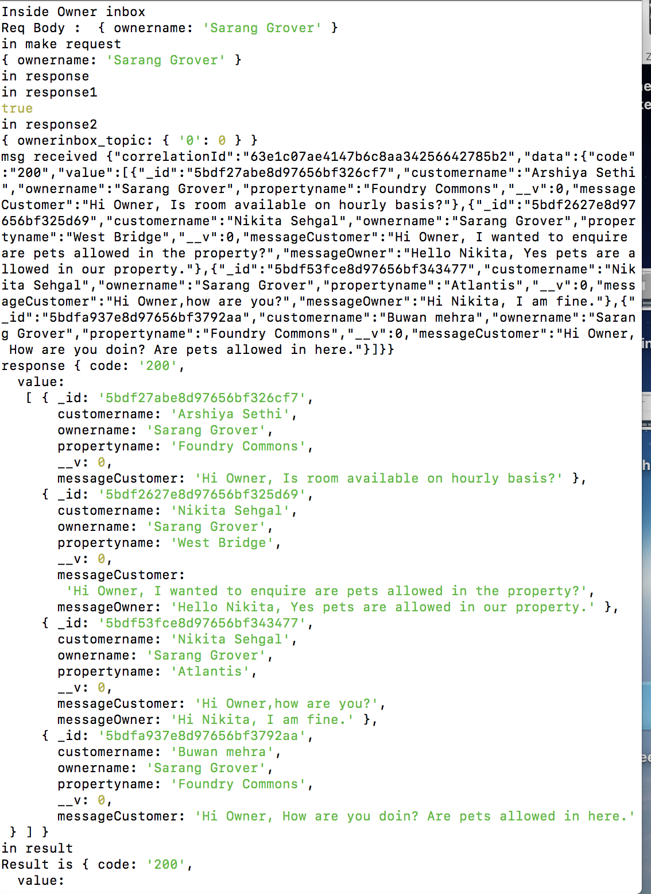

**Owner Replies and the sender views it in the traveler inbox**

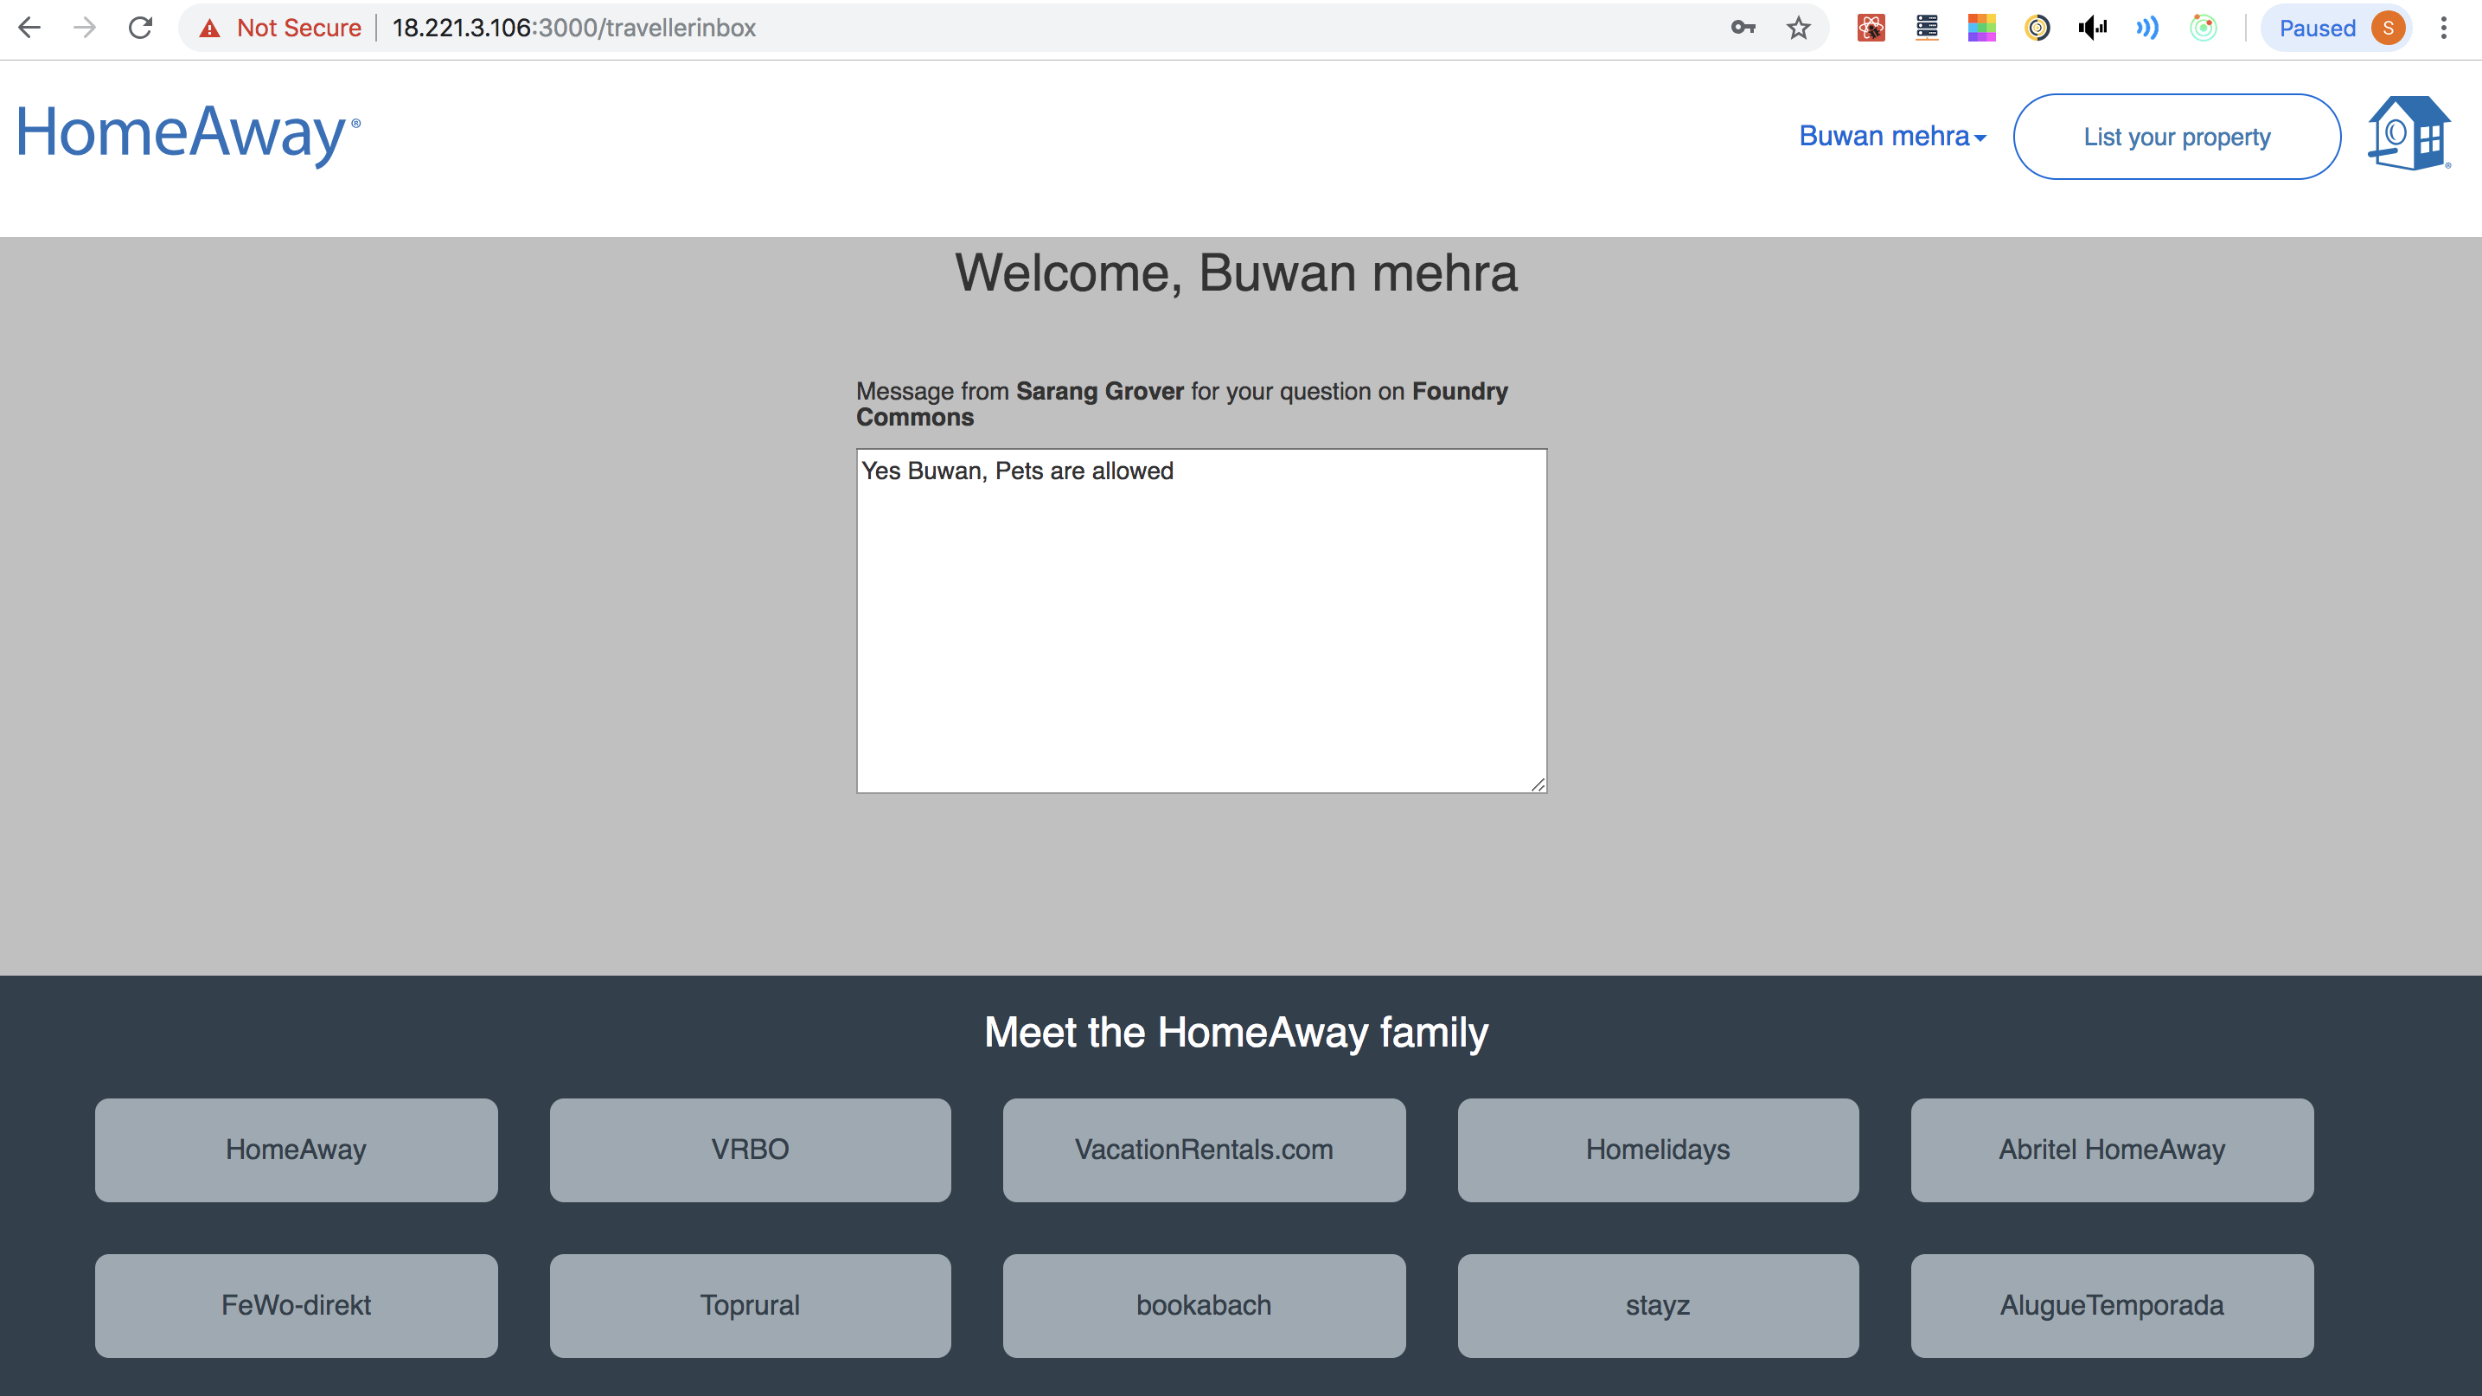

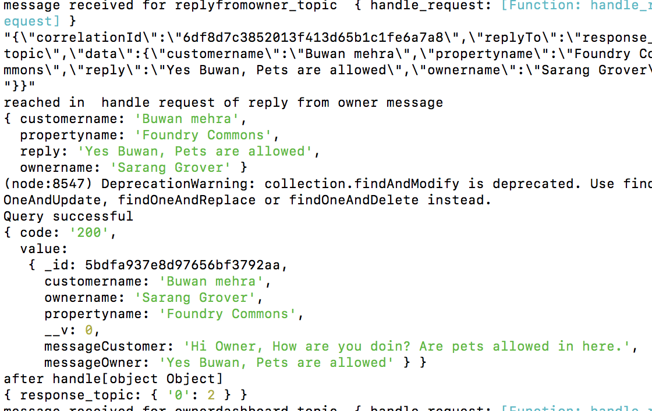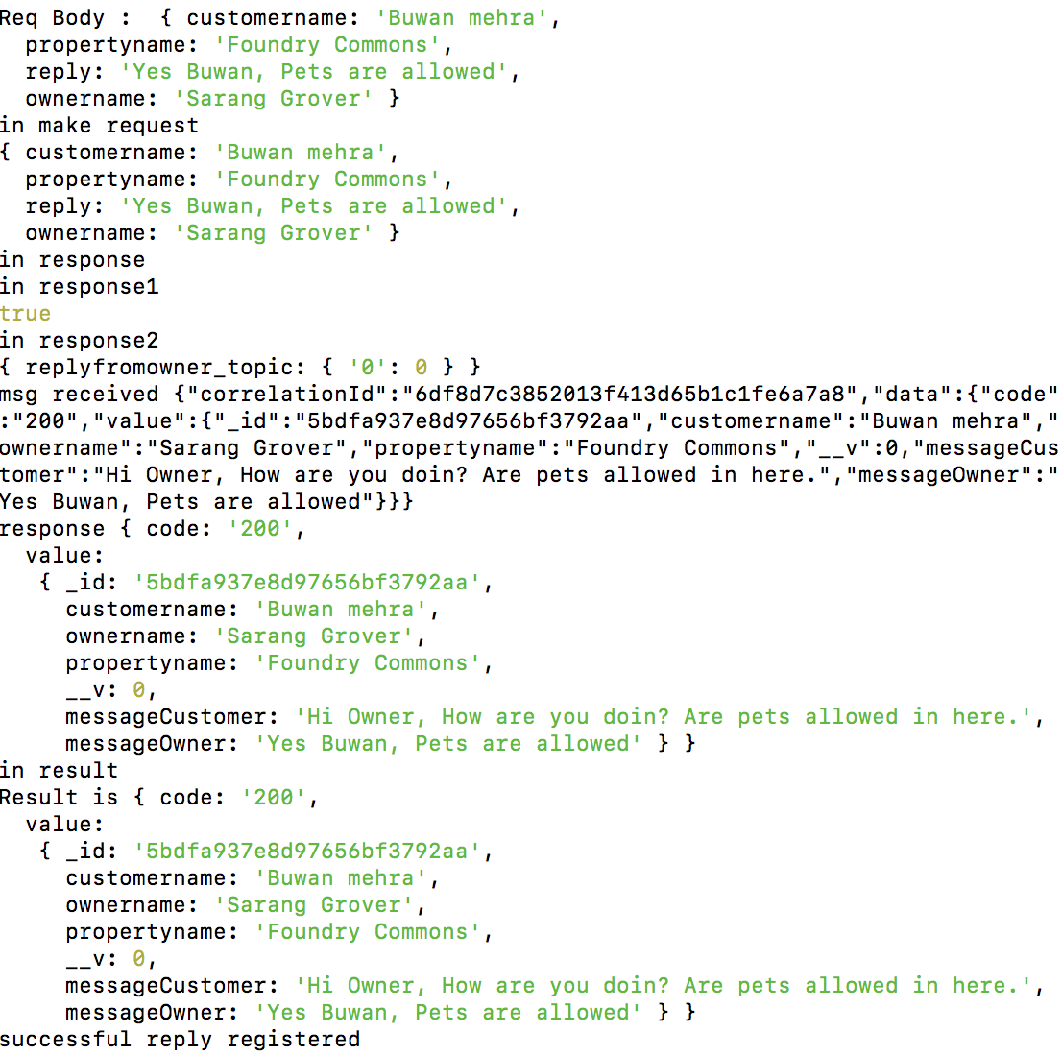

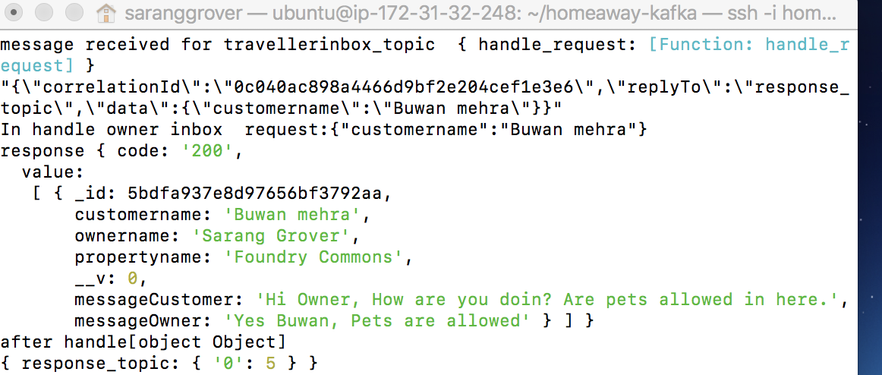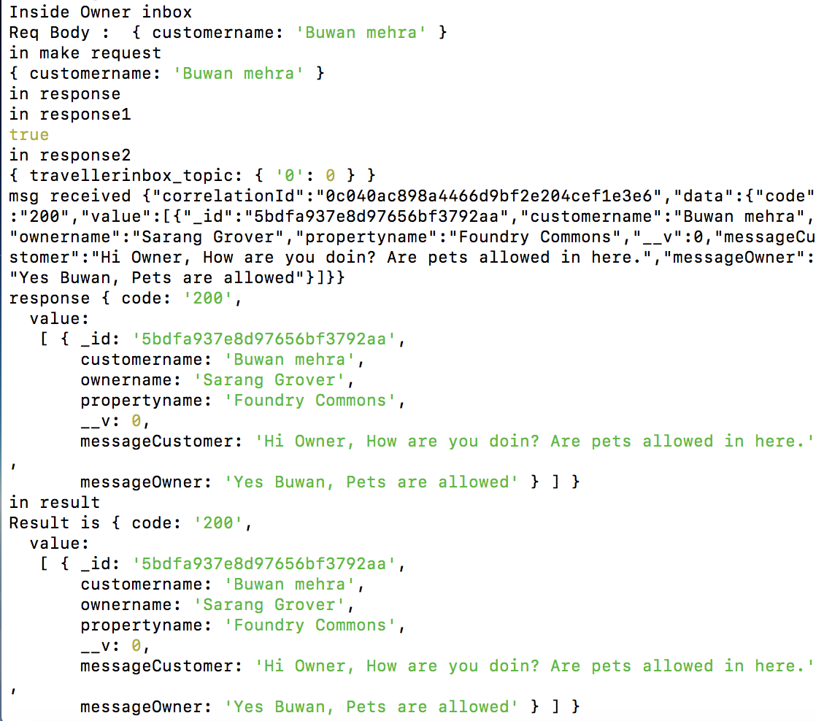

**8) Owner List his property and Owner Dashboard**

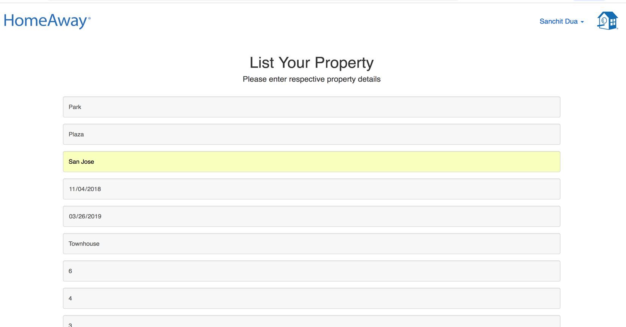

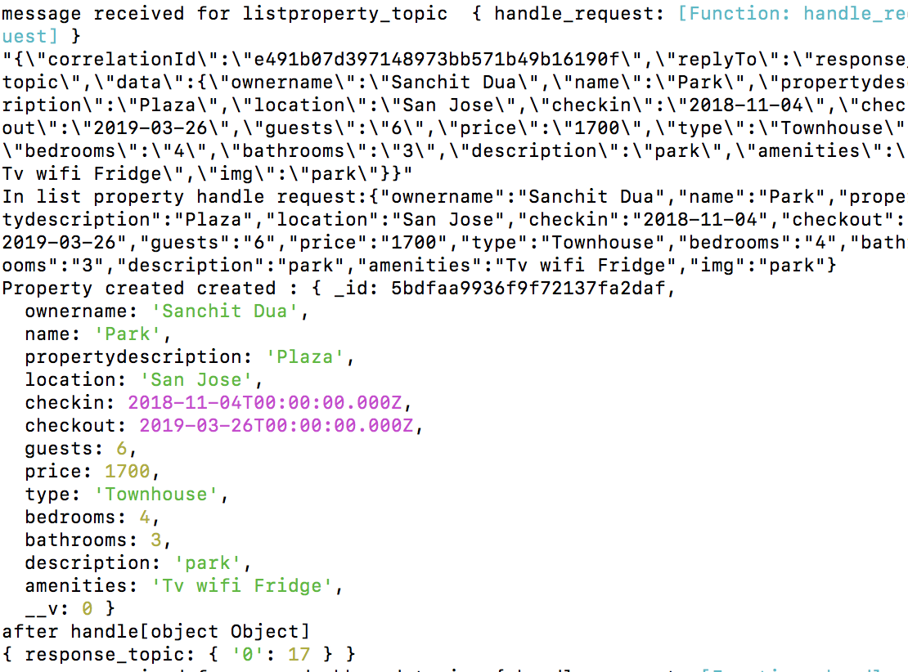

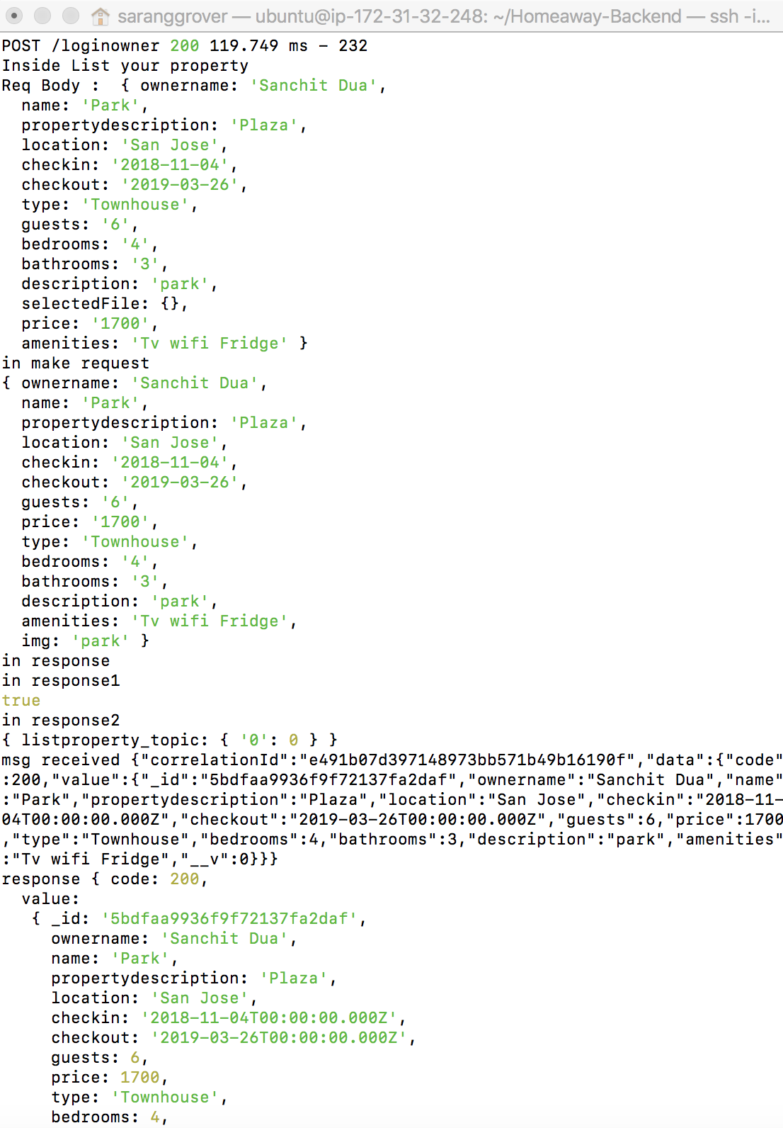

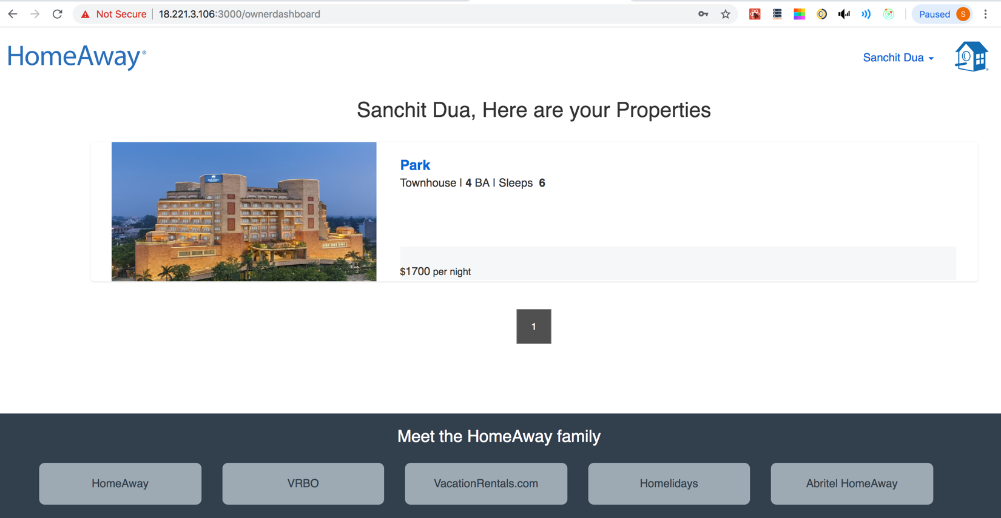

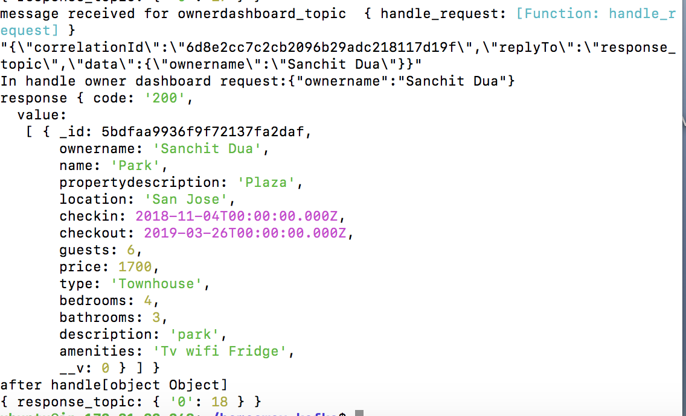

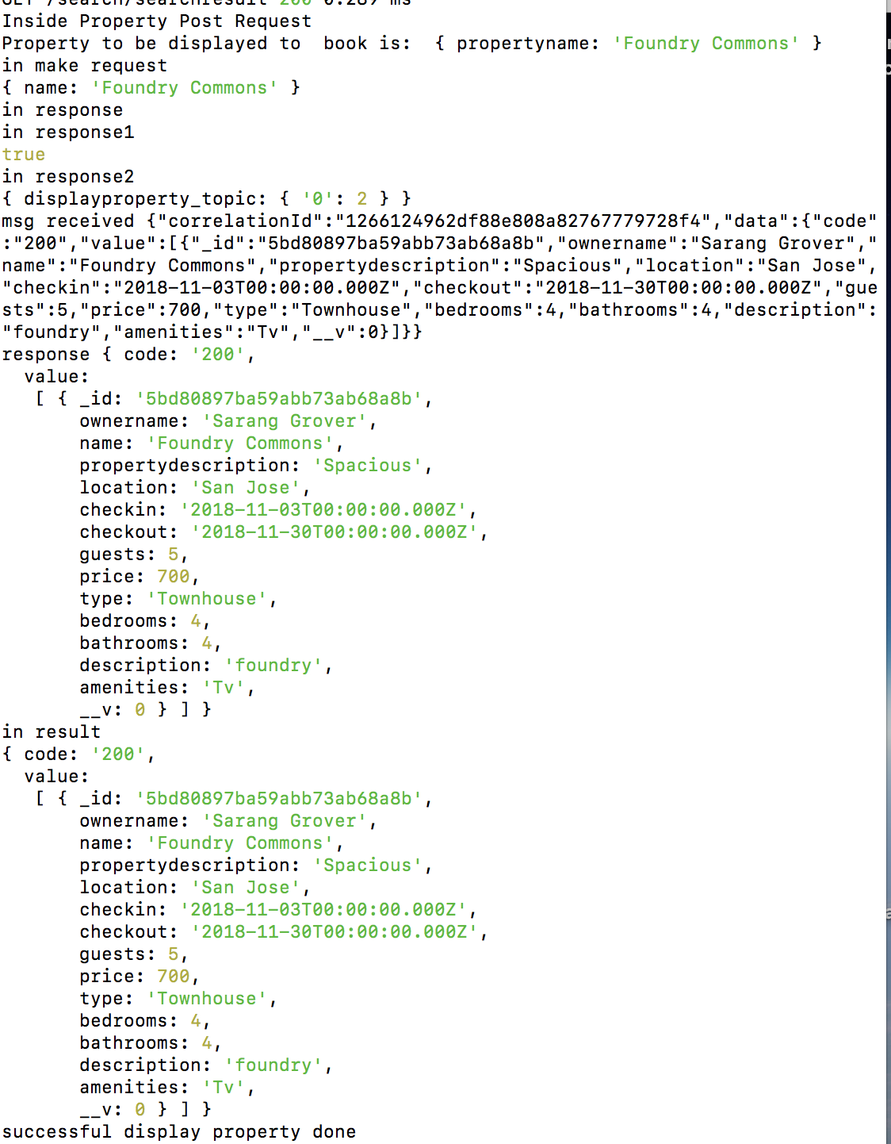

**---------------------------------------------------------------------------------------**

Owner and Traveler credentials with more properties and bookings to check pagination

1) Traveler – [nikita.sehgal28@gmail.com](mailto:nikita.sehgal28@gmail.com)

Password – nikita

2) Owner – [sarang@gmail.com](mailto:sarang@gmail.com)

Password – sarang

3) AWS url: 18.221.3.106:3000